|  |
| --- |
| **Name**  **Roll No.**  **Exam Seat No.**  **Year 20**  **20** |
| ELECTRONICS GROUP SEMESTER - VI DIPLOMA IN ENGINEERING AND TECHNOLOGY |
| LEARNING MATERIAL  FOR  **EMERGING TRENDS**  **IN**  **ELECTRONICS**  **(22636)**  **(**  **EJ, DE, IE, IS**  **)** |
|  |
| MAHARASHTRA STATE BOARD OF TECHNICAL EDUCATION, MUMBAI  (Autonomous) (ISO 9001 : 2015) (ISO / IEC 27001 : 2013) |

|  |
| --- |
| **Learning Manual for**      **Emerging Trends in Electronics**    **(22636)**    **Semester– VI**    **(DE/EJ/ET/EN/EX/EQ/IE/IS/IC)**                                **Maharashtra State**  **Board of Technical Education, Mumbai**  **(Autonomous) (ISO-9001-2015) (ISO/IEC 27001:2013)** |

|  |
| --- |
| **Maharashtra State**      **Board of Technical Education, Mumbai**  **(Autonomous) (ISO-9001-2015) (ISO/IEC 27001:2013)**  **4th Floor, Government Polytechnic Building, 49, Kherwadi, Bandra (East), Mumbai – 400051.**  **(Printed on November 2019)** |

|  |
| --- |
| **Maharashtra State**            **Board of Technical Education**    **Certificate**    This is to certify that Mr. / Ms. …………………………………. Roll No……………………….of ………… Semester of Diploma in……...……………………..………………………….of Institute …………………………………….………(Code………………..)  has attained pre-defined practical outcomes(PROs) satisfactorily in course **Emerging Trends in Electronics** **(22636)** for the academic year 20…….to 20…..... as prescribed in the curriculum.    Place ………………. Enrollment No……………………  Date:…..................... Exam Seat No. ………………......      **Course Teacher Head of the Department Principal**  Seal of the  Institute |

**Emerging Trends in Electronics (22636)**

# Preface

The primary focus of any engineering work in the technical education system is to develop the much needed industry relevant competency & skills. With this in view, MSBTE embarked on innovative “I” scheme curricula for engineering diploma programmes with outcome based education through continuous inputs from socio economic sectors. The industry experts during the consultation while preparing the Perspective Plan for diploma level technical education categorically mentioned that the curriculum, which is revised and implemented normally further revised after 4-5 years. The technological advancements being envisaged and faced by the industry in the present era are rapid and curriculum needs to be revised by taking care of such advancements and therefore should have a provision of accommodating continual changes. These views of industry experts were well taken &further discussed in the academic committee of MSBTE, wherein it was decided to have a dynamism in curriculum for imparting the latest technological advancements in the respective field of engineering. In order to provide an opportunity to students to learn the technological advancements, a course with a nomenclature of “Emerging Trends in Electronics Engineering” is introduced in the 6th semester of Electronics Engineering Group.

The technological advancements to be depicted in the course called emerging trends was a challenging task and therefore it was decided to prepare a learning material with the involvement of industrial and academic experts for its uniformity in the aspect of delivery, implementation and evaluation.

In the electronics sector, new applications are coming up and it is mandatory for all technologists to be well versed in these developments to survive and provide satisfactory and quality services to the society and industry. This course aims to prepare the diploma graduates to be conversant with such emerging trends. The main areas in which such developments encompass are Smart systems, Digital Factory and Communication. Each unit in the course given an insight to the learner about the latest development in the relevant fields.

This learning manual is designed to help all stakeholders, especially the students and teachers and to develop in the student the pre-determined outcomes. It is expected to explore further by both students and teachers, on the various topics mentioned in learning manual to keep updated themselves about the advancements in related technology.

MSBTE wishes to thank the Learning Manual development team, specifically Mr. Sudhir Panditrao, Chairman of the Course Committee, Industry Experts, Mr. K.P. Akole, Coordinator & Smt. Vidya Lunge, Co-coordinator of the Programmes and academic experts for their intensive efforts to formulate the learning material on “Emerging Trends in Electronics Engineering”. Being emerging trend and with the provision of dynamism in the curricula, any suggestions towards enrichment of the topic and thereby course will be highly appreciated.

**(Dr. Vinod M. Mohitkar)**

## Director MSBTE, Mumbai

i

**Emerging Trends in Electronics (22636)**

## Content

|  |  |  |
| --- | --- | --- |
| **Sr. No** | **Name of Topic** | **Page** |
| 1 | **Advance Processors** | 1 |
| 1.1 Advances in processor architecture | 1 |
| 1.2 Arduino | 7 |
| 1.3 Arduino IDE | 15 |
| 1.4 Arduino Interfacing: | 20 |
| 1.5 ARM | 24 |
| 2 | **Recent Electronic Components** | 35 |
| 2.1 Flexible PCB | 36 |
| 2.2 Battery [Li-ion, nuclear] | 38 |
| 2.3 Memristor, Organic LED | 41 |
| 2.4 Surface Mount Device | 44 |
| 3 | **Next Generation telecom Network** | 50 |
| 3.1 NGN architecture | 55 |
| 3.2 NGN Wireless Technology | 61 |
| 3.3Fiber to the Home(FTTH) | 68 |
| 3.4 NGN Core | 69 |
| 3.5 Next Generation transmission system | 72 |
| 4 | **Digital Factory** | 80 |
| 4.1 Internet of Things | 80 |
| 4.2 Architectures | 86 |
| 4.3 I4.0/IIoT/ Smart Manufacturing | 96 |
| 5 | **Smart World** | 115 |
| 5.1 Evolution of smart home. | 116 |
| 5.2 Basic requirements for Smart Home | 119 |
| 5.3 Basic requirements for Smart City | 127 |
| 5.4 IOT/M2M Network architecture: | 139 |
|  | |  |
| Appendix A Abbreviations | | 151 |
| Appendix B Answer Key | | 156 |
| Appendix C Bibliography | | 158 |

ii

# UNIT I Advance Processors

## Teaching Hrs: 10 Marks 16

**Course Outcome-**Suggest the relevant computing systems/processor for specific type of application

**To attain above course outcome candidate must able to:**

1. Describe the given advancement in the processor architecture.
2. Describe the given features of Arduino board.
3. Describe the given function in Arduino IDE.
4. Describe the given feature of the ARM7 processors.
5. Compare the given salient features of ARM 7 and ARM 7TDMI processors.

**Unit focus on following major points:**

* 1. **Advances in processor architecture**: RISC, Pipelining and Superscalar concepts, advantages and Applications.
  2. **Arduino**: Introduction, Compatible R2/R3 Uno board Features. Atmega 328: Introduction, pin description.

1..3 **Arduino IDE**: Features, Sketch: C,C++ functions setup(), loop(), pinMode(), digitalWrite(), digitalRead() and delay().

* 1. **Arduino Interfacing**: Key and LED, Relay, DC motor.
  2. **ARM**: Introduction, Features of ARM7 and ARM7TDMI, advantages, applications. Versions of ARM process or only features.

**1.1 Advances in processor architecture:**

## 1.1.1 Introduction

Processors have undergone a tremendous evolution throughout their history. A key milestone in this evolution was the introduction of the microprocessor, term that refers to a processor that is implemented in a single chip. The first microprocessor was introduced by Intel under the name of Intel 4004 in 1971. It contained about 2,300 transistors, was clocked at 740 KHz and delivered 92,000 instructions per second while dissipating around 0.5 watts. Since then, practically every year we have witnessed the launch of a new microprocessor, delivering significant performance improvements over previous ones. Some studies have estimated this growth to be exponential, in the order of about 50% per year, which results in a cumulative growth of over three orders of magnitude in a time span of two decades. These improvements have been fueled by advances in the manufacturing process and innovations in processor architecture.

The complexity of an integrated circuit is bounded by physical limitations on the number of [transistors](https://en.wikipedia.org/wiki/Transistors) that can be put onto one chip, the number of package terminations that can connect the processor to other parts of the system, the number of interconnections it is possible to make on the chip, and the heat that the chip can dissipate. Advancing technology makes more complex and powerful chips feasible to manufacture.

## 1.1.2 Processor Selection Criteria

With numerous kinds of processors, various design philosophies are available for digital systems. Following considerations need to be factored during processor selection for a Digital Systems.

1. Performance Considerations
2. Power considerations
3. Memory
4. Peripheral Set
5. Operating Voltage
6. Specialized Processing Units
7. Price
8. **Performance:** The first and foremost consideration in selecting the processor is its performance. The performance speed of a processor is dependent primarily on its architecture and its silicon design. Evolution of fabrication techniques helped packing more transistors in same area there by reducing the propagation delay. Also presence of cache reduces instruction/data fetch timing. Pipelining and super-scalar architectures further improves the performance of the processor. Branch prediction, speculative execution etc are some other techniques used for improving the execution rate. Multi-cores are the new direction in improving the performance.

Rather than simply stating the clock frequency of the processor which has limited significance to its processing power, it makes more sense to describe the capability in a standard notation. MIPS (Million Instructions Per Second) or MIPS/MHz was an earlier notation followed by Dhrystones and latest EEMBC’s **CoreMark**. CoreMark is one of the best ways to compare the performance of various processors.

Processor architectures with support for extra instruction can help improving performance for specific applications. For example, SIMD (Single Instruction/Multiple Data) set and Jazelle – Java acceleration can help in improving multimedia and JVM execution speeds. So size of cache, processor architecture, instruction set etc has to be taken in to account when comparing the performance.

1. **Power:** Increasing the logic density and clock speed has adverse impact on power requirement of the processor. A higher clock implies faster charge and discharge cycles leading to more power consumption. More logic leads to higher power density there by making the heat dissipation difficult. Further with more emphasis on greener technologies and many systems becoming battery operated, it is important the design is for optimal power usage.

Techniques like **frequency scaling** – reducing the clock frequency of the processor depending on the load, **voltage scaling**– varying the voltage based on load can help in achieving lower power usage. Further asymmetric multiprocessors, under near idle conditions, can effectively power off the more powerful core and load the less powerful core for performing the tasks. SoC comes with advanced power gating techniques that can shut down clocks and power to unused modules.

1. **Memory:** Usually, designers make the decision to use internal or external memory after they define the required amounts of code space and data memory. Internal memory is typically the most cost effective memory type, but it is also the least flexible. For this reason, designers must determine future growth possibilities and whether there is an upgrade path to microcontrollers with larger code space. Since cost is always a factor, the microcontroller with the least amount of memory to fit the application is typically selected. Therefore, care must be taken when predicting code size, since an increase in code size might require a different microcontroller.
2. **Peripheral Set:** Every system design needs, apart from the processor, many other peripherals for input and output operations. Since in an embedded system, almost all the processors used are SoCs, it is better if the necessary peripherals are available in the chip itself. This offers various benefits compared to peripherals in external IC’s such as optimal power architecture, effective data communication using DMA etc. So it is important to have peripheral set in consideration when selecting the processor.
3. **Operating Voltages:** Each and every processor will have its own operating voltage condition. The operating voltage maximum and minimum ratings will be provided in the respective data sheet or user manual.

While higher end processors typically operate with 2 to 5 voltages including 1.8V for Cores/Analogue domains, 3.3V for IO lines, needs specialized PMIC devices, it is a deciding factor in low end micro-controllers based on the input voltage. For example it is cheaper to work with a 5V micro-controller when the input supply is 5V and 3.3 microcontrollers when operated with Li-on batteries.

1. **Specialized Processing Units:** Apart from the core, presence of various co-processors and specialized processing units can help achieving necessary processing performance. Coprocessors execute the instructions fetched by the primary processor thereby reducing the load on the primary. Some of the popular co-processors include

Floating Point Co-processor: RISC cores supports primarily integer only instruction set. Hence presence of a FP co-processor can be very helpful in application involving complex mathematical operations including multimedia, imaging, coders and decoders (codec’s), signal processing etc.

Graphic Processing Unit: GPU (Graphic Processing Unit) also called as Visual processing unit is responsible for drawing images on the frame buffer memory to be displayed. Since human visual perception needed at-least 16 Frames per second for a smooth viewing, drawing for HD displays involves a lot of data bandwidth. Also with increasing graphic requirements such as textures, lighting shades etc, GPU’s have become a mandatory requirements for mobile phones, gaming consoles etc.

Various GPU’s like ARM’s MALI, PowerVX, OpenGLetc are increasing available in higher end processors. Choosing the right co-processor can enable smooth design of the embedded application.

Digital Signal Processor: DSP is a processor designed specifically for signal processing applications. Its architecture supports processing of multiple data in parallel. It can manipulate real time signal and convert to other domains for processing. DSP’s are either available as the part of the SoC or separate in an external package. DSP’s are very helpful in multimedia applications. It is possible to use a DSP along with a processor or use the DSP as the main processor itself.

**7. Price:** Various considerations discussed above can be taken in to account when a processor is being selected for an embedded design. It is better to have some extra buffer in processing capacities to enable enhancements in functionality without going for a major change in the design. While engineers (especially software/firmware engineers) will want to have all the functionalities, price will be the determining factor when designing the system and choosing the right processor.

**1.1.3 RISC** (Reduced Instruction Set Computer):

A single-chip processor need not be the same as the optimal architecture for a multi-chip processor. Their argument was subsequently supported by the results of a processor design project undertaken by a postgraduate class at Berkeley which incorporated Reduced Instruction Set Computer (RISC) architecture. This design, the Berkeley RISC I, was much simpler than the commercial CISC processors. The RISC I instruction set differed from the minicomputer-like CISC instruction sets used on commercial microprocessors in a number of ways.

It had the following key features:

1. A fixed (32-bit) instruction size with few formats; CISC processors typically had variable length instruction sets with many formats.
2. A load-store architecture where instructions that process data operate only on registers and are separate from instructions that access memory; CISC processors typically allowed values in memory to be used as operands in data processing instructions.
3. A large register bank of thirty-two 32-bit registers, all of which could be used for any purpose, to allow the load-store architecture to operate efficiently; CISC register sets were getting larger, but none was this large and most had different registers for different purposes (for example, the data and address registers on the Motorola MC68000).
4. These differences greatly simplified the design of the processor and allowed the designers to implement the architecture using organizational features that contributed to the performance of the prototype devices:
5. Hard-wired instructions decode logic; CISC processors used large microcode ROMs to decode their instructions.
6. Pipelined execution; CISC processors allowed little, if any, overlap between consecutive instructions (though they do now).
7. Single-cycle execution; CISC processors typically took many clock cycles to complete a single instruction.

### RISC advantages

1. A smaller die size. A simple processor should require fewer transistors and less silicon area.
2. A shorter development time. A simple processor should take less design effort and therefore have a lower design cost and be better matched to the process technology.
3. A higher performance.
4. Higher performance had been sought through ever-increasing complexity; this was a bit hard to swallow. The argument goes something like this: smaller things have higher natural frequencies (insects flap their wings faster than small birds, small birds faster than large birds, and so on) Clock rates so a simple processor ought to allow a high clock rate. So let's design our complex processor by starting with a simple one, and then add complex instructions one at a time. When we add a complex instruction it will make some highlevel function more efficient, but it will also slow the clock down a bit for all instructions. We can measure the overall benefit on typical programs, and when we do, all complex instructions make the program run slower. **RISC Disadvantages:**
5. There is still considerable controversy among experts about the ultimate value of RISC architectures. Its proponents argue that RISC machines are both cheaper and faster, and are therefore the machines of the future.
6. However, by making the hardware simpler, RISC architectures put a greater burden on the software. Is this worth the trouble because conventional microprocessors are becoming increasingly fast and cheap anyway
7. As memory speed increased, and high-level languages displaced assembly language, the major reasons for CISC began to disappear, and computer designers began to look at ways computer performance could be optimized beyond just making faster hardware.
8. One of their key realizations was that a sequence of simple instructions produces the same results as a sequence of complex instructions, but can be implemented with a simpler (and faster) hardware design. (Assuming that memory can keep up.) RISC (Reduced Instruction Set Computers) processors were the result.
9. CISC and RISC implementations are becoming more and more alike. Many of today’s RISC chips support as many instructions as yesterday's CISC chips. And today's CISC chips use many techniques formerly associated with RISC chips.

**RISC Applications:**

1. Video processing.
2. Image processing.
3. Telecommunications.

**CISC (**Complex Instruction Set Computer)**:**

CISC is an acronym for Complex Instruction Set Computer and are chips that are easy to program and which make efficient use of memory. Most common microprocessor designs such as the Intel 80x86 and Motorola 68K series followed the CISC philosophy.

But recent changes in software and hardware technology have forced a re-examination of CISC and many modern CISC processors are hybrids, implementing many RISC principles.

E.g. Pentium is considered a modern CISC processor

#### Table 1.1 Comparisons of RISC and CISC

|  |  |  |
| --- | --- | --- |
| **Sr. No.** | **CISC** | **RISC** |
| 1 | Emphasis on hardware | Emphasis on software |
| 2 | Includes multi-clock complex instructions | Single-clock, reduced instruction only |
| 3 | Memory-to –memory:"READ" and "WRITE" incorporated in instructions | Register to register:"LOAD" and  "STORE" are independent instructions |
| 4 | Small code sizes ,high cycles per second | Low cycles per second, large code sizes |
| 5 | Transistors used for storing complex Instructions | Spends more transistors on memory registers |

**1.1.4 Pipelining:** Instruction pipelining is a technique for implementing [instruction-level parallelism](https://en.wikipedia.org/wiki/Instruction-level_parallelism) within a single processor. Pipelining attempts to keep every part of the processor busy with some instruction by dividing incoming [instructions](https://en.wikipedia.org/wiki/Machine_code) into a series of sequential steps performed by different [processor units](https://en.wikipedia.org/wiki/Central_processing_unit#Structure_and_implementation) with different parts of instructions processed in parallel. It allows faster [CPU](https://en.wikipedia.org/wiki/CPU) [throughput](https://en.wikipedia.org/wiki/Throughput) than would otherwise be possible at a given [clock rate.](https://en.wikipedia.org/wiki/Clock_rate) Many designs include pipelines as long as 7, 10 and even 20 stages.

A processor executes an individual instruction in a sequence of steps. A typical sequence might be:

1. Fetch the instruction from memory (fetch).
2. Decode it to see what sort of instruction it is (dec).
3. Access any operands that may be required from the register bank (reg).
4. Combine the operands to form the result or a memory address (ALU).
5. Access memory for a data operand, if necessary (mem).
6. Write the result back to the register bank (res).

Not all instructions will require every step, but most instructions will require most of them. These steps tend to use different hardware functions, for instance the ALU is probably only used in step 4. Therefore, if an instruction does not start before its predecessor has finished, only a small proportion of the processor hardware will be in use in any step. An obvious way to improve the utilization of the hardware resources, and also the processor throughput, would be to start the next instruction before the current one has finished. This technique is called pipelining a very effective way of exploiting concurrency in a general-purpose processor. Taking the above sequence of operations, the processor is organized so that as soon as one instruction has completed step 1 and moved on to step 2, the next instruction begins step 1. This is illustrated in Fig. 1.1 .In principle such a pipeline should deliver a six times speed-up compared with non-overlapped instruction execution; in practice things do not work out quite so well for reasons we will see below.

It is relatively frequent in typical computer programs that the result from one instruction is used as an operand by the next instruction. When this occurs, the pipeline operation shown in Fig. 1.1 breaks down, since the result of instruction 1 is not available at the time that instruction 2 collects its operands. Instruction 2 must therefore wait until the result is available

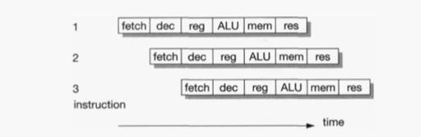

**Fig 1.1Pipelined instruction executions** **Pipe line efficiency:**

Though there are techniques which reduce the impact of these pipeline problems, they cannot remove the difficulties altogether. The deeper the pipeline (that is, the more pipeline stages there are), the worse the problems get. For reasonably simple processors, there are significant benefits in introducing pipelines from three to five stages long, but beyond this the law of diminishing returns begins to apply and the added costs and complexity outweigh the benefits. Pipelines clearly benefit from all instructions going through a similar sequence of steps. Processors with very complex instructions where every instruction behaves differently from the next are hard to pipeline. In 1980 the complex instruction set microprocessor of the day was not pipelined due to the limited silicon resource, the limited design resource and the high complexity of designing a pipeline for a complex instruction set.

Branch instructions result in even worse pipeline behavior since the fetch step of the following instruction is affected by the branch target computation and must therefore be deferred. Unfortunately, subsequent fetches will be taking place while the branch is being decoded and before it has been recognized as a branch, so the fetched instructions may have to be discarded. **Pipeline hazards**

It is relatively frequent in typical computer programs that the result from one instruction is used as an operand by the next instruction. When this occurs the pipeline operation shown in breaks down, since the result of instruction 1 is not available at the time that instruction 2 collects its operands. Instruction 2 must therefore wait until the result is available, giving the behavior. This is a read-after-write pipeline hazard.

**Advantages:**

1. Increase in the number of pipeline stages increases the number of instructions executed simultaneously.
2. Faster ALU can be designed when pipelining is used.
3. Pipelined CPU's works at higher clock frequencies than the RAM. Pipelining increases the overall performance of the CPU.

**Applications:**

Digital signal processing (DSP) systems

**1.1.5 Superscalar:** Superscalar architecture is a method of parallel computing used in many processors. In a superscalar computer, the central processing unit (CPU) manages multiple instruction pipelines to execute several instructions concurrently during a clock cycle.

**Advantages:**

The cycle time of the processor is reduced, thus increasing instruction issue-rate in most cases

### Application Specific System Processor (ASSP)

Application Specific System Processor (ASSP) ASSP is dedicated for faster processing and useful for applications like real-time video processing which incorporates lots of processing before transmitting. Assume embedded system for real time video processing.

Real time video arises for digital television, high definition TV decoder, set-top box, DVD players, web phones video conferencing etc. Processors which are dedicated to these types of specific tasks are the ASSP. These processors are configured and interfaced with the rest of the embedded system.

Assume an embedded system for specific protocol interconnects through some bus architecture to another system. In such applications some encryption and decryption is required. Also some RTOS features are necessary. If the software alone is used for this type of applications, then it will take a longer time. Therefore hardwired solutions are designed to meet the application specific system. Processor designed for these systems are the ASSP.

### Application Specific Instruction Processor (ASIP)

For a number of applications GPP core may not be a suitable solution. For various security applications, smart card, video game, mobile Internet, Gbps transceiver, Gbps LAN, missile system needs a special processing unit on a VLSI design circuit to function as a processor. These units are called Application Specific Instruction Processor (ASIP). Sometime for an application both configurable processor (FPGA or ASIP) and non - configurable processor (DSP or microprocessor or microcontroller) might be needed on a chip. Generally this type of applications are very important in some killer applications (application which is useful to millions of people) such as HDTV, cell-phone etc.

ASIP is a processor with instruction set designed for specific application area on VLSI chip or core. ASIP examples are microcontroller, I/O, DSP, Media, network or other domainspecific processors. ASIP can be designed with some VLSI design tools. ASIP are programmed with the instructions of the function related to Digital signal processing, control signal processing.

### Embedded processor / embedded microcontroller

Embedded processor is a processor with special features that allow it to embed multiple processes in to a system. Real time applications and aerodynamics are two areas whereas fast, precise, and intensive calculations with fast content switching (from one program to another), are essential.

**Embedded processor** should have following capabilities.

1. Fast context switching.
2. 32 bit or 64 bit addition/multiplication with no share data problem in the operation.
3. 32 bit RISC core for fast, precise, intensive calculations

**Embedded microcontroller** is specially designed microcontroller and should have following capabilities.

1. Microcontroller has RAM, large flash, ROM, interrupt handlers, devices and peripherals and no external memory, or device or peripherals required.
2. Fast context switching and therefore lower latency of task in complex real operations. For example ARM and 68HC1x microcontroller saves all CPU registers very fast.

**1.2 Arduino:**

**1.2.1 Introduction:** Arduino is an [open-source hardware](https://en.wikipedia.org/wiki/Open-source_hardware) and [software](https://en.wikipedia.org/wiki/Open-source_software) platform, project and user community that designs and manufactures [single-board microcontrollers](https://en.wikipedia.org/wiki/Single-board_microcontroller) and [microcontroller](https://en.wikipedia.org/wiki/Microcontroller) kits for building digital devices. Its products are licensed under the [GNU Lesser General Public License](https://en.wikipedia.org/wiki/GNU_Lesser_General_Public_License) (LGPL) or the [GNU General Public License](https://en.wikipedia.org/wiki/GNU_General_Public_License) (GPL), permitting the manufacture of Arduino boards and software distribution by anyone. Arduino boards are available commercially in preassembled form or as [do-ityourself](https://en.wikipedia.org/wiki/Do-it-yourself) (DIY) kits.

Arduino board designs use a variety of [microprocessors](https://en.wikipedia.org/wiki/Microprocessor) and controllers. The boards are equipped with sets of digital and analog [input/output](https://en.wikipedia.org/wiki/Input/output) (I/O) pins that may be interfaced to various expansion boards or [breadboards](https://en.wikipedia.org/wiki/Breadboards) (shields) and other circuits. The boards feature serial communications interfaces, including [Universal Serial Bus](https://en.wikipedia.org/wiki/Universal_Serial_Bus) (USB) on some models, which are also used for loading programs from personal computers. The microcontrollers can be programmed using [C](https://en.wikipedia.org/wiki/C_(programming_language)) and [C++](https://en.wikipedia.org/wiki/C%2B%2B) [programming languages.](https://en.wikipedia.org/wiki/Programming_language) In addition to Using traditional compiler tool chains, The Arduino project provides anintegrated development [environment](https://en.wikipedia.org/wiki/Integrated_development_environment) (IDE) based on the [Processing](https://en.wikipedia.org/wiki/Processing_(programming_language)) language project.

**Arduino UNO R3 board:** The Arduino Uno R3 is a microcontroller board based on a removable, dual-inline-package (DIP) ATmega328 AVR microcontroller.

Features:

1. 14 Digital IO pins (pins 0–13) these can be inputs or outputs, which is specified by the sketch you create in the IDE.
2. 6 Analogue In pins (pins 0–5) These dedicated analogue input pins take analogue values (i.e., voltage readings from a sensor) and convert them into a number between 0 and 1023.
3. 6 Analogue Out pins (pins 3, 5, 6, 9, 10, and 11) these are actually six of the digital pins that can be reprogrammed for analogue output using the sketch you create in the IDE.
4. The board can be powered from your computer’s USB port, most USB chargers, or an AC adapter (9 volts recommended, 2.1mm barrel tip and center positive). If there is no power supply plugged into the power socket, the power will come from the USB board, but as soon as you plug a power supply, the board will automatically use it. Programs can be loaded on to it from the easy-to-use Arduino computer program.

The Arduino has an extensive support community, which makes it a very easy way to get started working with embedded electronics. The R3 is the third, and latest, revision of the Arduino Uno.

#### Table 1.2 Atmel chips used in Arduino boards

|  |  |  |  |  |  |
| --- | --- | --- | --- | --- | --- |
| Chip Number | On-Chip  Flash | RAM | I/O pins | Pin numbers | Arduino Board |
| ATmega16 | 16K | 1K | 14 | 28 | Nano or Uno |
| ATmega328 | 32K | 2K | 14 | 28 | Nano or Uno |
| ATmega328p | (p) stands for low (Pico) Power consumption other features same as 328 | | | | |
| ATmega2560 | 256K | 4K | 54 | 100 | Mega |

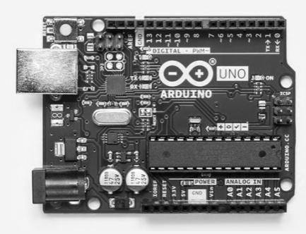

Fig 1.2 Arduino R3 UNO Board

## 1.2.2 AVR Overview

The AVR is a [modified Harvard architecture](https://en.wikipedia.org/wiki/Modified_Harvard_architecture) machine, where program and data are stored in separate physical memory systems that appear in different address spaces, but having the ability to read data items from program memory using special instructions.

### Basic families

AVRs are generally classified into following:

**TinyAVR** — the ATtiny series

1. 0.5–16 kB program memory
2. 6–32-pin package
3. Limited peripheral set **megaAVR** — the ATmega series
4. 4–256 kB program memory
5. 28–100-pin package
6. Extended instruction set (multiply instructions and instructions for handling larger program memories)
7. Extensive peripheral set

**XMEGA** — the ATxmega series

1. 16–384 kB program memory
2. 44–64–100-pin package (A4, A3, A1)
3. 32-pin package : XMEGA-E (XMEGA8E5)
4. Extended performance features, such as DMA, "Event System", and cryptography support.
5. Extensive peripheral set with [ADCs](https://en.wikipedia.org/wiki/Analog-to-digital_converter) **Application-specific AVR** megaAVRs with special features not found on the other members of the AVR family, such as LCD controller, [USB](https://en.wikipedia.org/wiki/Universal_Serial_Bus) controller, advanced PWM, CAN, etc.

### FPSLIC (AVR with FPGA)

1. [FPGA](https://en.wikipedia.org/wiki/Field-programmable_gate_array) 5K to 40K gates
2. SRAM for the AVR program code, unlike all other AVRs
3. AVR core can run at up to 50 MHz

### 32-bit AVRs

In 2006 Atmel released microcontrollers based on the 32-bit [AVR32](https://en.wikipedia.org/wiki/AVR32) architecture. Theyinclude [SIMD](https://en.wikipedia.org/wiki/SIMD) and [DSP](https://en.wikipedia.org/wiki/Digital_signal_processor) instructions, along with other audio- and video-processing features. This 32-bit family of devices is intended to compete with the [ARM-](https://en.wikipedia.org/wiki/ARM_architecture)based processors. The instruction set is similar to other RISC cores, but it is not compatible with the original AVR or any of the various ARM cores.

## 1.2.3 AVR ATmega328 Microcontroller High-Level Block Diagram

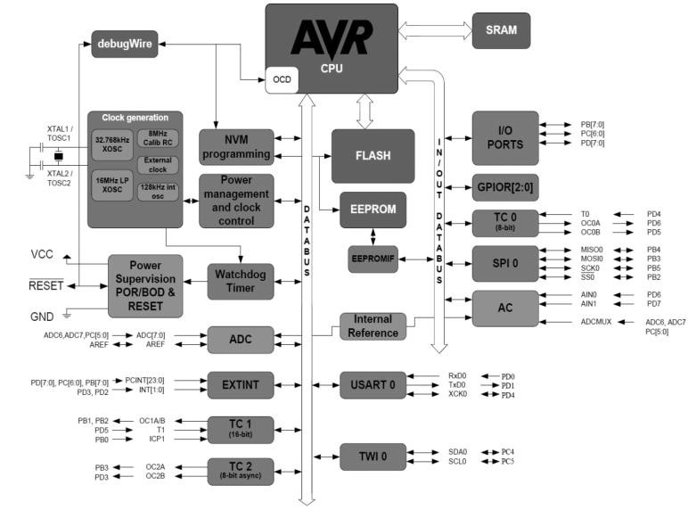

Fig 1.3 ATmega 328 block diagram

### ATmega328 Pin-out

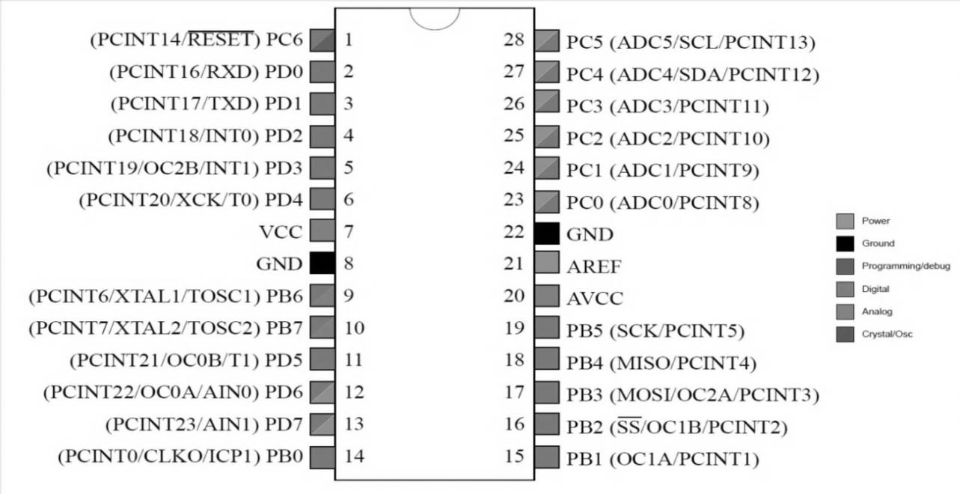

Fig 1.4 ATmega 328 Pin Diagram

### Device architecture

[Flash,](https://en.wikipedia.org/wiki/Flash_memory) [EEPROM,](https://en.wikipedia.org/wiki/EEPROM) and [SRAM](https://en.wikipedia.org/wiki/Static_random-access_memory) are all integrated onto a single chip, removing the need for external memory in most applications. Some devices have a parallel external bus option to allow adding additional data memory or memory-mapped devices. Almost all devices (except the smallest TinyAVR chips) have serial interfaces, which can be used to connect larger serial EEPROMs or flash chips.

### Program memory

Program instructions are stored in [non-volatile](https://en.wikipedia.org/wiki/Non-volatile) [flash memory.](https://en.wikipedia.org/wiki/Flash_memory) Although the [MCUs](https://en.wikipedia.org/wiki/Microcontroller_unit) are 8-bit, each instruction takes one or two 16-bit words.

The size of the program memory is usually indicated in the naming of the device itself (e.g., the ATmega64x line has 64 kB of flash, while the ATmega32x line has 32 kB).

There is no provision for off-chip program memory; all code executed by the AVR core must reside in the on-chip flash. However, this limitation does not apply to the AT94 FPSLIC AVR/FPGA chips.

**Internal data memory**

The data [address space](https://en.wikipedia.org/wiki/Address_space) consists of the [register file,](https://en.wikipedia.org/wiki/Register_file) I/O registers, and [SRAM.](https://en.wikipedia.org/wiki/Static_random-access_memory)

### Internal registers

The AVRs have 32 [single-byte](https://en.wikipedia.org/wiki/Byte) [registers](https://en.wikipedia.org/wiki/Processor_register) and are classified as 8-bit RISC devices.

In the tinyAVR and megaAVR variants of the AVR architecture, the working registers are mapped in as the first 32 memory addresses (000016–001F16), followed by 64 I/O registers

(002016–005F16). In devices with many peripherals, these registers are followed by 160

“extended I/O” registers, only accessible as [memory-mapped I/O](https://en.wikipedia.org/wiki/Memory-mapped_I/O) (006016–00FF16). Actual SRAM starts after these register sections, at address 006016 or, in devices with

“extended I/O”, at 010016.

Even though there are separate addressing schemes and optimized opcodes for accessing the register file and the first 64 I/O registers, all can still be addressed and manipulated as if they were in SRAM.

The very smallest of the tinyAVR variants use a reduced architecture with only 16 registers (r0 through r15 are omitted) which are not addressable as memory locations. I/O memory begins at address 000016, followed by SRAM. In addition, these devices have slight deviations from the standard AVR instruction set. Most notably, the direct load/store instructions (LDS/STS) have been reduced from 2 words (32 bits) to 1 word (16 bits), limiting the total direct addressable memory (the sum of both I/O and SRAM) to 128 bytes. Conversely, the indirect load instruction's (LD) 16-bit address space is expanded to also include non-volatile memory such as Flash and configuration bits; therefore, the Load Program Memory instruction is unnecessary and omitted.

In the XMEGA variant, the working register file is not mapped into the data address space; as such, it is not possible to treat any of the XMEGA's working registers as though they were SRAM. Instead, the I/O registers are mapped into the data address space starting at the very beginning of the address space. Additionally, the amount of data address space dedicated to I/O registers has grown substantially to 4096 bytes (000016–0FFF16). As with previous generations, however, the fast I/O manipulation instructions can only reach the first 64 I/O register locations (the first 32 locations for bitwise instructions). Following the I/O registers, the XMEGA series sets aside a 4096 byte range of the data address space, which can be used optionally for mapping the internal EEPROM to the data address space (100016–1FFF16). The actual SRAM is located after these ranges, starting at 200016.

### GPIO ports

Each [GPIO](https://en.wikipedia.org/wiki/GPIO) port on a tiny or mega AVR drives up to eight pins and is controlled by three 8-bitRegisters: DDR*x*, PORT*x* and PIN*x*, where *x* is the port identifier.

DDR*x*: Data Direction Register configures the pins as either inputs or outputs.

PORT*x*: Output port register. Sets the output value on pins configured as outputs. Enables or disables the [pull-up resistor](https://en.wikipedia.org/wiki/Pull-up_resistor) on pins configured as inputs.

PIN*x*: Input register, used to read an input signal. On some devices (but not all, check the datasheet), this register can be used for pin toggling: writing a logic one to a PIN*x*bit toggles the corresponding bit in PORT*x*, irrespective of the setting of the DDR*x* bit. xmegaAVR have additional registers for push/pull, totem-pole and pull-up configurations.

### EEPROM

Almost all AVR microcontrollers have internal [EEPROM](https://en.wikipedia.org/wiki/EEPROM) for semi-permanent data storage. Like flash memory, EEPROM can maintain its contents when electrical power is removed. In most variants of the AVR architecture, this internal EEPROM memory is not mapped into the MCU's addressable memory space. It can only be accessed the same way an external peripheral device is, using special pointer registers and read/write instructions, which makes EEPROM access much slower than other internal RAM.

However, some devices in the Secure AVR (AT90SC) family use a special EEPROM mapping to the data or program memory, depending on the configuration. The XMEGA family also allows the EEPROM to be mapped into the data address space.

Since the number of write to EEPROM is not unlimited — Atmel specifies 100,000 write cycles in their datasheets — a well-designed EEPROM write routine should compare the contents of an EEPROM address with desired contents and only perform an actual write if the contents need to be changed.

Note that erase and write can be performed separately in many cases, byte-by-byte, which may also help prolong life when bits only need to be set to all 1s (erase) or selectively cleared to 0s (write).

### Program execution

Atmel's AVRs have a two-stage, single-level [pipeline](https://en.wikipedia.org/wiki/Pipeline_(computing)) design. This means the next machine instruction is fetched as the current one is executing. Most instructions take just one or two clock cycles, making AVRs relatively fast among [eight-bit](https://en.wikipedia.org/wiki/Eight-bit) microcontrollers.

The AVR processors were designed clock speed to be optimized with the efficient execution of [compiled](https://en.wikipedia.org/wiki/Compiler) [C](https://en.wikipedia.org/wiki/C_(programming_language)) code in mind and have several built-in pointers for the task.

### MCU speed

The AVR line can normally support clock speeds from 0 to 20 MHz, with some devices reaching 32 MHz Lower-powered operation usually requires a reduced clock speed. All recent (Tiny, Mega, and Xmega, but not 90S) AVRs feature an on-chip oscillator, removing the need for external clocks or resonator circuitry. Some AVRs also have a system clock prescaler that can divide down the system clock by up to 1024. This prescaler can be reconfigured by software during run-time, allowing the.

Since all operations (excluding multiplication and 16-bit add/subtract) on registers R0–R31 are single-cycle, the AVR can achieve up to 1 [MIPS](https://en.wikipedia.org/wiki/Million_instructions_per_second) per MHz, i.e. an 8 MHz processor can achieve up to 8 MIPS. Loads and stores to/from memory take two cycles, branching takes two cycles. Branches in the latest "3-byte PC" parts such as ATmega2560 are one cycle slower than on previous devices.

### Development

AVRs have a large following due to the free and inexpensive development tools available, including reasonably priced development boards and free development software. The AVRs are sold under various names that share the same basic core, but with different peripheral and memory combinations. Compatibility between chips in each family is fairly good, although I/O controller features may vary.

See [external links](https://en.wikipedia.org/wiki/Atmel_AVR#External_links) for sites relating to AVR development.

### Features

Current AVRs offer a wide range of features:

1. Multifunction, bi-directional general-purpose I/O ports with configurable, built-in [pull-up resistors](https://en.wikipedia.org/wiki/Pull-up_resistor)
2. Multiple internal oscillators, including RC oscillator without external parts
3. Internal, self-programmable instruction [flash memory](https://en.wikipedia.org/wiki/Flash_memory) up to 256 kB (384 kB on XMega)
4. [In-system programmable](https://en.wikipedia.org/wiki/In-system_programming) using serial/parallel low-voltage proprietary interfaces or [JTAG](https://en.wikipedia.org/wiki/JTAG)
5. Optional boot code section with independent lock bits for protection
6. On-chip debugging (OCD) support through JTAG or [debugWIRE](https://en.wikipedia.org/wiki/DebugWIRE) on most devices
7. The JTAG signals (TMS, TDI, TDO, and TCK) are multiplexed on [GPIOs.](https://en.wikipedia.org/wiki/General_Purpose_Input/Output) These pins can be configured to function as JTAG or GPIO depending on the setting of a fuse bit, which can be programmed via ISP or HVSP. By default, AVRs with JTAG come with the JTAG interface enabled.
8. [debugWIRE](https://en.wikipedia.org/wiki/DebugWIRE) uses the /RESET pin as a bi-directional communication channel to access onchip debug circuitry. It is present on devices with lower pin counts, as it only requires one pin.
9. Internal data [EEPROM](https://en.wikipedia.org/wiki/EEPROM) up to 4 kB
10. Internal [SRAM](https://en.wikipedia.org/wiki/Static_random-access_memory) up to 16 kB (32 kB on XMega)
11. External 64 kB little endian data space on certain models, including the Mega8515 and Mega162.
12. The external data space is overlaid with the internal data space, such that the full 64 kB address space does not appear on the external bus and accesses to e.g. address 010016 will access internal RAM, not the external bus.
13. In certain members of the XMega series, the external data space has been enhanced to support both SRAM and SDRAM. As well, the data addressing modes have been expanded to allow up to 16 MB of data memory to be directly addressed.
14. AVRs generally do not support executing code from external memory. Some [ASSPs](https://en.wikipedia.org/wiki/Application-specific_standard_product) using the AVR core do support external program memory.
15. 8-bit and 16-bit timers
16. [PWM](https://en.wikipedia.org/wiki/Pulse-width_modulation) output (some devices have an enhanced PWM peripheral which includes a deadtime generator)
17. [Input capture](https://en.wikipedia.org/wiki/Input_capture) that record a time stamp triggered by a signal edge
18. Analog comparator
19. 10 or 12-bit [A/D converters,](https://en.wikipedia.org/wiki/Analog-to-digital_converter) with multiplex of up to 16 channels
20. 12-bit [D/A converters](https://en.wikipedia.org/wiki/Digital-to-analog_converter)
21. A variety of serial interfaces, including
22. [I²C](https://en.wikipedia.org/wiki/I%C2%B2C) compatible Two-Wire Interface (TWI)
23. Synchronous/asynchronous serial peripherals ([UART/](https://en.wikipedia.org/wiki/Universal_asynchronous_receiver/transmitter)USART) (used with [RS-232,](https://en.wikipedia.org/wiki/RS-232) [RS485,](https://en.wikipedia.org/wiki/RS-485) and more)
24. [Serial Peripheral Interface Bus](https://en.wikipedia.org/wiki/Serial_Peripheral_Interface_Bus) (SPI)
25. Universal Serial Interface (USI): a multi-purpose hardware communication module that can be used to implement an SPI, I2C or UART interface.
26. [Brownout](https://en.wikipedia.org/wiki/Brownout_(electricity)) detection
27. [Watchdog timer](https://en.wikipedia.org/wiki/Watchdog_timer) (WDT)
28. Multiple power-saving sleep modes
29. Lighting and motor control ([PWM-](https://en.wikipedia.org/wiki/Pulse-width_modulation)specific) controller models
30. [CAN](https://en.wikipedia.org/wiki/Controller_area_network) controller support
31. [USB](https://en.wikipedia.org/wiki/Universal_Serial_Bus) controller support
32. Proper full-speed (12 Mbit/s) hardware & Hub controller with embedded AVR.
33. [Ethernet](https://en.wikipedia.org/wiki/Ethernet) controller support
34. [LCD](https://en.wikipedia.org/wiki/Liquid_crystal_display) controller support
35. Low-voltage devices operating down to 1.8 V (to 0.7 V for parts with built-in DC–DC up converter)
36. Pico Power devices
37. [DMA](https://en.wikipedia.org/wiki/Direct_memory_access) controllers and "event system" peripheral communication.
38. Fast cryptography support for [AES](https://en.wikipedia.org/wiki/Advanced_Encryption_Standard) and [DES](https://en.wikipedia.org/wiki/Data_Encryption_Standard)

## 1.2.4 Programming interfaces

There are many means to load program code into an AVR chip. The method to program AVR chips varies from AVR family to family. Most of the methods described below use the RESET line to enter programming mode. In order to avoid the chip accidentally entering such mode, it is advised to connect a pull-up resistor between the RESET pin and the positive power supply. **ISP**

The [in-](https://en.wikipedia.org/wiki/In-system_programming)system programmin[g](https://en.wikipedia.org/wiki/In-system_programming) (ISP) programming method is functionally performed through [SPI,](https://en.wikipedia.org/wiki/Serial_Peripheral_Interface_Bus) plus some twiddling of the Reset line. As long as the SPI pins of the AVR are not connected to anything disruptive, the AVR chip can stay soldered on a [PCB](https://en.wikipedia.org/wiki/Printed_circuit_board) while reprogramming. All that is needed is a 6-pin connector and programming adapter. This is the most common way to develop with an AVR.

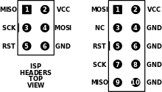

### Fig 1.5 ISP header 6 and 10-pin diagrams

The Atmel AVRISP mkII device connects to a computer's USB port and performs in-system programming using Atmel's software.

AVRDUDE (AVR Downloader/UploaDEr) runs on [Linux,](https://en.wikipedia.org/wiki/Linux) [FreeBSD,](https://en.wikipedia.org/wiki/FreeBSD) Windows, and [Mac OS X,](https://en.wikipedia.org/wiki/Mac_OS_X) and supports a variety of in-system programming hardware, including Atmel AVRISP mkII, Atmel JTAG ICE, older Atmel serial-port based programmers, and various third-party and "do-it-yourself" programmers.

**Bootloader:** Microcontrollers are usually programmed through a [programmer](https://www.arduino.cc/en/Hacking/Programmer) unless you have a piece of firmware in your microcontroller that allows installing new firmware without the need of an external programmer. This is called a bootloader.

Most AVR models can reserve a [boot loader](https://en.wikipedia.org/wiki/Bootloader) region, 256 Byte to 4 KB, where reprogramming code can reside. At reset, the boot loader runs first and does some userprogrammed determination whether to re-program or to jump to the main application. The code can re-program through any interface available, or it could read an encrypted binary through an Ethernet adapter like [PXE.](https://en.wikipedia.org/wiki/Preboot_Execution_Environment)

Optiboot Boot loader is a Small and Fast Boot loader used for Arduino and other Atmel AVR chips.

### ROM

AVRs are available with a factory mask-ROM rather than flash for program memory. Because of the large up-front cost and minimum order quantity, a mask-ROM is only cost-effective for high-production runs. **Debugging interfaces**

The AVR offers several options for debugging, mostly involving on-chip debugging while the chip is in the target system.

### Debug WIRE

[Debug WIRE](https://en.wikipedia.org/wiki/DebugWIRE) is Atmel's solution for providing on-chip debug capabilities via a single microcontroller pin. It is particularly useful for lower pin count parts which cannot provide the four "spare" pins needed for JTAG. The JTAGICE mkII, mkIII and the AVR Dragon support debug WIRE. Debug WIRE was developed after the original JTAGICE release, and now clones support it.

### JTAG

The Joint Test Action Group ([JTAG)](https://en.wikipedia.org/wiki/JTAG) feature provides access to on-chip debugging functionality while the chip is running in the target system. JTAG allows accessing internal memory and registers, setting breakpoints on code, and single-stepping execution to observe system behavior.

**1.3 Arduino IDE:**

**1.3.1 Arduino IDE:** Arduino IDE, the piece of software you run on your computer. You use the IDE to create a sketch (a little computer program) that you upload to the Arduino board.

The sketch tells the board what to do.

**Features:**

1. **Cross-platform** - The Arduino Software (IDE) runs on Windows, Macintosh OSX, and Linux operating systems. Most microcontroller systems are limited to Windows.
2. **Simple, clear programming environment** - The Arduino Software (IDE) is easy-to-use for beginners, yet flexible enough for advanced users to take advantage of as well. For teachers, it's conveniently based on the Processing programming environment, so students learning to program in that environment will be familiar with how the Arduino IDE works.
3. **Open source and extensible software** - The Arduino software is published as open source tools, available for extension by experienced programmers. The language can be expanded through C++ libraries, and people wanting to understand the technical details can make the leap from Arduino to the AVR C programming language on which it's based. Similarly, you can add AVR-C code directly into your Arduino programs if you want to.

**Sketch:**

A *sketch* is a program written with the Arduino IDE. Sketches are saved on the development computer as text files with the file extension **.ino**. Arduino Software (IDE) pre-1.0 saved sketches with the extension **.pde**.

The programming cycle on Arduino is basically as follows:

**»** Plug your board into a USB port on your computer.

**»** Write a sketch that will bring the board to life.

**»** Upload this sketch to the board through the USB connection and wait a couple of seconds for the board to restart.

**»** The board executes the sketch that you wrote.

**1.3.2 Arduino C/C++ program consists of two main functions:**

|  |
| --- |
| setup() |

|  |
| --- |
| main() |

* : This function is called once when a sketch starts after power-up or reset. It is used to initialize variables, input and output pin modes, and other libraries needed in the sketch. It is analogous to the function .

|  |
| --- |
| while(1) |

* loop(): After setup() function exits (ends), the loop() function is executed repeatedly in the main program. It controls the board until the board is powered off or is reset. It is analogous to the function

### Special symbols

Arduino includes a number of symbols to delineate lines of code, comments, and blocks of code.

**; (semicolon)** every instruction (line of code) is terminated by a semicolon. This syntax lets you format the code freely. You could even put two instructions on the same line, as long as you separate them with a semicolon. (However, this would make the code harder to read.) Example: **delay(100); {} (curly braces)**

This is used to mark blocks of code. For example, when you write code for the *loop()* function, you have to use curly braces before and after the code.

Example: void loop() {

Serial.println("MSBTE");

}

### C/Arduino

These are portions of text ignored by the Arduino processor, but are extremely useful to remind yourself (or others) of what a piece of code does.

There are two styles of comments in Arduino:

// single-line: this text is ignored until the end of the line

/* multiple-line: you can write a comments in here*/

### Constants

Arduino includes a set of predefined keywords with special values. HIGH and LOW are used, for example, when you want to turn on or off an Arduino pin. INPUT and OUTPUT are used to set a specific pin to be either and input or an output true and false indicate exactly what their names suggest: the truth or falsehood of a condition or expression.

### Variables

Variables are named areas of the Arduino’s memory where one can store data that one can use and manipulate in the sketch. As the name suggests, they can be changed as many times as one like . Because Arduino is a very simple processor, when one declare a variable that have to specify its type. This means telling the processor the size of the value one want to store. Here are the *data types* that are available: Boolean Can has one of two values: true or false. Character data type holds a single character, such as A. Like any computer, Arduino stores it as a number, even though one see text. When chars are used to store numbers, they can hold values from –128 to 127.

### Control Structures

Arduino includes keywords for controlling the logical flow of sketch. **if . . . else**

This structure makes decisions in your program. *If* must be followed by a question specified as an expression contained in parentheses. If the expression is true, whatever follows will be executed. If it’s false, the block of code following else will be executed. It’s possible to use just *if* without providing an *else* clause.

Example:

if (val == 1) { digitalWrite(LED,HIGH); else

digitalWrite(LED,LOW);

### } for

Lets you repeat a block of code a specified number of times.

Example:

for (int i = 0; i < 10; i++) {

Serial.print("MSBTE");

}

### switch case

The *if* statement is like a fork in the road for your program. *switch case* is like a massive roundabout. It lets your program take a variety of directions depending on the value of a variable. It’s quite useful to keep your code tidy as it replaces long lists of *if* statements. Example:

switch(sensorValue) { case 23: digitalWrite(13,HIGH);

break; case 46: digitalWrite(12,HIGH);

break;

default: // if nothing matches this is executed

digitalWrite(12,LOW); digitalWrite(13,LOW);

### } while

Similar to *if*, this executes a block of code while a certain condition is true.

Example:

// blink LED while sensor is below 512 sensorValue = analogRead(1); while (sensorValue< 512) { digitalWrite(13,HIGH); delay(100); digitalWrite(13,HIGH); delay(100);

sensorValue = analogRead(1);

}

### do . . . while

Just like *while*, except that the code is run just before the condition is evaluated. This structure is used when you want the code inside your block to run at least once before you check the condition.

Example:

do {

digitalWrite(13,HIGH); delay(100); digitalWrite(13,HIGH); delay(100); sensorValue = analogRead(1); } while (sensorValue< 512);

### Arithmetic and formulas

You can use Arduino to make complex calculations using a special syntax +, – and multiplication is represented with an * and division with a /.

There is an additional operator called “modulo” (%), which returns the remainder of an integer division. You can use as many levels of parentheses as necessary to group expressions. Contrary to what you might have learned in school, square brackets and curly brackets are reserved for other purposes (array indexes and blocks, respectively). Examples: a = 2 + 2;

light = ((12 * sensorValue) - 5 ) / 2;

remainder = 3 % 2; // returns 2 because 3 / 2 has remainder 1 **Comparison Operators**

To specify or test conditions *if*, *while*, and *for* statements following operators are used: == equal to

!= not equal to

<less than

>greater than

<= less than or equal to

>= greater than or equal to

### Boolean Operators

These are used when you want to combine multiple conditions. For example,if you want to check whether the value coming from a sensor is between 5and 10, you would write: if ((sensor => 5) && (sensor <=10))

There are three operators: and, represented with &&; or, represented with ||; and finally not, represented with !.

### Input and output functions

Arduino includes functions for handling input and output. You’ve already seen some of these in the example programs throughout the book.

### pinMode(pin, mode)

Reconfigures a digital pin to behave either as an input or an output.

Example:

pinMode(7,INPUT); // turns pin 7 into an input

### digitalWrite(pin, value)

Turns a digital pin either on or off. Pins must be explicitly made into an output using *pinMode* before *digitalWrite* will have any effect.

Example:

digitalWrite(8,HIGH); // turns on digital pin 8

### intdigitalRead(pin)

Reads the state of an input pin, returns HIGH if the pin senses some voltage or LOW if there is no voltage applied.

Example:

val = digitalRead(7); // reads pin 7 into val

### intanalogRead(pin)

Reads the voltage applied to an analog input pin and returns a number between 0 and 1023 that represents the voltages between 0 and 5 V.

Example:

val = analogRead(0); // reads analog input 0 into val

### analogWrite(pin, value)

Changes the PWM rate on one of the pins marked PWM.*pin* may be 11,10,9, 6, 5, 3. *Value* may be a number between 0 and 255 that represents the scale between 0 and 5 V output voltages. Example:

analogWrite(9,128); // Dim an LED on pin 9 to 50%

### shiftOut(dataPin, clockPin, bitOrder, value)

Sends data to a *shift register*, devices that are used to expand the number of digital outputs. This protocol uses one pin for data and one for clock. *Bit Order* indicates the ordering of bytes (least significant or most significant) and *value* is the actual byte to be sent out.

Example:

shiftOut(dataPin, clockPin, LSBFIRST, 255);

unsigned long pulseIn(pin, value)

Measures the duration of a pulse coming in on one of the digital inputs. This is useful, for example, to read some infrared sensors or accelerometers that output their value as pulses of changing duration.

Example:

time = pulsein(7,HIGH); // measures the time the next

// pulse stays high

### Time functions

Arduino includes functions for measuring elapsed time and also for pausing the sketch. **unsigned long millis()**

Returns the number of milliseconds that have passed since the sketch started.

Example:

duration = millis()-lastTime; // computes time elapsed since "last Time" **delay(ms)**

Pauses the program for the amount of milliseconds specified.

Example:

delay(500); // stops the program for half a second **delayMicroseconds(us)**

Pauses the program for the given amount of microseconds.

Example:delayMicroseconds(1000); // waits for 1 millisecond

#### Table 1.3 Summery of Arduino Functions Used for I/O

|  |  |  |
| --- | --- | --- |
| **Function** | **Description Syntax** |  |
| **pinMode();** | Designate the pin as OUTPUT or INPUT | pinMode(pin#, mode); |
| **digitalWrite();** | Write a LOW or HIGH to a pin | digitalWrite(pin#, value); |
| **digitalRead();** | Read the status of pin | digitalRead(pin#); |
| **delay();** | Create a delay in millisecond | delay(ms); |

**1.4 Arduino Interfacing**:

**Key and LED Interfacing:**

Pushbuttons or switches connect two points in a circuit when you press them. This example turns on the built-in LED on pin 13 when you press the button.

Hardware

* Arduino Board
* Momentary button or Switch
* 1K ohm resistor
* hook-up wires
* breadboard

Circuit

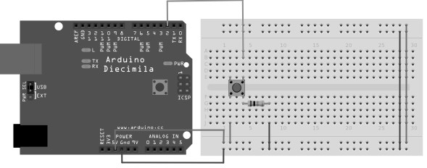

#### Fig 1.6 Interfacing of Push Button to Arduino board

|  |  |  |  |  |
| --- | --- | --- | --- | --- |
| pinMode() | , | digitalWrite() | , and | delay() |

Functions , which are provided by the internal libraries included in the IDE environment.

Connect three wires to the board. The first two, red and black, connect to the two long vertical rows on the side of the breadboard to provide access to the 5 volt supply and ground. The third wire goes from digital pin 2 to one leg of the pushbutton. That same leg of the button connects through a pull-down resistor (here 1K ohm) to ground. The other leg of the button connects to the 5 volt supply.

When the pushbutton is open (unpressed) there is no connection between the two legs of the pushbutton, so the pin is connected to ground (through the pull-down resistor) and we read a LOW. When the button is closed (pressed), it makes a connection between its two legs, connecting the pin to 5 volts, so that we read a HIGH.

You can also wire this circuit the opposite way, with a pullup resistor keeping the input HIGH, and going LOW when the button is pressed. If so, the behavior of the sketch will be reversed, with the LED normally on and turning off when you press the button.

If you disconnect the digital I/O pin from everything, the LED may blink erratically. This is because the input is "floating" - that is, it will randomly return either HIGH or LOW. That's why you need a pull-up or pull-down resistor in the circuit.

### Schematic

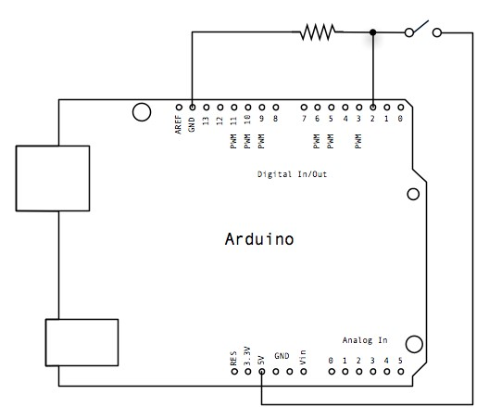

Fig 1.7Schematic of Push Button

|  |
| --- |
| /* Button  Turns on and off a light emitting diode (LED) connected to digital pin 13, when pressing a pushbutton attached to pin 2.  */  // constants won't change. They're used here to set pin numbers: const int buttonPin = 2; // the number of the pushbutton pin const int ledPin = 13; // the number of the LED pin    // variables will change: int buttonState = 0; // variable for reading the pushbutton status void setup() {  // initialize the LED pin as an output: pinMode(ledPin, OUTPUT);  // initialize the pushbutton pin as an input:  pinMode(buttonPin, INPUT);  } void loop() {  // read the state of the pushbutton value:  buttonState = digitalRead(buttonPin);  // check if the pushbutton is pressed. If it is, the buttonState is HIGH:  if (buttonState == HIGH) { // turn LED on:  digitalWrite(ledPin, HIGH);  } else {  // turn LED off:  digitalWrite(ledPin, LOW);  }  } |

**Relay Interfacing:**

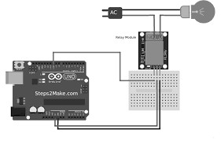

Fig 1.8 Interfacing of Relay to Arduino board

|  |
| --- |
| //Relay is turned on for 5 seconds and then off. void setup()  {  // Initialise the Arduino data pins for OUTPUT  pinMode(RELAY, OUTPUT);  }  void loop()  {  digitalWrite(RELAY,LOW); // Turns ON Relays delay(5000); // Wait 5 seconds  digitalWrite(RELAY,HIGH); // Turns Relay Off  } |

**DC motor Interfacing:**

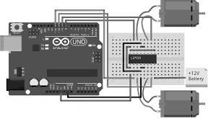

Fig 1.9 Interfacing of DC motor to Arduino board

A direct current, or DC, motor is the most common type of motor. DC motors normally have just two leads, one positive and one negative. If you connect these two leads directly to a battery, the motor will rotate. If you switch the leads, the motor will rotate in the opposite direction.

To control the direction of the spin of DC motor, without changing the way that the leads are connected, you can use a circuit called an H-Bridge. An H bridge is an electronic circuit that can drive the motor in both directions. H-bridges are used in many different applications, one of the most common being to control motors in robots. It is called an Hbridge because it uses four transistors connected in such a way that the schematic diagram looks like an "H."

Since we will be controlling only one motor in this tutorial, we will connect the Arduino to IN1 (pin 5), IN2 (pin 7), and Enable1 (pin 6) of the L298 IC. Pins 5 and 7 are digital, i.e. ON or OFF inputs, while pin 6 needs a pulse-width modulated (PWM) signal to control the motor speed. IN1 pin of the L298 IC is connected to pin 8 of the Arduino while IN2 is connected to pin 9. These two digital pins of Arduino control the direction of the motor. The EN A pin of IC is connected to the PWM pin 2 of Arduino. This will control the speed of the motor.

1. Connect 5V and ground of the IC to 5V and ground of Arduino.
2. Connect the motor to pins 2 and 3 of the IC.
3. Connect IN1 of the IC to pin 8 of Arduino.
4. Connect IN2 of the IC to pin 9 of Arduino.
5. Connect EN1 of IC to pin 2 of Arduino.
6. Connect SENS A pin of IC to the ground.
7. Connect the Arduino using Arduino USB cable and upload the program to the Arduino using Arduino IDE software or [Arduino Web Editor.](https://maker.pro/arduino/tutorial/getting-started-with-the-arduino-web-editor)
8. Provide power to the Arduino board using power supply, battery or USB cable. The motor should now run first in the clockwise (CW) direction for 3 seconds and then counter-clockwise (CCW) for 3 seconds.

Code:

|  |
| --- |
| constintpwm = 2 ; //initializing pin 2 as pwm constint in_1 = 8 ; constint in_2 = 9 ;  //For providing logic to L298 IC to choose the direction of the DC motor void setup()  {  pinMode(pwm,OUTPUT) ; //we have to set PWM pin as output  pinMode(in_1,OUTPUT) ; //Logic pins are also set as output pinMode(in_2,OUTPUT) ;  }  void loop()  {  //For Clock wise motion , in_1 = High , in_2 = Low digitalWrite(in_1,HIGH) ; digitalWrite(in_2,LOW) ; analogWrite(pwm,255) ;  /*setting pwm of the motor to 255 we can change the speed of rotation by changing pwm input but we are only using arduino so we are using highest value to driver the motor */  //Clockwise for 3 secs delay(3000) ; //For brake  digitalWrite(in_1,HIGH) ; |
| digitalWrite(in_2,HIGH) ; delay(1000) ;  //For Anti Clock-wise motion - IN_1 = LOW, IN_2 = HIGH digitalWrite(in_1,LOW) ; digitalWrite(in_2,HIGH) ; delay(3000) ; //For brake digitalWrite(in_1,HIGH) ; digitalWrite(in_2,HIGH) ; delay(1000) ; } |

## 1.5 ARM

### 1.5.1 Introduction

ARM designs microprocessor technology that lies at the heart of advanced digital products, from mobile phones and digital cameras to games consoles and automotive systems, and is leading intellectual property (IP) provider of high-performance, low-cost, power-efficient RISC processors, peripherals, and system-on-chip (SoC) designs through involvement with organizations such as the Virtual Socket Interface Alliance (VSIA) and Virtual Component Exchange (VCX). ARM also offers design and software consulting services. ARM's architecture is compatible with all four major platform operating systems: Symbian OS, Palm OS, Windows CE, and Linux. As for software, ARM also works closely with with its partners to provide optimized solutions for existing market segments. These benefits are making the ARM company a complete solution provider.

With over forty partners licensed to use its architecture, ARM enables original equipment

Manufacturers (OEM) to realize an accelerated time-to-market through complete product offerings, such as Prime Cell Peripherals, embedded software IP, development tools, training, and support The Company offers a complete solution that is essential to the manufacturing process. Although ARM does not manufacture processors itself, ARM licenses its cores to semi-conductor manufacturers to be integrated into ASIC standards and then the company in using test chips manufactured by its partners to measure and validate the functionality of the core.

ARM is able to accelerate OEM time-to-market by capitalizing on its architecture. By providing the IP and supporting services, customers can gain a jump on their design cycle and obtain a competitive edge in their targeted market segment. At that point, the architecture is portable to further product generations or applications as all code creation is directly compatible with any future architecture produced by ARM.

ARM's Global Technology Partner Network is the largest in the industry, spanning from

Semiconductor manufacturers to distributors. ARM has worked diligently to ensure that the partnerships provide proven solutions in real-time operating systems (RTOS), EDA tools, development systems, applications software, and design consulting, all built around the ARM Architecture. The ARM Company is working to establish standards, not just within the company, but across the industry by taking advantage of leadership opportunities in the creation of standards. ARM is the industry standard embedded microprocessor architecture, and is a leader in low-power high performance cores. ARM also has a large partner network supporting the entire design and development cycle. ARM is a full-solutions provider, supporting a broad range of applications.

**1.5.2 Basic of ARM architecture:**

ARM architecture is not synonymous with the single organization. But there is certain commonality across the different variants.

#### **Basic ARM Organization**

It consists of register bank. It is connected to the ALU by two buses A and B. A is connected directly to ALU and B is connected through Barrel shifter. This Barrel shifter can actually preprocess the data which can come from one of this source registers; and the Barrel shifter can shift to the left, shift to the right or even rotate the data before it is fed to the ALU. Now, since all of these blocks i.e. ALU, Barrel shifter is also combinational circuit. So, the entire, all these operations that is operation that ALU carries out as well as operation that Barrel shifter carries out can take place in one cycle itself and that actually splits up to the operation execution speed.

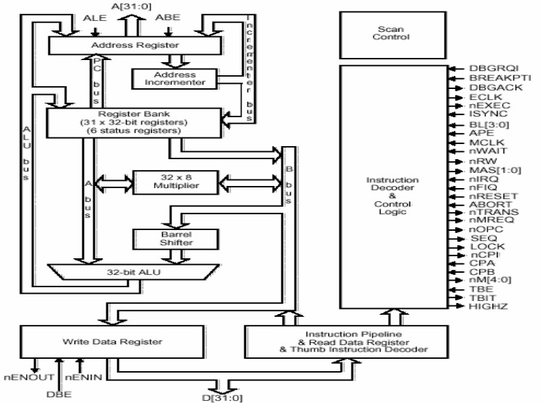

##### Fig 1.10 ARM7 TDMI Core Diagram

Register bank can generate the address also. In fact the PC address is, PC also is part of the register bank and that can generate the address. As well as the other register banks, can be made use of for generation for manipulation of address. Because registers are in a way symmetric they can have both address as well as the data and they can be operated in a symmetric way. The PC generates the address for the instruction.

Other operations can also be done using this registers. Instruction decodes and control provides a control signal. Address bus is 0 to 31 that means it is a 32 bit. Data buses are also 32 bits, so it is basically a 32 bit processor. It can operate on 32 bit operands and the addresses that it generates are also 32 bit. Register bank has a very prominent role.

All registers are 32 bits because data bus is 32 bit, operating at 32 bit operands as well as addresses are also 32 bits. There are 16 data registers in user mode and 2 data registers are visible.

User mode is a common operating mode. Used by user when running program on ARM. Data registers are typically r0 to r15 and in fact in ARM, all registers are refer to by r followed by a number. So, here we are talking about data registers r0 to r15 which are visible in the user mode. Out of these registers, 3 registers perform special function they are r13, r14 and r15. r13 is a stack pointer, so this stack pointer refers to the entry point on the stack and this is critical for implementation of a stack in the memory. r14 is a link register. This link register is a register where return address is put whenever a subroutine is called. A single link register is used and in this link register the return address is saved. Then r15 is the program counter and obviously the current instruction what is being executed will be pointed to by the content of r15.

Now, depending on the context registers r13 and r14 can also be used as general purpose registers. In addition there are 2 status registers. CPSR, (current program status register) and SPSR s (saved program status register). These are basically the status registers which are not data registers. So, here in this registers effectively the status of the current execution is being captured. In fact this status can include status of program as well as that of the processor. And when it is operating in 32 bit it is assume that all instructions are word aligned. That means all 32 bit instructions start at 32 bit boundary. And what does that imply, that implies that PC value is stored effectively in bits from 2 to 31, bit numbers 2 to 31, with bits 1, 0 effectively undefined or not really useful for referring to an instruction. Now, obviously this discussion refers to one fact that 32 bit address in ARM refers to byte locations. Each byte with associated with a unique address so, talking about 32 bit boundaries means effectively talking about what blocks of 4 bytes. So, if there is one instruction starting at location 0 then that instruction will occupy location 0, 1, 2 as well as 3. The next instruction would be located at 4 so, therefore these 2 bits, the least significant bits of PC that is r15 or in a way do not care for operations. So, that is why PC value is effectively stored in bits from 2 to 31.

Now, let us look at the status register CPSR. CPSR is- the current program status register; it has got a number of bits. Again it will be a 32 bit register; it is not that all bits are used at the same time. The condition code flags which occupy the higher that MSBs that is most significant bits in the status register; they are standard flags which reflect various arithmetic conditions. Negative flag results from ALU which is typically the most significant bit, it is associated with the most significant bit. If it is one then it can be interpreted as a negative result when we are doing signed arithmetic set, Z indicates 0, C is the carry and V is overflow. There is this sticky overflow flag; this is with reference to saturation arithmetic. There are two levels of interrupts. With Interrupt, disable bits.

So, user can enable or disable these two levels of interrupts by using these 2 bits. T bit indicates whether programmer is in thumb mode or not in thumb mode because when we actually have an embedded 16 bit processor into the 32 bit architecture, we shall be making use of this T bit to know whether operating in the thumb mode or ordinary 32 bit mode. And rests are mode bits and these mode bits really defined what is called the mode of processors operation. User can use about16 data registers, in program and normal operation and that is user mode. These modes are specified by these bits. Now, before going into these processor modes in detail, let us briefly look at this sticky overflow flag. What is saturation? Saturation means when we reach the maximum value or the minimum value because of an arithmetic operation which may have overflow or underflow.

Processor modes are either privileged or non-privileged mode. In a privileged mode, it is expected to have full read-write access to the CPSR. In a non-privileged mode only read access to the control field of CPSR but read-write access to the condition flags.

Now, try to understand this- what is the implication of these privileged and non- privileged modes. In a privileged mode what can happen actually, in a privileged modes as you can change the control bits that means you can have a full read as well as write access of the control bits. You can actually change the processor mode, you can enable, disable the interrupts. So, this is a privileged operation. In a non- privileged mode, these control fields can be simply read but cannot be changed, but the condition flags which can change because of an arithmetic operation would normally reflect the status of the arithmetic operation and that should be remain write enable even in non-privileged modes.

So, typically you will find that when we talk about these kind of operations, a typically user program is expected to run in a non- privileged mode because in user program is normally not expected to change the control bits.

And in a privileged mode typically you will expect the OS or the supervisory cell to run. Since we are targeting for ARM for more sophisticated applications, typically there would be an OS running in an ARM based system under which user programs are expected to execute. The OS is typically expected to be running in privileged mode and user applications running in non- privileged mode. In fact ARM has got 7 modes and these 7 modes can be now classified as privileged and non- privileged. In fact the privileged modes are abort, first interrupt request, supervisor system and another is undefined.

Now, privileged modes represent different scenarios. Abort is a mode when there is a failed attempt to access memory. This can happen for variety of reasons but this reasons we shall look at when we consider the memory architecture subsequently. But this is a particular mode in which the processor goes in when it detects that there is a failure to access the memory location.

The first interrupt request and interrupt request correspond to interrupt levels available on ARM. So, when a particular kind of interrupt occurs ARM processor goes into other first interrupt mode or interrupt request mode.

Supervisor mode is a state in which processor goes in after reset and generally it is a mode in which the OS kernel is supposed to operate because obviously when the processor is reset, the first thing that its excepted to execute is a operating system code and not user application of program. So, this is a supervisor mode in which the processor goes in when the reset happens. The other two privileged modes are system mode and another mode is called undefined. In a system mode, is a special version of user mode that allows full read-write access of CPSR. It is also targeted for supervisory applications; many of the OS routines can be configured to run in the system mode. The undefined mode, processer enters this undefined mode when it encounters an undefined instruction that means when you are trying to use an illegal op-code for undefined instruction, the instruction undefined for particular processor, and then it goes into an undefined.

So, it is found that these privileged modes are primarily targeted for OS handling of special error conditions as well as that of interrupts and user mode is a mode intended for running user applications. Now, these modes have got associated with them a very interesting capability to manage the registers.

ARM has got 37 registers in all and typically 20 registers are hidden from program at different times. They are not visible registers and they are called banked registers and this banked registers becomes available only when processors is in a particular mode. In fact processors modes other than system mode have a set of associated banked registers that are subset of these 16 registers that we have talked about in the user mode. These banked registers have one-to-one mapping with the user mode registers. So, what happens, let us look at this. Let us consider operation in user mode. In the user mode there are the 16 data registers which are available, and the current program which is getting executed, that status would get reflected in the CPSR register. Now, if the processor goes into some other mode, let us say that FIQ mode.

FIQ is first interrupt request; IRQ is interrupt request mode. Now, in an FIQ mode, what we will find that have got banked register r8, r9, r10, r11, r12 becoming available as well as r13 and r14.

What does that mean? These registers have got a one-to-one correspondence with the registers in the user mode that means effectively what is getting in a first interrupt mode, In other words, getting a fresh copy of r8 to r14.

Now, what does that imply? It implies that if programmer is having an interrupt service routine which is operating in FIQ that is which is basically serving in the interrupt, in the first interrupt mode, it can use r8, r9 to r14 without bothering about what happens to the original content of these registers.

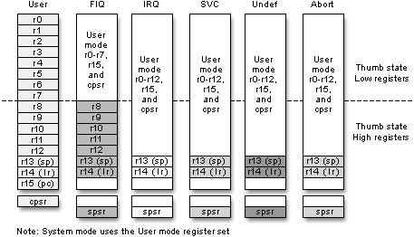

##### Fig 1.11 Register organization

**Register organization:** There are 37 total registers divided among seven different processor modes. Figure 1.11 shows the bank of registers visible in each mode. User mode, the only non-privileged mode, has the least number of total registers visible. It has no SPSR and limited access to the CPSR. FIQ and IRQ are the two interrupt modes of the CPU. SVC i.e Supervisor mode is the default mode of the processor on start up or reset. Undefined mode traps unknown or illegal instructions when they are passed through the pipeline. Abort mode traps illegal memory accesses as a result of fetching instructions or accessing data. Finally, system mode, which uses the user mode bank of registers, was introduced to provide an additional privileged mode when dealing with nested interrupts. Each additional mode offers unique registers that are available for use by exception handling routines. These additional registers are the minimum number of registers required to preserve the state of the processor, save the location in code, and switch between modes. FIQ mode, however, has an additional five banked registers to provide more flexibility and higher performance when handling critical interrupts. When the ARM core is in Thumb state, the registers banks are split into low and high register domains. The majority of instructions in Thumb state have a 3-bit register specifier. As a result, these instructions can only access the low registers in Thumb, R0 through R7. The high registers, R8 through R15, have more restricted use. Only a few instructions have access to these registers.

**TDMI: T**-D-M-I stands for

**T**humb, which is a 16-bit instruction, set extension to the 32-bit ARM architecture, referred as states of the processor.

"**D**" and "**I**" together comprise the on-chip debug facilities offered on all ARM cores.

These stand for the **D**ebug signals and Embedded**I**CE logic, respectively.

The “**M**” signifies the support for 64-bit results and an enhanced multiplier, resulting in higher performance. This multiplier is now standard on all ARMv4 architectures and above.

#### **Thumb 16-bit Instructions**

With growing code and data size, memory contributes to the system cost. The need to reduce memory cost leads to smaller code size and the use of narrower memory. Therefore ARM developed a modified instruction set to give market-leading code density for compiled standard C language. There is also the problem of performance loss due to using a narrow memory path, such as a 16-bit memory path with a 32-bit processor. The processor must take two memory access cycles to fetch an instruction or read and write data. To address this issue, ARM introduced another set of reduced 16-bit instructions labeled Thumb, based on the standard ARM 32-bit instruction set. For Thumb to be used, the processor must go through a change of state from ARM to Thumb in order to begin executing 16-bit code. This is because the default state of the core is ARM. Therefore, every application must have code at boot up that is written in ARM. If the application code is to be compiled entirely for Thumb, then the segment of ARM boot code must change the state of the processor. Once this is done, 16-bit instructions are fetched seamlessly into the pipeline without any result. It is important to note that the architecture remains the same. The instruction set is actually a reduced set of the ARM instruction set and only the instructions are 16-bit; everything else in the core still operates as 32-bit. An application code compiled in Thumb is 30% smaller on average than the same code compiled in ARM and normally 30% faster when using narrow 16-bit memory systems.

### 1.5.3 ARM7TDMI Processor Core

**Architecture version 4T:**

1. 3-stage pipeline
2. Unified bus architecture
3. 32-bit ARM ISA plus 16-bit Thumb extension
4. Forward compatible code
5. Embedded ICE on-chip debug
6. Hard Macrocell IP
7. Smallest Die Size: 0.53 mm2 on 0.18 μm process
8. Up to 110 MHz* on TSMC standard 0.18 μm
9. Industry leading 0.25 mW/MHz

The ARM7TDMI has a core based on the fourth version of the ARM architecture. This implementation uses a three stage pipeline - a standard fetch-decode-execute organization. It features a unified cache, as well as the Thumb extension permitting 32-bit and 16-bit operation. It is completely forward compatible, meaning that any code written for this core will be compatible with any new core releases, such as ARM9 or ARM10. This core also includes the on-chip debug extension discussed in the previous training module. The core is successful mainly because of the extremely small but high performance processor - slightly more than 70,000 transistors in all with extremely low power consumption.

The ARM7TDMI family is popular with applications where small die size, high performance, and low power consumption help reduce system costs, especially when the system does not require cache. Applications include cellular phones, MP3 players, and mass storage.

#### **ARM7TDMI applications**

The standard ARM7TDMI processor core is a 'hard' macrocell, which is to say that it is delivered as a piece of physical layout, customized to the appropriate process technology. The ARM7TDMI-S is a synthesizable version of the ARM7TDMI, delivered as a high-level language module which can be synthesized using any suitable cell library in the target technology. It is therefore easier to port to a new process technology than is the hard macrocell.

The synthesis process supports a number of optional variations on the processor core functionality. These include:

* Omitting the EmbeddedlCE cell;
* Replacing the full 64-bit result multiplier with a smaller and simpler multiplier that supports only the ARM multiply instructions that produce a 32-bit result. Either of these options will result in a smaller synthesized macrocell with reduced functionality. The full version is 50% larger and 50% less power-efficient than the hard macrocell.

The ARM7TDMI processor core has found many applications in systems with simple memory configurations, usually including a few kilobytes of simple on-chip RAM. A typical example is a mobile telephone handset (where the same chip usually incorporates sophisticated digital signal processing hardware and associated

#### **ARM9TDMI**

The ARM9TDMI core takes the functionality of the ARM7TDMI up to a significantly higher performance level. Like the ARM7TDMI (and unlike the ARMS) it includes support for the Thumb instruction set and an EmbeddedlCE module for on-chip debug support. The performance improvement is achieved by adopting a 5-stage pipeline to increase the maximum clock rate and by using separate instruction and data memory ports to allow an improved CPI (Clocks per Instruction - a measure of how much work a processor does in a clock cycle).

#### **ARM7TDMI and ARM9TDMI pipeline comparison**

The ARM7TDMI implements the Thumb instruction set by 'decompressing' Thumb instructions into ARM instructions using slack time in the ARM7 pipeline. The ARM9TDMI pipeline is much tighter and does not have sufficient slack time to allow Thumb instructions to be first translated into ARM instructions and then decoded; instead it has hardware to decode both ARM and Thumb instructions directly. The extra 'Memory' stage in the ARM9TDMI pipeline does not have any direct equivalent in the ARM7TDMI. Its function is performed by additional 'Execute' cycles that interrupt the pipeline flow. This interruption is an inevitable consequence of the single memory port used by the ARM7TDMI for both instruction and data accesses. During a data access an instruction fetch cannot take place. The ARM9TDMI avoids this pipeline interruption through the provision of separate instruction and data memories. The ARM9TDMI has a coprocessor interface which allows on-chip coprocessors for floatingpoint, digital signal processing or other special-purpose hardware acceleration requirements to be supported. (At the clock speeds it supports there is little possibility of off-chip coprocessors being useful.)

The EmbeddedlCE functionality in the ARM9TDMI core gives the same system-level debug features as that on the ARM7TDMI core, with the following additional features:

* Hardware single-stepping is supported.
* Breakpoints can be set on exceptions in addition to the address/data/control conditions supported by ARM7TDMI.

#### **ARM10TDMI**

Increased clock rate

The ARM10TDMI is the current high-end ARM processor core. Just as the ARM9TDMI delivers approximately twice the performance of the ARM7TDMI on the same process, the ARM10TDMI is positioned to operate at twice the performance of the ARM9TDMI. It is intended to deliver 400 Dhrystone 2.1 MIPS at 300 MHz on 0.25 urn CMOS technology. In order to achieve this level of performance, starting from the ARM9TDMI, two approaches have been combined:

1. The maximum clock rate has been increased.
2. The CPI (average number of Clocks per Instruction) has been reduced. **Resources**

|  |  |
| --- | --- |
| **Sr. No.** | **Website** |
| 1. | https://slideplayer.com/slide/8290583/ |
| 2. | https://www.arduino.cc/en/Guide/HomePage |
| 3. | <https://en.wikipedia.org/wiki/ARM_architecture> |
| 4. | http://www.microdigitaled.com |
| 5. | <https://www.youtube.com/watch?v=4VRtujwa_b8>  Lecture series by IIT professor shantanuchaudhary on ARM processor. |

**Sample Question:**

|  |  |
| --- | --- |
| **Sr. No.** | **Question** |
| 1. | Main processor chip in computers is   1. ASIC 2. ASSP 3. CPU 4. CPLD |
| 2. | ARM stands for _____________   1. Advanced Rate Machines 2. Advanced RISC Machines 3. Artificial Running Machines 4. Aviary Running Machines |
| 3. | The CISC stands for ___________.   1. Computer Instruction Set Compliment 2. Complete Instruction Set Compliment 3. Computer Indexed Set Components 4. Complex Instruction set computer |
| 4. | The GPIO stand for__________________.   1. General Purpose Inner Outer Propeller 2. General Purpose Input Output Pins 3. General Purpose Interested Old People 4. General Purpose Input Output Processor |
| 5. | The IDE stand for________________.   1. In Deep Environment 2. Integrated Development Environment 3. Internal Deep Escape 4. IDE |
| 6. | A program written with the IDE for Arduino is called _______.   1. IDE source 2. Sketch 3. Cryptography |

|  |  |
| --- | --- |
| **Sr. No.** | **Question** |
|  | D. Source code |
| 7. | Arduino IDE consists of 2 functions. What are they?   1. Build() and loop() 2. Setup() and build() 3. Setup() and loop() 4. Loop() and build and setup() |
| 8. | ALU of ARM7TDMI is_____bit.   1. 8 2. 32 3. 64 4. 10 |
| 9. | How many digital pins are there on the UNO board?   1. 14 2. 12 3. 16 4. 20 |
| 10. | Most of processors designed by ARM are   1. 16 bit 2. 32 bit 3. 64 bit 4. 8 bit |
| 11. | The function of link register in ARM7TDMI is__________   1. To store return address whenever subroutine is called 2. To store address of I/O device 3. Multiplex the address and data lines 4. Perform addition |
| 12. | The function of register r15 in ARM7TDMI is as   1. Program Counter 2. CPSR 3. SPSR 4. ALU |
| 13. | In the ARM Nomenclature **ARMxTDMI,** D and M stand for   1. Debug and Fast Multiplier units are present 2. Division and Multiplier units are present 3. Debugger and Multiplier units are not present 4. Division and Multiplier units are not present |
| 14. | The computer architecture aimed at reducing the time of execution of instructions is ________   1. CISC 2. RISC 3. ISA 4. ANNA |
| 15. | In CISC processor the nature of instruction size is   1. Fixed 2. Variable 3. Both A and B 4. None of the above |
| 16. | If the three stages of execution in pipelining are overlapped, how |

|  |  |
| --- | --- |
| **Sr. No.** | **Question** |
|  | would be the speed of execution?   1. Higher 2. Moderate 3. Lower 4. Unpredictable |
| 17. | In RISC Processors configuration status of control unit is_______.   1. Hardwired 2. Micro programmed 3. Both A and B 4. None of the above |
| 18. | A function is a series of programming statements that can be called by name. Which command is called once when the program starts: A. loop()   1. setup() 2. (output) 3. (input) |
| 19. | In ATmega328p ‘p’ refers to?   1. Production 2. Pico-Power 3. Peripheral 4. Programmable on chip |
| 20. | The throughput of a super scalar processor is _______   1. less than 1 2. 1 3. More than 1 4. Not Known |
| 21. | Each stage in pipelining should be completed within ____ cycle. A. 1   1. 2 2. 3 3. 4 |
| 22. | The main importance of ARM micro-processors is providing operation with ______   1. Low cost and low power consumption 2. Higher degree of multi-tasking 3. Lower error or glitches 4. Efficient memory management |
| 23. | In ARM processor when Interrupt occurs ARM processor goes into following mode   1. FIQ mode 2. Abort mode 3. Supervisor mode 4. Undefined mode |
| 24. | The function of Barrel shifter is   1. Shift Operation in same instruction cycle 2. Shift operation in 2 instruction cycle 3. Shift operation in 4 instruction cycle 4. None of the above |
| **Sr. No.** | **Question** |
| 25. | Evaluate the following statements   1. R13 is traditionally used as the stack pointer and stores the head of the stack in the current processor mode 2. R14 is the link register where the core puts the return address on executing a subroutine 3. R15 is the program counter and contains the address of the next instruction to be fetched A. All the options are true 4. I and II are true 5. II and III are true 6. I and III are true |
| 26. | When the processor is executing simple data processing instructions, the pipeline enables one instruction to be completed every clock cycle, this is also called as _____   1. Throughput 2. Latency 3. Execution 4. None of the above |
| 27. | It starts with a /* and continues until a */ what does this do?   1. Loads a sketch 2. Makes comments 3. Compiles quicker 4. Makes stars appear |
| 28. | The function used to execute one or many statements, multiple time_______.   1. setup() 2. loop() 3. (input) 4. (output) |
| 29. | Default boot loader for the Arduino UNO is_______   1. Optibootloader 2. AIR-boot 3. Bare box 4. GAG |
| 30. | Select proper microcontroller used in Arduino UNO.   1. ATmega328p 2. ATmega2560 3. ATmega32114 4. AT91SAM3x8E |

# UNIT 2 Recent Electronic Components

## Teaching Hrs: 8 Marks 10

**Course Outcome-** Suggest the relevant components for the emerging application/s.

**To attain above course outcome candidate must able to :** a. State features of given component.

1. Explain the advantages of given component.
2. Explain the concept of SMD and soldering method.

**Unit focus on following major points:**

* 1. **Flexible PCB**: Features and Applications
  2. **Battery** [Li-ion, nuclear] :Concepts and Applications
  3. **Memristor, Organic LED**: Concepts, Features and Applications
  4. **Surface Mount Device**: Concepts, advantages, Applications and Reflow soldering method.

## Introduction

The electrical and physical characteristics of electronics components and technology govern electronic circuit features and its applications. Due to advances in material science and new device fabrication technology, various emerging appliances and circuit designs are possible to design. Desirable features of electronics components suitable for emerging applications are

* Miniature size
* Lower power consumption
* Leadless mounting
* Higher operating speed
* Multi-function operation
* Multi- level compatibility
* Higher noise immunity
* Higher operating temperature range
* Least Radiation
* Higher operating frequency
* Reliability
* Higher operating life
* For Display device : Brighter multi color , flexible nature and size
* For battery: Smaller size ,Higher rating , fast charging , maintenance free operation

Modern electronics consumer and industrial systems demand high component density and multilayer electrical interconnectivity. Introduction of Flexible Printed Circuits (FPC) is fulfilling the requirements. FPCs offer a number of clear system-level benefits over rigid Printed Circuit Board (PCB) technology such as Lighter weight, Lower thickness, Dynamically bendable, Accessible for 3D interconnection assembly, More space saving and higher freedom on electronic design and mechanical design.

Exponential market growth in mobile electronics such as smart phones, Personal Data Assistance (PDAs), notebooks and portable wearable gadgets is pushing rigid circuitry beyond its current limits. Today Flexible printed circuits are found in variety of applications from automobiles, VCR's, camcorders, portable phones and SLR cameras to sophisticated military and avionics systems.

This chapter will discuss the overview of new generation Flexible Printed Circuits and Flexible PCB making technology , latest trends in battery , Optical LEDS, concept of the 4th fundamental electric circuit component named as Memristor and the concept and advantages of Surface Mount Devices and Reflow soldering method. **2.1 Flexible PCB**

Flexible-printed circuit technology has a well-established history that goes back nearly one hundred years. However, its commercial use is prominently observed within the last few decades, the advance of electronic systems is evidence of a major digital technology revolution. Today our homes with cordless phones and digital TVs, cars equipped with hands-free communications and telematics, and business world with notebook computers and mobile personal data assistants (PDAs) need to replace costly and increasingly complicated wired assemblies. This has become possible due to the flexible circuits which offer a much simpler and more cost-effective interconnection method. Flexible circuits provide enormous design freedoms for electronic engineers and product designers. As the demands of modern electronic systems call for increasing functionality, greater circuit density, higher connectivity, better environmental performance, and all at lower cost, flexible circuitry can be the ultimate answer for the twenty-first century electronics.

The heart of FPC is the flexible PCBs which comprise films and thin layers of conductive circuit traces. Basic material elements that constitute a flexible PCB are a dielectric substrate film (base material), adhesives to bond the various materials together, electrical conductors (circuit traces), and a protective coatings (cover lay or cover coat). Together the above materials form a basic flexible-circuit laminate suitable for use as a simple wiring assembly as shown in Fig 2.1and 2.2

**Cover lay**

**Conductor**

**Adhesive**

**Base Substrate**



### Fig 2.1 Flexible PCB Layer structure

**Dielectric substrate film**: Commonly used dielectric substrate materials in the form of very thin films (12–120 microns) are polyester and polyimide. Polyester material is very cheap and is used for low-cost flexible circuits used in calculators, touch panels, keypads, cameras and automotive dashboards. Because of its highly flexible nature it is used for the connection between a notebook PC keyboard and its screen, where thousands of flexing operations are required. Polyimide material has excellent high temperature characteristics and low thermal expansion. Therefore it is used for aerospace and defense sector applications where complex multilayer circuits withstanding around 7000C are required. For very high temperature applications PEEK (Polyether ether ketone), which is a colour less organic thermoplastic polymer in the poly aryl ether ketone (PAEK) family is used. PEEK has excellent mechanical and chemical resistance properties even at high temperatures.

**Adhesive:** Common adhesive that offers maximum compatibility with the chosen base material are polyimide and polyester adhesives .Also ‘universal’ adhesives such as acrylics, epoxies, and phenolics are used. In conjunction with the basic building blocks, appropriate stiffening materials such as aluminum , steel and moulder polymers are used in the circuitry to provide solutions to electrical interconnect problems.

**Conductors:** Fine metallic copper foil material is used. Two main types commonly used are Electrodeposited (ED) copper and rolled-annealed (RA) copper. ED copper foils offer the industry low-cost circuitry, whereas RA copper foils offer high resistance to continuous flexing required for circuits in dynamic applications. They are deposited onto the base substrate, by spraying or sputtering. Other than copper, gold, aluminum, nickel or silver, can also be used as a conductor.

**Protective Coatings (Cover lay)**: Protective coatings of FPC protect it from moisture, contamination and abrasion, and also reduce conductor stress during bending. The most commonly used materials are polyester film coated with polyester adhesive, polyimide film with acrylic adhesive, and polyimide film with epoxy adhesive. To reduce conductor damage from frequent bending, the thickness of the cover lay should be the same as the thickness of the dielectric layer.

## 2.1.1 Flexible-Circuit Construction

Many of the flexible circuits follow six basic designs.

(1) **Single-Sided Flexible Circuits:**

Single-sided flexible circuits are the most common types of flexible circuits available. They consist of a single conductor layer on a flexible dielectric film with access from one side only. They can be manufactured with or without cover lays and protective coatings, and they have simple design and are cheap. The conductors used can be conventional metal foil or polymer thick-film (PTF) ink. Many times a printable conductive ink, loaded with carbon or silver particle is directly applied to the flexible substrate in the circuit pattern. Such circuits are useful in applications such as computer printers and disk drives. Nearly all of the world’s calculators consist of PTF flexible circuits on polyester film

### (2) Double Access Flexible Circuits

Double access flexible circuits allow more number of component placing on both sides of the flexible dielectric film. This often uses punching through-holes in the dielectric film prior to its lamination with the conductor. Because of the more process steps required to produce double access circuitry it is not widely used.

1. **Double-Sided Flex Circuits:**

The double-sided flexible circuits are also very popular as they incorporate more than a single conductive layer on the same base film. With double-sided circuits it is necessary to ensure reliable connectivity paths between components mounted on the top and the bottom of the board. For this conductive metal staples, pins and rivets techniques are used. The most popular flexible circuit through-board interconnectivity technique is the plated through hole (PTH), which is also the most popular approach in the rigid- Printed Circuit Board(PCB) . These circuits are complex to construct and have high costs, but they meet demands of designers, manufacturers and consumers for even greater circuit density. Flexible multilayer circuits are popular within the defense and aerospace sectors where dynamic high-density circuits are required. However, life span is not more than 25 years.

1. **Sculptured Flex:**

In sculptured flex circuits a conductor layer of varying thickness is used. The conductive layer is etched back to provide thin layers and thicker layers for joining and circuit interconnection. Such circuits provide improved mechanical strength and rigidity.

1. **Multilayer Flex Circuits**: These flexible circuits have three or more layers of conductors. These circuits are complex to construct and have high costs but they meet demands of designers, manufacturers and consumers with greater circuit density.
2. **Rigid-Flex Circuits**: Rigid-flex circuits (Fig.2.3) are hybrid constructions consisting of rigid and flexible substrates laminated together. Predominantly, the rigid circuits are used to house the components, whereas the flexible circuitry provides the necessary interconnects between them. Like double-sided and multilayer circuits they use PTH interconnects where required. These types of boards are used in the defense electronics circuits for high reliability, strength and flexibility. They are also used in commercial microelectronics applications such as laptop computers and notebooks and extensively in the construction of hearing aids.

### Applications of Flexible PCB

* Thin and light LED products
* Smart phones and tablet PCs
* Automotive PCB
* Component embedded PCB
* RFID products
* CSP (chip-scale package) technology
* Space Electronics Circuits



#### Fig 2. 2 Flexible Printed Circuit Board

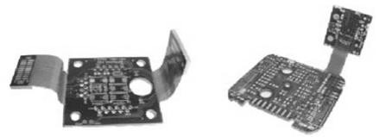

Fig 2.3 Rigid-Flex Circuit

## 2.2 Battery [Li-ion, Nuclear]

For the portable DC power many times rechargeable batteries are preferred to non chargeable battery. Among rechargeable batteries Nickel-Cadmium (Ni-Cd), Nickel Metal Hydride (NiMH /Ni-MH) and Lithium-ion (Li-ion/ LIB) are the most popular types used commercially. Following table compares the characteristics of these three types.

(Note: Unlike electronic devices, for batteries, positive electrode is termed as cathode and negative electrode is termed as anode.)

### 2.2.1 Li-ion Battery

A Lithium-ion battery is commonly called as Li-ion battery or abbreviated as LIB. It is a rechargeable electrochemical battery converting chemical energy into electrical energy and viceversa.

**Table 2.1 Comparative study of rechargeable batteries**

|  |  |  |  |
| --- | --- | --- | --- |
| **Features** | **Nickel-Cadmium(NiCd)** | **Nickel Metal Hydride (NiMH /Ni-MH)** | **Lithium-ion (Li-ion/ LIB)** |
| Cathode Material | Nickel hydroxide (Ni (OH) 2) | Nickel hydroxide (Ni (OH) 2) | Lithium Metal Oxide |
| Anode  Material | Cadmium hydroxide (Cd (OH) 2) | Hydrogen absorbing alloy (Metal Hydride) | Graphite |
| Electrolyte Material | Potassium hydroxide (KOH) | Potassium hydroxide (KOH) | Lithium salt, LiPF6 in an organic solution |
| Battery Voltage | 1.2 V | 1.2 V | 3.5 V |
| Battery cycle count | 500 cycles | 600 cycles | 2000+ cycles |
| Memory Effect | Good | Reduced | No |
| Self Discharge / month | High (15%-20%) | High (20%-30%) | Low (5%-10%) |
| Toxic | Toxic | Less Toxic | Less Toxic |
| Cost | Less expensive | Moderate | High Cost |
| Battery Images |  |  |  |

It is getting popularity for portable electronics and electric vehicles, military

and aerospace applications. Li-ion battery is made up of an anode (Negative Electrode), cathode (Positive Electrode), separator, and electrolyte as shown in Fig.2.4. Most lithium batteries (Li-ion) used in computer, communication, consumer electronics products use cathodes (Positive Electrodes) made of lithium compounds, such as lithium cobalt oxide (LiCoO2), lithium manganese oxide (LiMn2O4) , and lithium nickel oxide (LiNiO2). The anodes ( Negative Electrodes )are generally made of graphite .

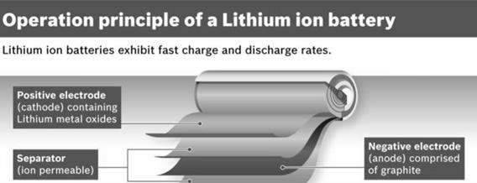

#### Fig 2.4 Lithium-ion battery

All lithium-ion batteries work in broadly the same way. The anode and cathode store the lithium. The electrolyte carries positively charged lithium ions from the anode to the cathode and vice versa through the separator .As shown in Fig.2.5 when the battery is charging up, the lithium-cobalt oxide, (positive electrode) releases some of its lithium ions, which move through the electrolyte to the graphite (negative electrode) and remain there. The battery takes in and stores energy during this process. When the battery is discharging, the lithium ions move back across the electrolyte to the positive electrode, producing the energy that powers the load. In both charging and discharging cases, electrons flow in the opposite direction to the ions around the outer circuit. Electrons do not flow through the electrolyte which is effectively an insulating barrier, so far as electrons are concerned. Unlike simpler batteries, lithium-ion ones have built in electronic controllers that regulate how they charge and discharge. They prevent the overcharging and overheating that can cause lithium-ion batteries to explode in some circumstances.

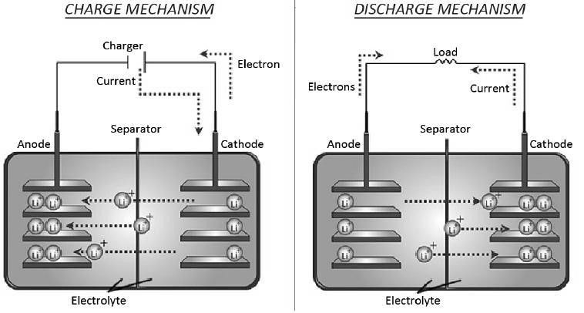

#### Fig 2.5 Charging and Discharging of Li-ion battery

Lithium batteries operate in extremely cold climates or extremely hot climates, are light in weight and require less maintenance. However, they require protection circuit to maintain voltage and current within safe limits and are expensive to manufacture. It is about 40 percent higher in cost than nickel-cadmium.

**2.2.2 Nuclear Battery:**

Small, compact and smart devices of next generation require new batteries with increased functionality, reliability and long life. A nuclear battery also called as atomic battery, tritium battery or radioisotope generator can be the solution for this need.(Fig.2.6) Nuclear battery is a device which uses energy from the emission of a radioactive isotope to generate electricity. As half life period of radioactive materials is in terms of decades, it is capable to provide power for 10 to 20 years. For example, the radioactive isotope, Tritium isotope, has half life of 12.32 years while Ni-63 isotope has half life of 100 years which shows that nuclear batteries equipped with theses isotopes can provide electricity for a much longer periods. This is a unique feature of nuclear battery. These batteries generate electricity from nuclear energy, but they do not use a chain reaction (chain reaction is normally used in nuclear reactor to generate electricity from nuclear energy).

Radioactive isotopic material required for the nuclear battery can be obtained from radioactive waste of the nuclear fission reaction from the nuclear reactor. Thus nuclear batteries can be also useful for the disposal of waste from the nuclear reactors. These batteries can be the solution for the bulky chemical batteries which need to be replaced frequently. Nuclear batteries can work in space as they are not dependent on solar energy; the significant features of nuclear batteries are its compactness, reliable, light weight and long life. It can work in space at extremely low and high temperature variation.

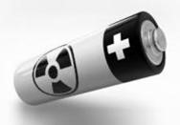

Fig.2.6 Nuclear-Diamond Battery developed in Bristol

However, high initial cost of production and observing the regional and country specific laws regarding use and disposal of radioactive fuels can be a hurdle in its commercial use. These batteries need to gain social acceptance for its application **Applications:**

They are used in **s**pace applications due to its compact size and light weight and long lasting reliable voltage supply independent of atmospheric conditions. Nuclear batteries can be used in cardiac pacemaker to avoid frequent battery replacement problem for the patients. Nuclear powered laptop battery can offer long life time with less need of frequent charging.

**2.3 Memristor, Organic LED:**

**2.3.1 Memristor:**

For nearly 180 years, circuit theory is studied with three fundamental circuit elements, which are resistor, capacitor and inductor. They describe the relations between voltage, current, charge and flux as shown in the Fig 2.7 Resistance relates voltage and current (dv=R*di), capacitance relates charge and voltage (dq=C*dv) and inductance relates flux and current (dφ =L*di), respectively and thus connect the three points of the quadrant of Fig.2.7. On the basis of symmetry, in 1971,Prof. Leon .O. Chua theoretically predicted that there must be a missing passive element, establishing a relationship between flux(φ) and electric charge (q) , which completes the 4th point of a quadrant of Fig.2.7. This element was named as **Memristor**, that is, resistor with memory (concatenation of Memory Resistor) described with equation dφ = M* dq. It remembers the charge that has flowed through it or the voltage that was last applied across it. Symbol of Memristor is as shown in Fig.2.8

**Features of Memristor can be summarized as:**

* Memristor is essentially a charge dependent resistor and is defined by relation dφ = M dq.
* Memristor is claimed as a fundamental circuit element because no combination of passive devices can reproduce the properties of a Memristor.

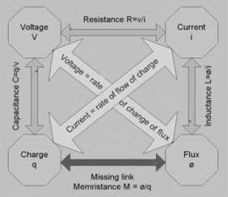

#### Fig.2.7 Fundamental circuit elements



#### Fig.2.8 Memristor Symbol

* Prof. Chua proved that Memristor shows non linear relationship between voltage and current which is exhibited by a hysteretic loop as shown in Fig.2.9.Memristor features unique properties like memory effect (non volatile nature) and non linearity
* Memristor does not introduce a phase shift between current and voltage at zero crossing i.e.

i=0 only if v=0

.

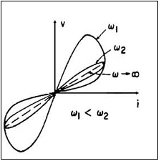

#### Fig.2.9 Memristor I-V Characteristics

In 2008, that is after 37 years of the invention of Memristor by Prof. Chua, the first physical Memristor device was demonstrated by Hewlett Packard (HP) Lab research team in the form of a sandwich structure of Pt/TiO2/Ti02-x /Pt. HP team successfully correlated the resemblance of Memristor characteristics with the characteristics of nano scale ReRAM device which they fabricated (Fig.2.10). This Metal-Insulator-Metal (MIM) structure was termed as Resistive switching Random Access Memory (ReRAM). Thereafter the terms 'Memristor' and 'ReRAM' are very often used interchangeably though there is a fine line of demarcation between them. ReRAM is considered as a subset of Memristor. These devices thereafter are used as switches in crossbar architectures of Non Volatile Memory (NVM) as shown in Fig.2.11

Such ReRAM has a potential to replace the most popular flash memory which is having more than 90% share in the semiconductor market, as on today. The ReRAM has highlighting features such as simple construction, high packaging density, high operation speed, low operational voltages, high scalability, and multibit storage potential. ReRAM is therefore getting a considerable attention by industry as well as researchers as a NVM of next generation.

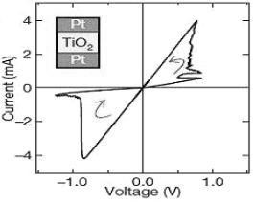

#### Fig 2.10 HP ReRAM I-V characteristics resembling Memristor

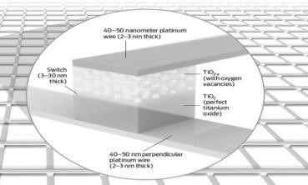

#### Fig.2.11. ReRAM used as switches in crossbar architecture of Nonvolatile Memory

**Applications:**

Memristor devices has widened the application and research novelty in almost all engineering fields including computational and logic circuits, NVM, artificial intelligence and neuromorphic systems as seen from Fig.2.12. Memristor have been used for different digital logic applications like flip flop, logic gates and FPGA (Field Programmable Gate Array) with a crossbar array of Memristors. This improves the performance of analog circuits with reduced area and added functionality. Memristors have also been proposed in designing ultra wideband receivers, adaptive filters, programmable threshold comparators, oscillators, Schmitt triggers, difference amplifiers, in chaos circuits and also for biometric circuits. Memristor can contribute significant advancements in the field of neuro morphic computing because it is found that the dynamics of a Memristor closely resemble those of the synapse in brain tissue. It is proposed to develop real-time data analysis in neural network and neuromorphic applications.

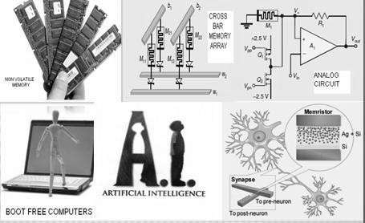

#### Fig.2.12 Versatile Application Areas of Memristor

**2.3.2 Organic LED:**

**O**rganic light-emitting diode (**OLED)** is an advanced display technology made from thin films of light emitting organic materials. OLEDS are made by placing a series of thin films, one emissive layer and one conducting layer between two electrodes (Metallic cathode and

Transparent anode), as shown in the Fig 2.13. When electrical current is applied (Fig.2.13 (a-

c), electrons in the cathode region are pushed towards emissive layer and holes in the anode region towards the conductive layer. When the electrons and holes combine, a bright light is emitted (Fig.2.13 (d)). This is the basic working principle of OLED.

**Features and Applications:**

Currently OLED displays are made by evaporating gases in a vacuum chamber but in future they can be made by ink jet printing which is a very fast and cost effective method. OLED displays are simpler than LCD because they do not require backlight or filtering. They provide better contrast, higher brightness, fast refresh rates (necessary for gaming and VR), lower power consumption and simple design which enables ultra thin, flexible, foldable and transparent displays . Currently all leading companies manufacturing smart phone, wearable smart watches and gadget , VR/AR headsets, TV Displays, computer monitors, handheld game consoles and PDAs are using OLEDS. The flexible OLED displays are opening the possibility of roll able TV and stretchable displays. (Fig. 2.14 and 2.15)

|  |  |
| --- | --- |
| A | **b** |
| C | d |

#### Fig.2.13 ( a to d) Working Principle and operation of OLED

|  |  |
| --- | --- |
| Fig. 2.14 Prototype OLED lighting panels | Fig.2.15. Prototype flexible display (4.1") |

**2.4 Surface Mount Device:**

A surface-mount device (SMD) is an electronic device whose components are directly placed or mounted onto the surface of the PCB. The technology or method for producing electronic circuits using SMD is called Surface-mount technology (SMT). It has largely replaced the through-hole technology (THT) especially in devices that need to be small or flat. With SMT both sides of a PCB can be used when required. SMD components can be smaller than THT components since they can have either smaller leads or no leads at all.(Fig. 2.16) This makes it easier to shrink the components down.

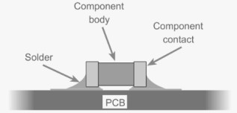

#### Fig.2.16 Surface Mount Technology

SMT process consists of 5 steps :

1. **Printing:** PCB stencil is aligned on the surface of the boards and solder paste is applied to ensure that the pads are coated with a uniform and controlled amount of solder paste. The machine used is called screen printer or solder paste printer.
2. **Mounting** : The surface mount components are accurately placed onto the pads with the help of pick and place machines, as shown in Figure 2.17 . This machine is  [also called as chip mounter or chip shooter machine**.**](http://www.smdmachine.com/smt-chip-mounter.html)The wet solder paste applied during this process acts as a temporary adhesive. However, it is important to ensure that the boards are moved gently to prevent misalignment.
3. **Reflow Soldering** : The boards are passed through a reflow oven, as shown in Figure 2.18. It is also called reflow soldering machine or smt reflow oven) which subjects the boards to infrared radiation after which the solder paste melts and solder joints are formed.
4. **AOI (Automatic Optic Inspection)** : AOI Machine runs a number of quality checks for the boards visually, such as component alignment and checking for solder bridges. The boards then proceed to further testing.
5. **Testing**: PCBs are tested for the desired operation and performance

|  |
| --- |
|  |

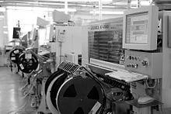

#### Fig.2.17 Assembly line with SMT placement equipment

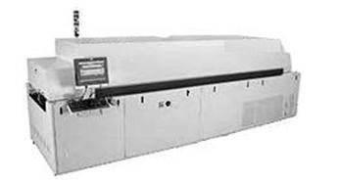

#### Fig 2.18 Commercial reflow oven

**Advantages of SMT** over the older through-hole technique:

1. Smaller components.
2. Much higher component density Components can be placed on both sides of the circuit board.
3. Higher density of connections because holes do not block routing space on inner layers, nor on back-side layers if components are mounted on only one side of the PCB.
4. Accurate placing of components
5. Better mechanical performance under shock and vibration conditions [6] Fewer holes need to be drilled which is time-consuming and expensive.
6. Lower initial cost and time of setting up for mass production, using automated equipment.
7. Simpler and faster automated assembly. Some placement machines are capable of placing more than 136,000 components per hour.
8. Many SMT parts cost less than equivalent through-hole parts.

#### **Disadvantages of SMT**

1. As the device complexity increases, the heat generated by operation increases. If the heat is not removed, the temperature of the device rises shortening the operational life.
2. SMT is unsuitable for some parts such as transformers, heat-sinked power semiconductors, physically large capacitors, fuses, connectors
3. SMDs' solder connections may be damaged after going through thermal cycling.

#### **Resources**

|  |  |
| --- | --- |
| 1. | https://www.youtube.com/watch?v=C-2ysGoCRoo |
| 2. | https://www.electronics-notes.com/articles/electronic_components/surface-mounttechnology-smd-smt/what-is-smt-primer-tutorial.php |
| 3. | https://www.explainthatstuff.com/how-lithium-ion-batteries-work.html |
| 4. | https://en.wikipedia.org/wiki/Memristor |
| 5. | https://nanohub.org › resources › memristor |

#### **Sample Questions**

|  |  |
| --- | --- |
| **Sr. No.** | **Question** |
| 1. | Statement 1: In Li-ion batteries, lithium ions move from the negative electrode to the positive electrode during discharge. Statement 2: In Li-ion batteries lithium ions move from the positive electrode to the negative electrode during charging.  Select correct option for above statement   1. Statement 1 is true but statement 2 is false 2. Statement 2 is true but statement 1 is false 3. Both statements are true 4. Both statements are false |
| 2. | In Li-ion battery, the ____________ is/are lithium ion based   1. Positive electrode 2. Negative electrode 3. Positive and negative electrode 4. Electrolyte |

|  |  |
| --- | --- |
| 3. | A nuclear battery is a device which uses energy from the ________ to generate electricity.   1. Hydrocarbon 2. Hydrogen 3. Emission of radioactive isotopes 4. chain reaction of radioactive element |
| 4. | Compared to other batteries, nuclear batteries are very ______, but have an extremely ____ and high energy density   1. Cheap, long life 2. Costly, long life 3. Cheap, short life 4. Costly, short life |
| 5. | Surface-mount technology (SMT) is a method for producing ____ in which the components are mounted or placed directly onto the surface of ______   1. Electric circuit, electric board 2. Electronic circuit, printed circuit board 3. Pneumatic circuit, pneumatic bench 4. Instrumentation circuit, control panel |
| 6. | OLED stands for ______   1. Organic Light emitting display. 2. Optical Light emitting display. 3. Organic Light emitting diode. 4. Optical Light emitting diode. |
| 7. | In OLED, at least one of the electrode is _______   1. Reactive 2. Transparent 3. Passive 4. Idle |
| 8. | OLEDs are used to create digital display in devices such as _______   1. Only TV screens 2. Only smart phones 3. Only computer monitors 4. All of above |
| 9. | Statement 1: An OLED display works without a backlight Statement 2: Because OLED emits visible light. Select correct option for above statement   1. Statement 1 is true but statement 2 is false 2. Statement 2 is true but statement 1 is false 3. Both statements are true 4. Both statements are false |
| 10. | Memristor is defined by relation ______   1. dφ = M*dq. 2. dq=C*dv. 3. dφ =L*di. 4. dv=R*di. |

|  |  |
| --- | --- |
| 11. | The surface mount components are accurately placed onto the pads with the help of ____________ A. Pick and place machine.   1. Manually. 2. Reflow Machine. 3. Printing Machine. |
| 12. | Desirable feature of electronics components suitable for emerging applications is __________ A. Higher power consumption.   1. Miniature size. 2. Lower operation speed. 3. Low operating frequency. |
| 13. | _______allow more number of components placing on both sides of the flexible dielectric film   1. Single sided flexible circuits 2. Single mounted flexible circuits C. Double access flexible circuits   D. Sculptured Flex circuits. |
| 14. | Memristor features unique properties like _______ and _______. A. Nonvolatile nature, linearity.   1. Volatile nature, non-linearity. 2. Volatile nature, linearity. 3. Nonvolatile nature, non-linearity. |
| 15. | _______is considered as a subset of Memristor   1. ROM 2. ReRAM 3. Static RAM 4. DRAM |
| 16. | Hysteresis loop and ______ phase shift between current and voltage, at _____ are the significant features of Memristor.   1. 0-degree, zero crossing 2. 90-degree, zero crossing 3. 45 degree, non-zero crossing 4. 180 degree, non-zero crossing |
| 17. | Memristor shows ________ relationship between voltage and current. A. Linear   1. Nonlinear 2. Exponential 3. logarithmic |
| 18. | Currently OLED displays are made by ____________. A. Evaporating gases in a vacuum chamber.   1. Evaporating liquid in a vacuum chamber. 2. Evaporating solid in a vacuum chamber. 3. Anodization. |
| 19. | OLED displays are simpler than LCD because they do not require ________ or ________.   1. Power, filtering. 2. Power, diffusing. 3. Backlight, diffusing. 4. Backlight, filtering. |
| 20. | In the cover lay of FPC, to reduce conductor damage from frequent bending, the thickness of the cover lay should be ______   1. Same as the thickness of the dielectric layer. 2. more than the thickness of the dielectric layer 3. less than the thickness of the dielectric layer 4. Independent of the thickness of the dielectric layer |

**UNIT– 3**

**Next Generation telecom Network**

**Expected Course Outcome:** Suggest different telecom network for given application

#### **Teaching Hrs. 12 Marks 16 To attain above course outcome candidate must able to**

1. Explain the function of given Network components.
2. Describe the Spectrum in Telecom sector.
3. Compare given Mobile Network with respect to given parameter.
4. Explain the given component used in FTTH.
5. Explain the Multi-Protocol Label Switching in NGN core.
6. Describe the features of OTN and PON.

#### **This unit mainly focuses on following major points**

3.1 **NGN architecture**: Features, Functional block diagram, Network components: Media Gateway, Media Gateway Controller, and Application Server.

3.2 **NGN Wireless Technology**: Telecom network Spectrum: Types [licensed and unlicensed], Mobile Network Evolution (2G to 5G), Comparative features, 3.3 **Fiber to the Home** (FTTH): Features, Architecture and Components: Optical Line Termination (OLT), Optical Network Unit (ONU).

3.4 **NGN Core**: Features, Multi-Protocol Label Switching (MPLS): Concepts, Features and Advantages.

3.5 **Next generation transmission system**: Optical Transport Network variants:

Synchronous Transfer Module STM1, STM4, STM16, STM64 and STM256 Features: bit rates and capacity. Passive Optical Network: BPON, Ethernet PON, Gigabit PON features.

**Introduction:**

Next Generation Network (NGN) is a new concept and becoming more and more important for future telecommunication networks. Next Generation Network (NGN) is a packet-based network able to provide telecommunication services and able to make use of multiple broadband, Quality of service (QoS)-enabled transport technologies. It supports mobility .In NGN service related functions are independent from underlying transport-related technologies. It enables unfettered access for users to networks and to competing service providers. It supports generalized mobility which will allow consistent and ubiquitous provision of services to users.

The general idea behind the NGN is that one network transports all information and services (voice, data, and all sorts of media such as video) by encapsulating these into IP [packets,](https://en.wikipedia.org/wiki/Network_packet) similar to those used on the [Internet.](https://en.wikipedia.org/wiki/Internet) NGNs are commonly built around the [Internet Protocol,](https://en.wikipedia.org/wiki/Internet_Protocol) and therefore the term all IP is also sometimes used to describe the transformation of formerly telephone-centric networks toward NGN.

* Objectives of NGN

NGN will define a framework for architecture and capabilities to provide open user access to networks with fulfilling various regulatory requirements. NGN will ensure universal provision and access to services promoting equality of opportunity to the citizen. It also promoting diversity of content, including cultural and linguistic diversity

* NGN Capabilities

NGN shall provide the capabilities to make the creation, deployment and management of all kinds of services (Present or future) possible. This comprises of services using different kinds of media (audio, visual, audiovisual), with all kinds of encoding schemes and data services, conversational, unicast, multicast and broadcast, messaging, simple data transfer services, real-time and non-real-time, delay-sensitive and delay-tolerant services. Services with different bandwidth demands from a few kbit/s to hundreds of Mbit/s, guaranteed or not, should be supported within the capabilities of the transport technologies. Within the NGN there is an increased emphasis on service customization by the Service Providers whereby some of them will offer their customers the possibility to customize their own services.

* NGN Basic terms

NGN: NGN is a packet-based network able to provide telecommunication services and able to make use of multiple broadband, QoS-enabled transport technologies and in which service related functions are independent from underlying transport related technologies. Generalized mobility is the ability for the user or other mobile entities to communicate and access services irrespective of changes of the location or technical environment.

NGN Application: A software entity residing on an application server that contributes to the delivery of an end user service.

Application network interface (ANI): Interface which provides a channel for interactions and exchanges between applications and NGN elements. The ANI offers capabilities and resources needed for the realization of applications.

Application programming interface (API): An API provides a set of interfaces from an application environment to an execution environment. The execution environment provides services to the application environment.

NGN service stratum: That part of the NGN which provides the user functions that transfer service-related data and functions. It control and manage service resources and network services to enable user services and applications.

NGN transport stratum: That part of the NGN which provides the user functions that transfer data and the functions. It controls and manages transport resources to carry such data between terminating entities.

Open service environment capabilities: Capabilities provided by an open service environment to enable enhanced and flexible service creation and provisioning based on the use of standards interfaces.

Service: A set of functions and facilities offered to a user by a provider.

Authorized account: A profile of the entity which a NGN end user can subscribe for accessing the information via messaging exchange. Authorized means the account is sanctioned and recognized by the service provider (third-party provider) and it is always available to be accessed. The profile is a numeric string which includes the identity of the entity and the service information of the entity.

Authorized account messaging service: A messaging service through which third-party provider can register to an authorized account and interact with the account subscribers via messaging exchange.

• Connectivity to the NGN

Fig. 3-1 shows the different connectivity, direct or indirect (i.e., through another network), that a NGN may support. The UNI (user-network interface) is used to provide connectivity to terminal equipments, user networks and corporate networks. The UNI supports both a control level type of interaction and a media level type of interaction.

The NNI (network-network interface) is used to provide connectivity to:

* Other NGNs (at the service stratum and/or transport stratum level);
* Other IP-based networks;
* PSTN/ISDN

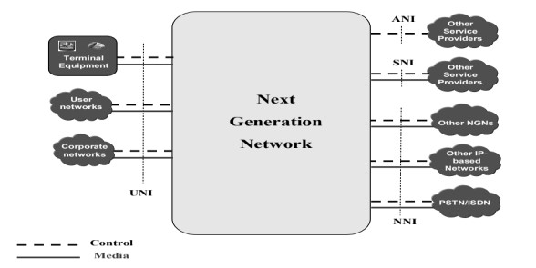

##### Fig. 3.1: Connectivity to NGN [ITU-T Y.2011]

The NNI supports both a control level type of interaction and a media level type of interaction.

The ANI (application network interface) is an interface which provides a channel for interactions and exchanges between a NGN and applications. The ANI offers capabilities and resources needed for realization of applications. The ANI supports only a control plane level type of interaction without involving media level (or data plane) interaction. The ANI is used to provide connectivity to other service providers, and their applications,. It has to be noted that a NGN operator can also be an application provider as it may support "in-house" applications.

The SNI (service network interface) is an interface which provides a channel for interactions and exchanges between a NGN and other service providers). The SNI supports both a control plane level type of interaction and a media level (or data plane) type of interaction.

• NGN APPLICATIONS

The next generation network (NGN) is expected to implement various functions for creating various kinds of broadband services, such as end-to-end quality control, unicast communication functions, multicast communication functions, and interactive communication functions. Major applications are

1. Intelligent Call Routing (ICR)

Intelligent Call Routing is a core network application that allows the execution of a service flow (the business logic of decision nodes) by the underlying routing engine. When a caller makes a phone call to a number, it triggers the right service flow provisioned in ICR based on the dialed number and call treatment is done as per the decision nodes – e.g. connect to IVR menu, play announcement based on time of day, origin or time-based routing, fetch information from external Database, execute commands or call APIs, route the call to operator or call center,

1. Advanced Toll Free

The Advanced Toll-Free or Free Phone service is a core network application that allows callers to make a free phone call to a service-subscriber by dialing a special service

1. Voice Virtual Private Network (VPN) service
2. Number Portability
3. Flexi charge (Real time Rating and Charging)
4. Call Screening Service

1. Emergency Calling Services
2. Call Diversion Service (CDIV)
3. Interactive Voice Response (IVR)
4. Single Number Service (SNS)
5. Caller ID on TV
6. Call Intercept Service (CIS)
7. ZIP Code Routing (ZCR)

#### **NGN Features**

* NGN Support for a wide range of converged services between fixed/mobile NetworksA fundamental characteristic of NGN is the ability to deliver a wide variety of services including voice, video, audio and visual data, via session and interactive based services in unicast, multicast and broadcast modes. Furthermore, wire line and wireless technologies can be used interchangeably for delivery of services. The NGN can be used in a consistent manner anytime and anywhere across various environments using converged terminal equipment (i.e., those terminals capable of accepting all services) in a digital environment. The concurrent delivery of all content types will allow their simultaneous presentation on single terminal equipment (TE) or on separate devices as required.
* NGN provides End-to-end QoS (Quality of Service):The NGN aims to provide high quality broadband communication by controlling the quality of service (QoS) on end to end basis. The NGN support a wide range of QoS enabled services as it define: 
  1. Bearer service QoS classes;
  2. QoS control mechanisms;
  3. QoS control functional architecture;
  4. QoS control/signaling.
* NGN provides *e*nd-to-end Packet-based Transfer withBroadband capabilities

Technologies used at access and transport are broadband in nature. 3G WCDMA, 4 G LTEAdvance is used at wireless access whereas FTTH, xDSL technology used at wire line access

MPLS use at transport technology

* Separation of control functions among bearer capabilities, call/session
* Decoupling of service provision from transport

One of the main characteristics of NGN is the decoupling of services and transport, allowing them to be offered separately and to evolve independently. Therefore in the NGN architectures, there shall be a clear separation between the functions for the services and the functions for the transport. NGN allows the provisioning of both existing and new services independently of the network and the access type used

The service provisioning process is separated from transport network operation by using distributed and open control mechanism. Distributed control will enable adaptation to the distributed processing nature of packet-based networks and support location transparency for distributed computing. The network control environment is open to support service creation, service updating, and incorporation of service logic provision by third parties.

The separation is represented by two distinct blocks or stratum of functionality. The transport functions reside in the transport stratum and the service functions related to applications reside in the service stratum as shown in Fig.3.2

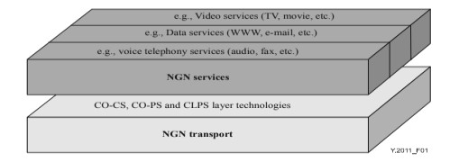

##### Fig. 3.2: Separation of services from transport in NGN [**Courtesy: (T-REC-Y.2011-200410-I!!PDF-E%20**ITU-T

Y.2001]

* Interworking with legacy (old) networks via open interfaces

Unlike NGN, many existing networks and their services are vertically integrated, i.e., do not have a clear separation between services and packet transport. It is clear that many services have to be operated across a hybrid combination of NGN and non NGN technologies. In such cases interworking arrangements will be necessary. Interworking between NGNs of different operators and between NGN and existing networks such as PSTN (Public Switched Telephone Network), ISDN (Integrated Services Digital Network) and GSM (Global System for Mobile communications) is provided by means of gateways.

* NGN Provides Generalized Mobility

Generalized mobility is the ability for the user or other mobile entities to communicate and access services irrespective of changes of the location (anywhere in world) or technical environment.(technology independent)

* Unrestricted access by users to different service providers

User can access services of different service providers along with own service provider.

* Variety of identification schemes

Since the NGN consists of interconnected heterogeneous networks, using heterogeneous user access and heterogeneous user devices and that the NGN should provide a seamless capability, independent of access method and network, the NGN should address Numbering, Naming and Addressing. Individual users may be identified by name/numbers using a name/number resolution system which will be able to translate a given name/number into a routable and valid address in order to establish a transfer (transport) facility (connection or flow).

Examples of such Naming/Numbering schemes may be:

1. E.164 numbering scheme (Country code+STDcode+Telephone No);
2. Unified Resource Locator (URL) scheme;
3. Unique name system (e.g., 1800Airways etc.);

* NGN support of multiple last mile technologies

The NGN offer the configuration flexibility needed to support multiple last mile access technologies (FTTH/ xDSL/ LTE-A/ Wi-Max)

* NGN compliant with all regulatory requirements, for example concerning emergency communications, security, privacy, lawful interception, etc.
* Security: The NGN will include functions for monitoring signal traffic and data traffic, for checking telephone numbers, IP addresses and other information identifying origination and for blocking unusual traffic at the entrance and exit nodes to the network.
* Reliability: To improve reliability, every communication device is highly reliable. Provision of redundant configuration for communication circuits and equipments is maintained
* NGN is Layered Architecture

Following four layers of NGN

* 1. Access Layer
  2. Transport /Core Layer
  3. Control Layer
  4. Service Layer

## 3.1 NGN Architecture

The recommended architecture of NGN combines the features of all networks.

Fig. 3.3 shows an overview of the NGN functional architecture. The NGN functional architecture supports the UNI, NNI, ANI and SNI reference points. The NGN architecture supports the delivery of multimedia services and content delivery services, including video streaming and broadcasting. An aim of the NGN is to serve as a [PSTN](https://www.techabulary.com/p/pstn/) and [ISDN](https://www.techabulary.com/i/isdn/) replacement. The NGN architecture defines a Network-Network Interface (NNI), User-Network Interface (UNI), and an Application Network Interface (ANI). The Transport (layer) stratum provides IP connectivity services to NGN users under the control of Transport control functions, including the Network Attachment Control Functions (NACF) and Resource and Admission Control Functions (RACF) and mobility management and control functions (MMCF).

.The NGN functions are divided into service stratum functions and transport stratum functions. To provide services, several functions in both the service stratum and the transport stratum are needed, as illustrated in Figure 3.3. The delivery of services/applications to the end-user is provided by utilizing the application support functions and service support functions, and related control functions.

### 3.1.1 Transport stratum functions

The transport stratum functions include transport functions and transport control functions.

* Transport functions

The transport functions provide the connectivity for all components and physically separated functions within the NGN. These functions provide support for unicast and/or multicast transfer of media information, as well as the transfer of control and management information. Transport functions include access network functions, edge functions, core transport functions, and gateway functions.

* Access network functions

The access network functions take care of end-user’s access to the network as well as collecting and aggregating the traffic coming from these accesses towards the core network. These functions also perform QoS control mechanisms dealing directly with user traffic, including buffer management, queuing and scheduling, packet filtering, traffic classification, marking, policing, and shaping. In addition, the access network provides support for mobility. The access network includes access-technology dependent functions, e.g., for W-CDMA technology and xDSL access.

Depending on the technology used for accessing NGN services, the access network includes functions related to:

1. Cable access;
2. xDSL access;
3. Wireless access (e.g., [b-IEEE 802.11] and [b-IEEE 802.16] technologies and 3G

RAN access);

1. Optical access.

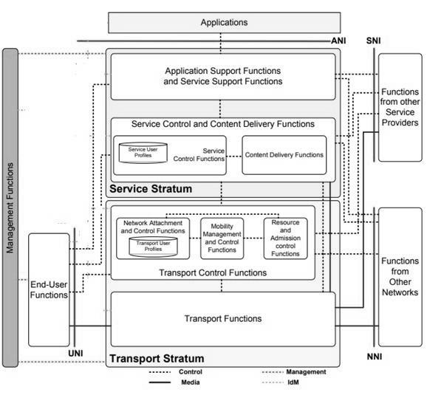

Fig. 3.3: NGN Architecture Overview [**Courtesy: (T-REC-Y.2012-200609-S!!PDF-E**ITU-T Y.2012]

* + Edge functions

The edge functions are used for media and traffic processing when aggregated traffic coming from different access networks is merged into the core transport network; they include functions related to support for QoS and traffic control. The edge functions are also used between core transport networks.

* + Core transport functions

The core transport functions are responsible for ensuring information transport throughout the core network. They provide the means to differentiate the quality of transport in the core network. These functions provide QoS mechanisms dealing directly with user traffic, including buffer management, queuing and scheduling, packet filtering, traffic classification, marking, policing, shaping, gate control, and firewall capability.

* + Gateway functions

The gateway functions provide capabilities to interwork with end-user functions and/or other networks, including other types of NGN and many existing networks, such as the PSTN/ISDN, the public Internet, and so forth. Gateway functions can be controlled either

directly from the service control functions or through the transport control functions

* + Media handling functions

The media handling functions provide specialized media resource processing for service provision, such as generation of tone signals and transcoding. These functions are specific to media resource handling in the transport stratum.

* + Transport control functions

The transport control functions include resource and admission control functions, network attachment control functions as well as mobility management and control functions.

* + Resource and admission control functions (RACF)

Within the NGN architecture, the resource and admission control functions (RACF) act as the arbitrator between service control functions and transport functions for QoS. The decision is based on transport subscription information, SLAs, network policy rules, service priority, and transport resource status and utilization information. The RACF provides an abstract view of transport network infrastructure to service control functions (SCF) and makes service stratum functions agnostic to the details of transport facilities, such as network topology, connectivity, resource utilization and QoS mechanisms/technology, etc. The RACF interacts with the SCF and transport functions for a variety of applications (e.g., SIP-based call, video streaming, etc.) that require the control of NGN transport resource, including QoS control, NAPT and firewall control and NAPT traversal. The RACF performs the policy-based transport resource control upon the request of the SCF, determines the transport resource availability and admission, and applies controls to the transport functions to enforce the policy decision, including resource reservation, admission control and gate control, NAPT and firewall control, and NAPT traversal. The RACF interacts with transport functions for the purpose of controlling one or more of the following functions in the transport layer: bandwidth reservation and allocation, packet filtering; traffic classification, marking, policing, and priority handling; network address and port translation; and firewall. The RACF takes into account the capabilities of transport networks and associated transport subscription information for subscribers in support of the transport resource control. Transport subscription information is the responsibility of the network attachment control functions (NACF). The RACF and the NACF interact to exchange relevant transport subscription information and information on the user terminal's point of attachment. For delivering of those services across multiple service providers and/or network operators, SCF, RACF and transport functions may interact with the corresponding functions in other NGNs.

* + Network attachment control functions (NACF)

The network attachment control functions (NACF) provide registration at the access level and initialization of end-user functions for accessing NGN services. These functions provide transport stratum level identification/authentication, manage the IP address space of the access network, and authenticate access sessions. They also announce the contact point of NGN functions in the service stratum to the end user.

The NACF provides the following functionalities:

* 1. Dynamic provisioning of IP addresses and other user equipment configuration

parameters.

* 1. By endorsement of user, auto-discovery of user equipment capabilities and

other parameters.

* 1. Authentication of end user and network at the IP layer (and possibly other layers). Regarding the authentication, mutual authentication between the end user and the network attachment is performed.
  2. Authorization of network access, based on user profiles.
  3. Access network configuration, based on user profiles.

• Location management at the IP layer. The NACF includes the transport user profile which takes the form of a functional database representing the combination of a user's information and other control data into a single "user profile" function in the transport stratum. This functional database may be specified and implemented as a set of cooperating databases with functionalities residing in any part of the NGN. • Mobility management and control functions (MMCF)

The mobility management and control functions (MMCF) provide functions for the support of IP based mobility in the transport stratum. These functions allow the support of mobility of a single device. The MMCF provides mechanisms to achieve seamless mobility if network conditions permit, but does not provide any mechanism to deal with service adaptation if the post-handover quality of service is degraded from the quality of service before handover. The MMCF assumes that mobility is a service, explicitly specified by parameters in the user service profile. The MMCF is not dependent on specific access technologies, and supports handover across different technologies.

3.1.2 Service stratum functions

Functional grouping in the service stratum includes:

1. The service control and content delivery functions including service user profile functions.
2. The application support functions and service support functions. 
   * Service control and content delivery functions (SC and CDF)

The service control and content delivery functions include service control functions and content delivery functions.

* + Service control functions (SCF)

The service control functions (SCF) include resource control, registration and authentication- authorization functions at the service level for both mediated and non-mediated services. They can also include functions for controlling media resources, i.e., specialized resources and gateways at the service-signaling level. Regarding the authentication, mutual authentication between end user and the service is performed. The service control functions accommodate service user profiles which represent the combination of user information and other control data into a single user profile function in the service stratum, in the form of functional databases.

* + Content delivery functions (CDF)

The content delivery functions (CDF) receive content from the application support functions and service support functions, store, process, and deliver it to the end-user functions using the capabilities of the transport functions, under control of the service control functions.

* + Application support functions and service support functions (ASF&SSF) The application support functions and service support functions (ASF&SSF) include functions such as the gateway, registration, authentication and authorization functions at the application level. These functions are available to the "applications" and "end-user" functional groups. The application support functions and service support functions work in conjunction with the service control functions to provide end users and applications with the NGN services they request.

Through the UNI, the application support functions and service support functions provide reference points to the end-user functions. Application interactions with the application support functions and service support functions are handled through the ANI reference point.

* + End-user functions

No assumptions are made about the diverse end-user interfaces and end-user networks that may be connected to the NGN access network. End-user equipment may be either mobile or fixed.

* + Management functions

Support for management is fundamental to the operation of the NGN. These functions provide the capabilities to manage the NGN in order to provide NGN services with the expected quality, security, and reliability. These functions are allocated in a distributed manner to each functional entity (FE), and they interact with network element (NE) management, network management, and service management FEs.

Management functions apply to the NGN service and transport strata. For each of these strata, they cover the following areas:

* 1. Fault management;
  2. Configuration management;
  3. Accounting management;
  4. Performance management;
  5. Security management.

### 3.1.3 NGN Network components

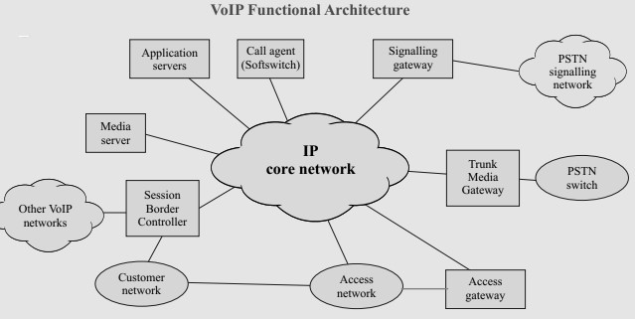

#### Fig. 3.4: NGN Network Components [TEC]

* Media Gateway Controller (MGC):

Media gateway controllers are also known as Softswitches and Callcontrollers, Wireless Call Server or Call Agents. The MGC is located in the service provider's network in control layer and provides call logic and call control functions, typically maintaining call state for every call in the network. Many MGCs interact with application servers to supply services that are not directly hosted on MGCs.

* Media Gateway :

Media Gateways are located in access layer of NGN. Media Gateway performs following functionality

* 1. Access gateway (AG)
  2. Trunk Media gateway (TMG)
  3. Signaling gateway (SG)
  4. Border Gateway (BGW)/ Session Border Controller(SBC)

Access gateway (AG):

The AG is located in the service provider's network. It supports the line side interface to the core IP network for use by phones, devices, and PBXs. This element provides functions such as media conversion (circuit to Packet, Packet to circuit) and echo control.

Trunk Media gateway (TMG):

The TMG supports a trunk side interface to the PSTN and/or IP routed flows in the packet network. It supports functions such as packetisation, echo control etc.

Signaling gateway (SG):

The SG provides the signaling interface between the VoIP network and the PSTN signaling network. It terminates SS7 links and provides Message Transport Part (MTP) Level 1 and Level 2 functionality. Each SG communicates with its associated CA to support the end-toend signaling for calls.

Border Gateway (BGW)/ Session Border Controller (SBC)

It is deployed at the edge and core of a service provider's network to control signaling and media streams as they enter and exit the network. The “edge” is any IP-IP network border such as between a service provider and a customer or between a service provider and an enterprise network. The “core” is any IP-IP network border such as those between two service providers. SBC provides functions such as security, denial of Service attacks, overload control, Network Address Translation and Firewall Traversal, Lawful Interception, Quality of Service (QoS) management, Protocol Translation, call accounting etc Access network (AN):

The access network provides connectivity between the customer premises equipment and the access gateways in the service provider's network. There are various access methods: TDM direct access, switched TDM, broadband access (cable, DSL), IP managed Internet service, etc.

IP core network:

The primary function of the IP core network is to provide routing and transport of IP packets. The IP core also has the added value of architecturally isolating the gateways, and their associated access networks, from the MGC and associated service intelligence. In order to address the performance needs of each of the typical traffic streams associated with the VoIP architecture (bearer channels, signaling, and management traffic), the core network may support separate QoS mechanism.

Media Server

The Media Server is located in the service provider's network and uses a control protocol such as H.248 or SIP, under the control of the MGC or application server, to provide announcements and tones, and collect user information.

Application Server

The Application Server is located in the service provider’s network and provides the service logic and execution for one or more applications or services that are not directly hosted on the MGC. Typically the MGC routes calls to the appropriated AS for features the MGC does not support.

NGN service-specific components

* IP multimedia service component

The IP multimedia service component supports mediated multimedia services. These services may include multimedia session services, such as voice or video telephony or PSTN/ISDN simulation, and some non-session services, such as subscribe/notify for presence information and the message method for message exchange.

* PSTN/ISDN emulation service component

PSTN/ISDN emulation refers to the provision of PSTN/ISDN service capabilities and interfaces

using adaptation to an IP infrastructure. The PSTN/ISDN emulation service component enables the support of legacy terminals connected through a gateway to an IP network. All PSTN/ISDN

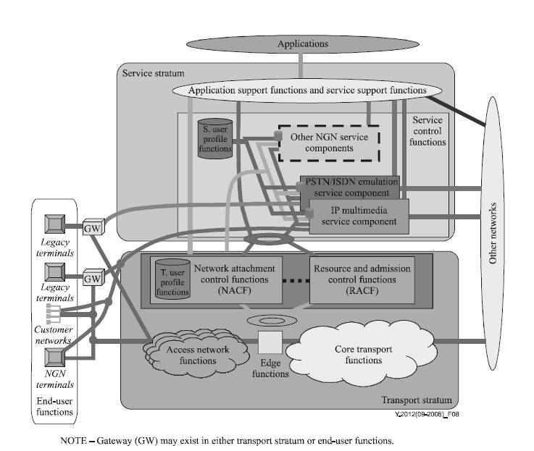

Fig 3.5: NGN Components (**Courtesy: T-REC-Y.2012-200609-S!!PDF-E)**

Services remain available and identical, such that end users are unaware that they are not connected to a TDM-based PSTN/ISDN. Not all service

Capabilities and interfaces have to be present to provide PSTN/ISDN emulation. By contrast, PSTN/ISDN simulation refers to the provision of PSTN-/ISDN-like services to advanced terminals such as IP phones.

## 3.2 NGN Wireless Technology

### 3.2.1 Licensed and Unlicensed Radio Bands

The radio spectrum is the part of the electromagnetic spectrum with frequencies from 30 hertz to 300 GHz. Electromagnetic waves in this frequency range, called radio waves, are widely used in modern technology, particularly in telecommunication. Radio Spectrum, in general, can be categorized into two types, licensed radio bands and unlicensed radio bands.

Licensed radio bands-To use this radio bands, a license must be obtained from a government agency. This requirement is true of all users of these radio spectrums. A few of the uses of licensed radio bands are as follows:

* AM broadcast (short wave between 1.711 MHz–30.0 MHz, medium wave between 520 kHz–1,610 kHz, and long wave between 148.5 kHz–283.5 kHz )
* FM broadcast (87.5 to 108.0 MHz)
* Cellular phones (840 MHz,900MHz)

Unlicensed radio bands have been allocated to certain users by the government or any individual can use it, but to be able to use and broadcast on these bands, you do not need to have a license; you only need to create compliant devices that are to be used. Regulations exist around these bands.

Some of the types of unlicensed radio bands are as follows:

* Industrial, Scientific, Medical (ISM): This type includes several medical monitors and other devices that operate in the 900-MHZ, 2.4-GHz, and 5-GHz bands.
* Unlicensed National Information Infrastructure (U-NII): This type defines the specifications for the use of wireless devices such as WLAN access points and routers in the 5-GHz band.

IEEE 802.11 networks have several choices of wireless bands that are available to them to use, without the requirement to lease the frequencies from the government .Following groups and standards bodies have helped to develop standards so that all users can be good neighbors with others who use those radio bands.

* FCC (Federal Communications Commission): Manages and sets standards with regard to the spectrum use
* IEEE (Institute of Electrical and Electronics Engineers): A leading standards organization which publishes standards that are adopted across industries
* Wi-Fi Alliance: An organization that attempts to create a single standard for WLANs, thereby ensuring interoperability
* ETSI (European Telecommunications Standards Institute): Another standards organization that has contributed many worldwide standards
* ITU-R (International Telecommunication Union, Radio communication Sector): With the FCC, defines how WLANs should operate from a regulatory perspective, such as operating frequencies, antenna gain, and transmission power
* WLANA (WLAN Association): Provides information resources related to WLANs with regard to industry trends and usage. They are now defunct.
* WPC (The Wireless Planning and Coordination) is the National Radio Regulatory Authority responsible for Frequency Spectrum Management, including licensing and caters for the needs of all wireless users (Government and Private) in the India. It exercises the statutory functions of the Central Government and issues licenses to establish, maintain and operate wireless stations

**3.2.2 Mobile Network Evolution (2G to 5G):**

In the last few decades, Mobile Wireless Communication networks have experienced a remarkable change. The mobile wireless Generation (G) generally refers to a change in the nature of the system, speed, technology, frequency, data capacity, latency etc. Each generation have some standards, different capacities, new techniques and new features which differentiate it from the previous one .The first generation (1G) mobile wireless communication network was analog used for voice calls only. The second generation (2G) is a digital technology and supports text messaging. The third generation (3G) mobile technology provided higher data transmission rate, increased capacity and provide multimedia support. The fourth generation (4G) integrates 3G with fixed internet to support wireless mobile internet, which is an evolution to mobile technology and it overcome the limitations of 3G. It also increases the bandwidth and reduces the cost of resources. 5G stands for 5th Generation Mobile technology and is going to be a new revolution in mobile market which has changed the means to use cell phones within very high bandwidth. User never experienced ever before such high value technology which includes all type of advance features and 5G technology will be most powerful and in huge demand in near future.

* First Generation(1G) Mobile Technology

These phones were the first mobile phones to be used, which was introduced in 1982. It was used for voice services and was based on technology called as Advanced Mobile Phone System (AMPS). The AMPS system was frequency modulated and used frequency division multiple access (FDMA) with a channel capacity of 30 KHz and frequency band of 824894MHz. Its basic features are:

* Speed-2.4 kbps
* Voice calls allowed within country with poor voice quality• Use analog signal.
* Large phone size with poor battery life
* Limited capacity
* Poor handoff reliability
* Poor security
* Offered very low level of spectrum efficiency

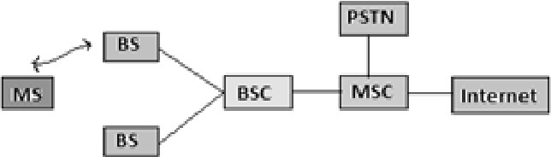

#### Fig 3.6 Architecture of Advance Mobile Phone System

* Second Generation (2G) Mobile Technology

2G refers to the second generation based on GSM (Global System for Mobile communication) and was emerged in late 1980s. It uses digital signals for voice transmission. Main focus of this technology was on digital signals and provides services to deliver text and picture message at low speed (in kbps). It uses the bandwidth of 30 to 200 KHz. Next to 2G, 2.5G system uses packet switched and circuit switched domain and provide data rate up to 144 kbps. e.g. GPRS (General Packet Radio Services),CDMA (Code-Division Multiple Access) and EDGE (Enhanced Data Rates for GSM (Global System for Mobile) EvolutionThe main features of Second generation (2G) Mobile Technology:

* Data speed was up to 64kbps
* Use digital signals
* Enables services such as text messages, picture messages and MMS (Multimedia message)
* Provides better quality and capacity
* Unable to handle complex data such as videos.
* Required strong digital signals to help mobile phones work. If there is no network coverage in any specific area, digital signals would weak.

The main features of (2.5G) generation Mobile Technology:

The GSM technology was continuously improved to provide better services which led to

Development of advanced Technology between 2G and 3G

* Provides phone calls
* Send/receive e-mail messages
* Web browsing Speed : 64-144 kbps
* Camera phones

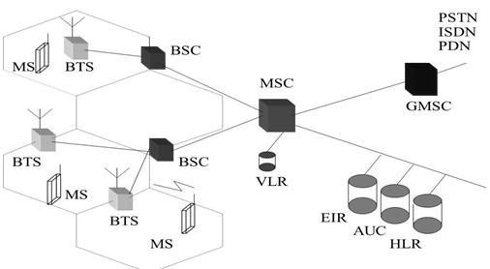

#### Fig 3.7: GSM System Architecture

* Third Generation (3G) Mobile Technology

3G is based on GSM and was launched in 2000. The aim of this technology was to offer high speed data. The original technology was improved to allow data up to 14 Mbps and more using packet switching. It uses Wide Band Wireless Network with which clarity is increased. It also offers data services, access to television/video, new services like Global Roaming. It operates at a range of 2100MHz and has a bandwidth of 15-20MHz used for High-speed internet service, video chatting.

The main features of 3G are:

* Speed 2 Mbps
* Typically called smart phones
* Increased bandwidth and data transfer rates to accommodate web-based applications and audio and video files.
* Provides faster communication
* Send/receive large email messages
* High speed web/more security/video conferencing/3D gaming
* Large capacities and broadband capabilities
* TV streaming/mobile TV/Phone calls
* To download a 3 minute MP3 song only 11 sec-1.5 mins time required.
* Expensive fees for 3G licenses services
* It was challenge to build the infrastructure for 3G
* High bandwidth requirement
* Expensive 3G phones
* Large cell phones

3G mobile system was called as UMTS (Universal Mobile Telecommunication System) in Europe, while CDMA2000 is the name of American 3G variant. Also the IMT2000 has accepted a new 3G standard from China, i.e TD-SCDMA. WCDMA is the air-interface technology for UMTS. Take a time of 6-9 mins. to download a 3 mins. MP3 song.

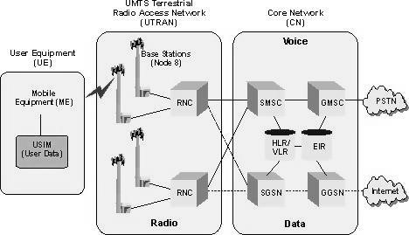

#### Fig. 3.8 WCDMA Network Diagram

* Fourth Generation (4G) Mobile Technology

4G offers a downloading speed of 100Mbps. 4G provides same feature as 3G and additional services like Multi-Media Newspapers, to watch T.V programs with more clarity and send Data much faster than previous generations . LTE (Long Term Evolution) is considered as 4G technology. 4G is being developed to accommodate the QoS and rate requirements set by forthcoming applications like wireless broadband access, Multimedia Messaging Service (MMS), video chat, mobile TV, HDTV content, Digital Video Broadcasting (DVB), minimal services like voice and data, and other services that utilize bandwidth. The main features of 4G are:

* Uplink speed 100 Mbps
* Download link speed 200 Mbps
* Capable of provide 10Mbps-1Gbps speed
* High quality streaming video
* Combination of Wi-Fi and Wi-Max
* High security
* Provide any kind of service at any time as per user requirements anywhere
* Expanded multimedia services
* Low cost per-bit
* Battery uses is more
* Hard to implement
* Need complicated hardware
* Expensive equipment required to implement next generation network

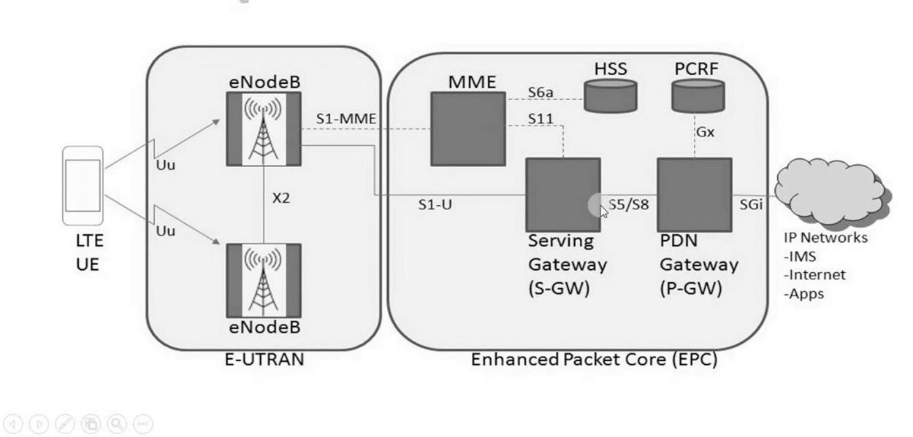

Fig 3.9. 4 G Network Architecture

* Fifth Generation (5G)Mobile Technology

5G refer to Fifth Generation Mobile technology probably implemented in 2020 in India. Facilities that might be seen with 5G technology includes far better levels of connectivity and coverage. The main focus of 5G will be on World-Wireless World Wide Web (WWWW).

The main features of 5G are:

* It is highly supportable to WWWW (wireless World Wide Web)
* High speed, high capacity
* Provides large broadcasting of data in Gbps.
* Multi-media newspapers, watch TV programs with the clarity (HD Clarity)
* Faster data transmission that of the previous generation
* Large phone memory, dialing speed, clarity in audio/video
* Support interactive multimedia, voice, streaming video, internet and other
* More effective and attractive

The current trend of 5G technology has a following feature.

* 5G technology offer high resolution for cell phone user and bi- directional large bandwidth sharing.
* 5G technology is providing large broadcasting of data in Gigabit which supporting almost 65,000 connections.
* The uploading and downloading speed of 5G technology touching the peak• The 5G technology also support virtual private network.
* The 5G terminals will have software defined radios and modulation schemes as well as new error control schemes that can be downloaded from the Internet.
* The development is seen towards the user terminals as a focus of the 5G mobile networks.

e.g. The advanced billing interfaces of 5G technology makes it more attractive and effective,

* The 5G technology network offering enhanced and available connectivity just about the world The terminals will have access to different wireless technologies at the same time and the terminal should be able to combine different flows from different technologies.
* In 5G, each network will be responsible for handling user-mobility, while the terminal will
* Make the final choice among different wireless/mobile access network providers for a given service. Such choice will be based on open intelligent middleware in the mobile phone.
* The remote diagnostic is a great feature offered by 5G, through which a user can get better and fast solution.Challenges Facing by 5G

1. Integration of various standards:

One of the big challenges facing 5G is standardization. There are already multiple groups working to come up with standards around interoperability, backward compatibility with older technologies (4G, 3G), and making sure the network will be future-proof.

1. Common Platform:

There is no common architecture for interconnecting various engineering practices. One common governing body is required, which creates a common platform for all engineering practices to regularize the interconnectivity issues as well as knowledge sharing

1. Building the infrastructure:

It is a huge task, with issues around spectrum and installing new antennas. 5G is likely going to rely, at least in part, on higher-frequency bands. There is more space in those airwaves available, but at such high frequencies, signals can’t travel nearly as far as they can over the frequencies used for 4G, resulting in a poor connection. d) Obstacles:

Like buildings, trees and even bad weather can also cause interference. To offset that, carriers will need to install more base stations to ensure better coverage, and use antenna technologies like MIMO.

Table 3.1 Comparison of All Generations of Mobile Technologies:

|  |  |  |  |  |  |
| --- | --- | --- | --- | --- | --- |
| Technology | 1G | 2G | 3G | 4G | 5G |
| Start/  Development | 1970-80 | 1990-2004 | 2004-10 | 2010-12 | Soon (probably by 2020) |
| Data bandwidth | 2 Kbps | 64 Kbps | 2 Mbps | 1 Gbps | Higher than 1 Gbps |
| Technology | Analog | Digital | CDMA-2000, UMTS,EDGE | Wi max, Wi-Fi, LTE | WWWW |
| Core network | PSTN | PSTN | Packet Network | Internet | Internet |
| Multiplexing | FDMA | TDMA/ CDMA | CDMA | CDMA | CDMA |
| Switching | Circuit | Circuit Packet | Packet (except Air interference) | All Packet | All Packet |
| Primary service | Analog phone calls | Digital phone calls and  Messaging | Phone calls and Messaging, data.  Integrated high quality audio, video and data | Dynamic  integration of access, variable  devices. All IP service  (including voice messages) | Dynamic  integration of access , variable deviceswith air interference . High speed, High capacity and provide large broadcasting of  data in Gpbs |
| Key  differentiator | Mobility | Secure ,  Mass adoption | Better Internet experience | Faster broadband  Internet  ,lower  Latency | Better coverage and no  dropedcalls ,much lower latency, Better performance |

**3.3 Fiber to the Home (FTTH**):

##### **3.3.1 FTTx Network architecture:-**

The optical section of a local access network system can be either active or passive and its architecture can be either point-to-point or point-to-multipoint. Figure 3.10 shows the architectures considered, such as fiber to the home (FTTH), fiber to the cell sites (FTTCell), fiber to the building/curb (FTTB/C) and fiber to the cabinet (FTT Cab).

The differences among these FTTx options are mainly due to the different services supported and the different locations of the ONUs.

With above FTTx scenario following service categories have been considered:

* Asymmetric broadband services (e.g., digital broadcast services, VoD, Internet, distant learning, telemedicine, etc.).
* Symmetric broadband services (e.g., telecommunication services for small business customers, tele consulting, etc.).
* PSTN and ISDN. The access network must be able to provide in a flexible way the narrowband telephone services with the appropriate timing for the introduction.

##### **3.3.2 FTTH Features:-**

* Indoor ONU's can be considered, resulting in more favorable environmental conditions.
* No change of intermediate ONU is required to upgrade access network capabilities to accommodate future evolution of broadband and multimedia services.
* Maintenance is easy, because it requires maintenance only for fibre systems, and all fibre systems are regarded as more reliable than hybrid fibre-metallic ones.
* FTTH is a driver for the development of advanced optoelectronics technologies. The greater volume in production of optical modules will also accelerate the reduction in cost. The ODN offers one or more optical paths between one OLT and one or more ONUs. Each optical path is defined between reference points S and R in a specific wavelength window.

The two directions for optical transmission in the ODN are identified as follows: • Downstream direction for signals travelling from the OLT to the ONU(s);

* Upstream direction for signals travelling from the ONU(s) to the OLT.

This describes the reference architecture for supporting ATM over a PON. This system consists of Optical Line Termination (OLT), Optical Network Unit (ONU) and fibre cable which has a Passive Optical Network (PON) configuration with a passive optical splitter. One fibre is passively split between multiple ONU's who share the capacity of one fibre. Because of the passive splitting, special actions are required with respect to privacy and security. Moreover, in the upstream direction a TDMA protocol is required

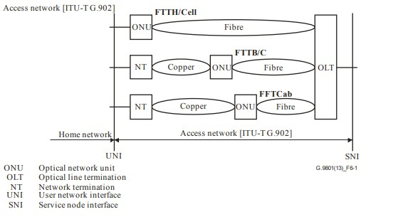

Fig. 3.10: FTTx Network Architecture [ITU-T G.983.1 (01/2005)]

### 3.3.3 FTTH Functional Component

* Optical Line Termination

The Optical Line Termination (OLT) interface is over the SNI to service nodes, and to the PON. The OLT is connected to the switched networks via standardized interfaces (VB5.x, V5.x, NNI's). The OLT is responsible for managing all the PON-specific aspects of the ATM transport system. The ONU and OLT provide transparent ATM transport service between the UNIs and the SNI over the PON.

* Optical Network Unit

The Optical Network Unit (ONU) interfaces over the IFPON to the OLT, and to the UNI. Together with the OLT, the ONU is responsible for providing transparent ATM transport service between the UNI and the SNI. In this architecture, the ATM transport protocols at an IFPON are described as consisting of Physical Media Dependent layer, Transmission Convergence layer, and ATM layer. The Physical Media Dependent layer would include the modulation schemes for both the upstream and downstream channels (they may be different).

* Optical Distribution Network

The Optical Distribution Network provides the optical transmission means from the OLT towards the users and vice versa. It utilizes passive optical components.

## 3.4 NGN Core

MPLS (Multi protocol label switching) is used at core transport technology used in NGN network.

### 3.4.1 MPLS Overview

As a packet of a connectionless network layer protocol travels from one router to the next, each router makes an independent forwarding decision for that packet. That is, each router analyzes the packets header, and each router runs a network layer routing algorithm. Each router independently chooses a next hop for the packet, based on its analysis of the packet's header and the results of running the routing algorithm.

Packet headers contain considerably more information than is needed simply to choose the next hop. Choosing the next hop can therefore be thought of as the composition of two functions. The first function partitions the entire set of possible packets into a set of Forwarding Equivalence Classes (FECs).The second maps each FEC to a next hop. In so far as the forwarding decision is concerned, different packets which get mapped into the same FEC are indistinguishable. All packets which belong to a particular FEC and which travel from a particular node will follow the same path (or if certain kinds of multi-path routing are in use, they will all follow one of a set of paths associated with the FEC).

In conventional IP forwarding, a particular router will typically consider two packets to be in the same FEC if there is some address prefix X in that router's routing tables such that X is the "longest match" for each packet's destination address. As the packet transverse the network, each hop in turn reexamines the packet and assigns it to a FEC.

In MPLS, the assignment of a particular packet to a particular FEC is done just once, as the packet enters the network. The FEC to which the packet is assigned is encoded as a short fixed length value known as a "label". When a packet is forwarded to its next hop, the labels sent along with it; that is, the packets are "labeled" before they were forwarded.

At subsequent hops, there is no further analysis of the packet's network layer header. Rather, the label is used as an index into a table which specifies the next hop, and a new label. The old label is replaced with the new label, and the packet is forwarded to its next hop.

### 3.4.2 MPLS Basics

I. Labels

A label is a short, fixed length, locally significant identifier which is used to identify a FEC. The label which is put on a particular packet represents the Forwarding Equivalence Class to which that packet is assigned.

Most commonly, a packet is assigned to a FEC based on its network layer destination address.

For example If Ru and Rd are LSRs, they may agree that when Ru transmits a packet to Rd, Ru will label with packet with label value L if and only if the packet is a member of a particular FEC That is, they can agree to a "binding" between label L and FEC F for packets moving from Ru to Rd. As a result of such an agreement, L becomes Ru's "outgoing label" representing FEC F, and L becomes Rd's "incoming label" representing FEC.

II. Label Switch Router

A label switch router (LSR) is a router that supports MPLS. It is capable of understanding MPLS labels and of receiving and transmitting a labeled packet on a data link. Three kinds of LSRs exist in an MPLS network:

1. Ingress LSRs—Ingress LSRs receive a packet that is not labeled yet, insert a label (stack) in front of the packet, and send it on a data link.
2. Egress LSRs—Egress LSRs receive labeled packets, remove the label(s), and send them on a data link. Ingress and egress LSRs are edge LSRs.
3. Intermediate LSRs—Intermediate LSRs receive an incoming labeled packet, perform an operation on it, switch the packet, and send the packet on the correct data link.

Upstream and Downstream LSRs

Suppose Ru and Rd have agreed to bind label L to FEC, for packets sent from Ru to Rd. Then with respect to this binding, Ru is the "upstream LSR", and Rd is the "downstream LSR". An LSR can do the three operations: PUSH, POP, or SWAP. It must be able to pop one or more labels (remove one or more labels from the top of the label stack) before switching the packet out. An LSR must also be able to push one or more labels onto the received packet. If the received packet is already labeled, the LSR pushes one or more labels onto the label stack and switches out the packet. If the packet is not labeled yet, the LSR creates a label stack and pushes it onto the packet. An LSR must also be able to swap a label. This simply means that when a labeled packet is received, the top label of the label stack is swapped with a new label and the packet is switched on the outgoing data link. An LSR that pushes labels onto a packet that was not labeled yet is called an imposing LSR because it is the first LSR to impose labels onto the packet. One that is doing imposition is ingress LSR. An LSR that removes all labels from the labeled packet before switching out the packet is a disposing LSR. One that does disposition is an egress LSR.

In case of MPLS, the ingress and egress LSRs are referred to as provider edge (PE) routers. Intermediate LSRs are referred to as provider (P) routers.

**i.** Label Switch path

A label switched path (LSP) is a sequence of LSRs that switch a labeled packet through an MPLS network or part of an MPLS network. Basically, the LSP is the path through the MPLS network or a part of it that packets take. The first LSR of an LSP is the ingress LSR for that LSP, whereas the last LSR of the LSP is the egress LSR. All the LSRs in between the ingress and egress LSRs are the intermediate LSRs. LSP is unidirectional. The flow of labeled packets in the other direction right to left between the same edge LSRs would be another LSP. **ii.** MPLS Header



#### Fig 3.11.: Header Field of One MPLS Label

A "labeled packet" is a packet into which a label has been encoded. One MPLS label is a field of 32 bits with a certain structure. Fig.3.11 shows the syntax of one MPLS label.

* The first 20 bits are the label value. This value can be between 0 and, 220 - 1 or 1,048,575. However, the first 16 values are exempted from normal use; that is, they have a special meaning.
* The bits 20 to 22 are the three experimental (EXP) bits. These bits are used solely for quality of service (QoS).
* Bit 23 is the Bottom of Stack (BoS) bit. It is 0, unless this is the bottom label in the stack. If so, the BoS bit is set to 1. The stack is the collection of labels that are found on top of the packet. The stack can consist of just one label, or it might have more. The number of labels (that is, the 32-bit field) that we can find in the stack is limitless, although we should seldom see a stack that consists of four or more labels.
* Bits 24 to 31 are the eight bits used for Time to Live (TTL). This TTL has the same function as the TTL found in the IP header. It is simply decreased by 1 at each hop, and its main function is to avoid a packet being stuck in a routing loop. If a routing loop occurs and no TTL is present, the packet loops forever. If the TTL of the label reaches 0, the packet is discarded.

### 3.4.3 MPLS Features

1. MPLS technology capable of efficiently supporting packet-based services and applications on their transport networks with guaranteed Service Level Agreements (SLAs).
2. MPLS increases operator revenue while keeping lowest network Total Cost of Ownership(TCO).Investment in equipment and facilities Capital Expenditure(CAPEX)) and Operational Expenditure (OPEX) should be minimized.
3. MPLS gives options for carriers to meet the challenge of increased service sophistication and transport efficiency, with increasing usage of hybrid packet-transport and circuittransport technology solutions by offering the same high benchmarks for reliability and operational simplicity set by SDH/SONET and OTN technologies.
4. MPLS provide control and deterministic usage of network resources, end-to-end control to engineer network paths and to efficiently utilize network resources.
5. MPLS capable to support static (management-plane-based) or dynamic (control-planebased) provisioning of deterministic, protected, and secured services and their associated resources.
6. It is ensure smooth interworking of the packet transport network with other existing/legacy packet networks,

### 3.4.4 Advantages of MPLS

In the MPLS forwarding paradigm, once a packet is assigned to a FEC, no further header analysis is done by subsequent routers; all forwarding is driven by the labels. This has a number of advantages over conventional network layer forwarding.

1. MPLS forwarding can be done by switches which are capable of doing label lookup and replacement, but are either not capable of analyzing the network layer headers or are not capable of analyzing the network layer headers at adequate speed.
2. Since a packet is assigned to a FEC when it enters the network, the ingress router may use, in determining the assignment, any information it has about the packet, even if that information cannot be gleaned from the network layer header. For example, packets arriving on different ports may be assigned to different FECs. Conventional forwarding, on the other hand, can only consider information which travels with the packet in the packet header.
3. A packet that enters the network at a particular router can be labeled differently than the same packet entering the network at a different router, and as a result forwarding decisions that depend on the ingress router can be easily made. This cannot be done with conventional forwarding, since the identity of a packet's ingress router does not travel with the packet.
4. The considerations that determine how a packet is assigned to a FEC can become ever more and more complicated, without any impact at all on the routers that merely forward labeled packets.
5. Sometimes it is desirable to force a packet to follow a particular route which is explicitly chosen at or before the time the packet enters the network, rather than being chosen by the normal dynamic routing algorithm as the packet travels through the network. This may be done as a matter of policy, or to support traffic engineering. In conventional forwarding, this requires the packet to carry an encoding of its route along with it ("source routing"). In MPLS, a label can be used to represent the route, so that the identity of the explicit route need not be carried with the packet.
6. Some routers analyze a packet's network layer header not merely to choose the packet's next hop, but also to determine a packet's precedence" or "class of service". They may then apply different discard thresholds or scheduling disciplines to different packets. MPLS allows (but does not require) the precedence or class of service to be fully or partially inferred from the label. In this case, one may say that the label represents the combination of a FEC and a precedence or class of service. MPLS stands for "Multiprotocol" Label Switching, multiprotocol because its techniques are applicable to ANY network layer protocol.

**3.5 Next generation transmission system:**

### 3.5.1 Synchronous Digital Hierarchy (SDH)

Bandwidth demand continues to grow worldwide, stimulated by the accelerating growth and penetration of new packet-based services such as Ethernet, Voice over IP (VoIP), Layer 2 (L2) / Layer 3 (L3) Virtual Private Networks (VPNs), IP television (IPTV), Radio Access Network (RAN) backhauling, etc. and multimedia applications as Packet-based services applications with various bandwidth and Quality of Service (QoS) requirements. This growth in demand has resulted in dramatic increases in access rates that are, in turn, driving dramatic increases in metro and core network bandwidth requirements. Over the period, the evolving optical transport infrastructure (Synchronous Optical Networking (SONET) / Synchronous Digital Hierarchy (SDH), Optical Transport Network (OTN)) has provided carriers with a high benchmark for reliability and operational simplicity.

Synchronous digital hierarchy (SDH) are standardized protocols that transfer multiple digital bit streams synchronously over optical fiber using [lasers](https://en.wikipedia.org/wiki/Laser) or highly coherent from lightemitting diodes (LEDs). At low transmission rates data can also be transferred via an electrical interface. The method was developed to replace the Plesiochronous Digital Hierarchy (PDH) system for transporting large amounts of telephone calls and data traffic over the same fiber without the problems of synchronization.

SONET and SDH, which are essentially the same, were originally designed to transport [circuit mode](https://en.wikipedia.org/wiki/Circuit_mode) communications (e.g., E1, E3) from a variety of different sources, but they were primarily

Designed to support real-time, uncompressed, circuit-switched voice encoded in [PCM](https://en.wikipedia.org/wiki/Pulse-code_modulation) format.The primary difficulty in PDH was that the synchronization sources of these various circuits were different. This meant that each circuit was actually operating at a slightly different rate and with different phase. SDH allowed for the simultaneous transport of many different circuits of differing origin within a single framing protocol. SDH is not a communications protocol in itself, but a transport protocol.

#### Table 3.2 SDHData Rates

|  |  |  |  |  |  |  |
| --- | --- | --- | --- | --- | --- | --- |
|  | SDH Level | | Payload Bandwidth (kbits/Sec) | Line Rate | Equivalent SONET  Optical Carrier Level | SONET Frame |
| STM -0 | | 50,112 | 51,840 | OC -1 | STS -1 |
| STM-1 | | 150,336 | 155,520 | OC-3 | STS-3 |
| STM -4 | | 601,344 | 622,080 | OC-12 | STS-12 |
| -- | | 1,202,688 | 1,244,160 | OC-24 | STS-24 |
| STM -16 | | 2,405,376 | 2,488,320 | OC-48 | STS-48 |
| STM-64 | | 9,621,504 | 9,953,280 | OC-192 | STS-192 |
| STM -256 | | 38,486,016 | 39,813,120 | OC-768 | STS-768 |
| SDH Frame | |  |  |  |  |  |

The Synchronous Transport Module, level 1 (STM-1) frame is the basic transmission format for SDH—the first level of the synchronous digital hierarchy. The STM-1 frame is transmitted in exactly 125 [µs,](https://en.wikipedia.org/wiki/Microsecond) therefore, there are 8,000 frames per second on a 155.52 Mbit/s.

The STM-4 has a bit rate of 622.080 Mbit/s. This is called STM-4. The STM-4 specification is designed to carry 7,680 8-bit "voice" frames every 125 micro-seconds for a total payload bit rate of 622,080 Mbit/s. The other levels defined by the SDH standard are [STM-1,](https://en.wikipedia.org/wiki/STM-1) [STM16,](https://en.wikipedia.org/wiki/STM-16) [STM-64](https://en.wikipedia.org/wiki/STM-64) and [STM-256.](https://en.wikipedia.org/wiki/STM-256).

Each rate is an exact multiple of the lower rate, therefore the hierarchy is synchronous.

### 3.5.2 Optical Transport Network

OTN is the next generation industry standard protocol facilitating integration of legacy TDM networks and the IP-based packet switched networks over a WDM system. The OTN architecture is defined by ITU-T recommendation G.872. The OTN layer can be positioned over the layer-1 DWDM networks, thereby facilitating efficient convergence of traditional SONET/SDH and IP-based data service. OTN provide multiservice provisioning capabilities, enabling effective mapping of multiprotocol, multibit rates through 100-Gbps pipes in a transparent manner with native support.

#### Table 3.3 Transmission Technology Features

|  |  |  |  |
| --- | --- | --- | --- |
| Sr. No. | Technology | Bit Rate | Features |
| 1 | SDH | 51.84Mbps39.13Gbps | Performance Monitoring, Fault Detection,  Connection Channel and Multiplexing features available. |
| 2 | WDM/DWDM | Up to 400 Gbps | All SDH features available. Higher bit rate achieved with WDM/DWDM Multiplexing. |
| 3 | OTN | Up to 400 Gbps | All features DWDM available. Operation,  Network Management and Protection facility available. |

#### Table 3.4 OTN STANDARDS

|  |  |
| --- | --- |
| **ITU-T**  **STANDARDS** | **DESCRIPTION** |
| G.878 | OTN architecture |
| G.709 | Frame format and payload mapping (Ethernet ,storage, SDH/SONET) |
| G.798 | Characteristics of optical transport network hierarchy equipment functional blocks |
| G.873.1 | Optical transport networks (OTN): Linear protection |

The OTN consists of four layers. Namely optical channel, optical transport unit, optical data

unit, optical payload unit. Table 3.4 list out the functions of layers Table 3.5 OTN Layers

|  |  |
| --- | --- |
| OTN layer | Function |
| Optical channel (OCH) | End to end optical path |
| Optical transport unit(OTU) | Represent physical optical port Performance monitoring |
| Optical data unit (ODU) | Path level monitoring , alarm indication signals , Automatic protection switching |
| Optical Payload unit (OPU) | Client signal encapsulation , Rate Justification |

OTN support transport of range of protocols including SDH/SONET, IP, ATM, frame relay, and storage area networks (SANs) in their original format. It does not perform any mapping or de-mapping process.

The functions G 709 OTN control plane are

1. Improving operational efficiency
2. Compute optimal client connection path
3. Computing diverse protection path
4. Reserving bandwidth
5. Ensures optimal utilization of network resources

According to ITU T G872, OTN architecture consists of Optical channel, Optical multiplex Section (OMS) and Optical transmission section (OTS)

#### Table 3.6-G872 OTN Layers

|  |  |
| --- | --- |
| **OTN layer** | **Function** |
| Optical channel (OCH) | 1. Optical signal transmission 2. Ensuring integrity and maintenance of optical signals |
| Optical multiplex section (OMS ) | 1. Networking functionality for multi-wavelength optical signals 2. Ensuring integrity and maintenance of optical signals |
| Optical transmission section (OTS) | 1. End to End (E2E) networking of optical channels with encapsulation of client signals 2. Flexible routing and OAM functions |

#### **Key features of OTN:-** • 400 Gbps support

* Generic mapping procedure
* Support for 1.25 Gbps tributaries
* Support multistage multiplexing
* Support internal switching at 1.25 Gbps
* Stronger forward error correction
* Enhanced tandem connection monitoring• Switching scalability

**3.5.3 Passive Optical Network Access: BPON, Ethernet PON, Gigabit PON**

## Features:-

PON systems such as B-PON, G-PON and XG-PON defined in ITU-T Recommendations, and 1G-EPON and 10G-EPON defined in IEEE • Broadband Passive Optical Network (B-PON)

ATM-based Broadband Passive Optical Network (B-PON) provides a flexible optical fiber access network capable of supporting the bandwidth requirements of narrowband and broadband services. It describes systems with nominal downstream line rates of 155.52, 622.08 and 1244.16 Mbit/s, and nominal upstream line rates of 155.52 and 622.08 Mbit/s. Reference configuration for an ATM based PON as shown in Fig 3.12 • Gigabit-capable passive optical networks (GPON):

GPON is also described as 1G-EPON in IEEE (802.3). GPON describes a flexible optical fibre access network capable of supporting the bandwidth requirements of business and residential services and covers systems with nominal line rates of 2.4 Gbit/s in the downstream direction and 1.2 Gbit/s and 2.4 Gbit/s in the upstream direction. GPON able to support service following service

1. Data Service (Ethernet)
2. PSTN (POTS, ISDN-BRI, ISDN-PRI)
3. Private Line(2.048 Mbit/s E1, 34.368 Mbit/s E3)
4. Video (Video over IP)

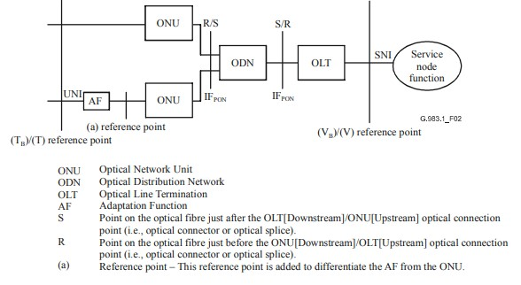

### Fig. 3.12: Reference configuration for an ATM based PON [ITU-T G.983.1(01/2005)]

Reference configuration for GPON as shown in Fig 3.13

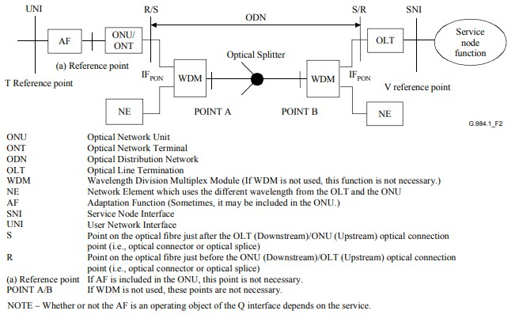

Fig. 3.13: Reference configuration for G PON [ITU-T G.984.1 (3/2008)]

• 10-Gigabit-capable passive optical network (XG-PON) systems XG-PON is also described as 10G-EPON in IEEE (802.3).

XG-PON able to support service following service

1. Telephony (POTS, VoIP)
2. TV -Real-time (IPTV, Digital TV broadcasting
3. Leased line(2.048 Mbit/s E1)
4. High speed Internet access(UNI is typically Gigabit Ethernet)
5. L2 VPN Services(Ethernet services)
6. IP Services (L3 VPN, and VoIP)
7. Mobile backhaul

Coexistence of G-PON and XG-PON with Video Overlay as shown in fig. 3.14

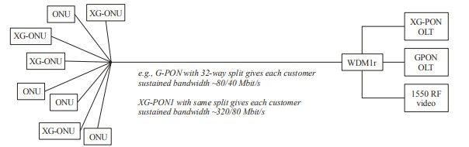

Fig. 3.14: Coexistence of G-PON and XG-PON with Video Overlay [ITU-T G.987.1 (3/2016)]

The wavelength range of the XG-PON1 downstream signal on a single-fiber system is from 1575-1580 nm (1575-1581 nm for outdoor application), and the range of upstream signal for XG-PON1 is from 1260-1280 nm

1G class PON, 10G class PON and video distribution services can co-exist on the same ODN because their downstream signals use different wavelengths. However, TDMA technology is necessary for multiplexing upstream signals of 1G class PON and 10G classes PON because some of their wavelengths are the same.

### List of standards for NGN

ITU-T Recommendation Y.2001

ITU-T Y.2341 specifies requirements of profile management, identification, messaging related features, open API, resource allocation and policy control, as well as capabilities support of service stratum, transport stratum and end user in next generation network (NGN) evolution for supporting authorized account messaging service.

### ITU-T recommendation G.872 NGN

ITU T G872, OTN architecture

G 709 OTN control plane

G.873.1 Optical transport networks (OTN): Linear protection

G.798Characteristics of optical transport network hierarchy equipment functional blocks

### Resources

|  |  |
| --- | --- |
| Sr. No. | Website used |
| 1. | [www.trai.gov.in](http://www.trai.gov.in/) |
| 2. | [https://www.itu.int/rec/dologin_pub.asp?lang=e&id=T-RECY.2012-200609-S!!PDF-E&type=items](https://www.itu.int/rec/dologin_pub.asp?lang=e&id=T-REC-Y.2012-200609-S!!PDF-E&type=items) |
| 3. | [https://pdfs.semanticscholar.org/4dfd/40cc3a386573ee861c5329ab4 c6711210819.pdf](https://pdfs.semanticscholar.org/4dfd/40cc3a386573ee861c5329ab4c6711210819.pdf) |
| 4. | [www.tec.gov.in](http://www.tec.gov.in/) |

**Sample Question**:

|  |  |
| --- | --- |
| Sr.  No. | Question |
| 1. | The E2Eoptical path in an OTN network is specified by layer   1. ODU 2. OTU 3. OCH 4. OPU |
| 2. | In NGN ,the interface not supporting media interaction is   1. UNI 2. ANI 3. NNI 4. SNI |
| 3. | Number of layer in NGN architecture are   1. 7 2. 6 3. 5 4. 4 |
| 4. | In NGN communication is possible   1. Within a city 2. Within a state 3. Within a country 4. Anywhere in world |
| 5. | Layers of NGN are   1. Access ,Transport, Control ,Service Layer 2. Physical , Data link, Network , Session Layer 3. Application , Session , Data link , Network, Transport, layerD. Network , Application Layer |
| 6. | In NGN CDF (Content Delivery Function ) is a function of   1. Transport Stratum 2. Service Stratum 3. Transport and Service stratum 4. Not from above |
| 7. | The wavelength range of the XG-PON1 downstream signal and the range of upstream signal on a single-fiber system are   1. Same 2. For downs stream signal wavelength is greater than that of upstream signal 3. For downs stream signal wavelength is lower than that of upstream signal D. Depend on application it varies |
| 8. | ---------- multiplexing is used in 3G.   1. FDMA 2. CDMA 3. TDMA 4. Not From Above |
| 9. | MPLS header length is a field of ---- bits.   1. 32 2. 24 3. 20 4. 8 |
| Sr.  No. | Question |
| 10. | 8000 frames/sec are transmitted in 125 µsec, in   1. STM-4 2. STM-64 3. STM-1 4. STM-256 |
| 11. | The use of EXP (Experimental) bits are   1. Quality of service 2. Avoid a packet being stuck in a routing loop 3. Receiving, transmitting a labeled packet on a data link. 4. Not from above |
| 12. | The protection scheme in an OTN network is defined by   1. G 709 2. G 873.1 3. G 798 4. G 872 |
| 13. | SDH is ----------   1. Session layer Protocol 2. Transport layer Protocol 3. Service Protocol 4. Application Protocol |
| 14. | Data speed in 5G is -------- A. More than 1Gbps   1. 64Kbps 2. 2 Mbps 3. 4 Kbps |
| 15. | TTL in a MPLS label is   1. Transistor Transistor Logic 2. Time To Live 3. Technology Transfer Layer 4. Not from above |

# UNIT 4 Digital Factory

## Teaching Hrs.10 Marks 16

**Course Outcome: -**Suggest the relevant Internet of Things ( IoT) Technologies for the Digital Factory

**To attain above course outcome candidate must able to:**

1. Explain the principle of IoT.
2. Explain the architecture of IoT.
3. Explain the importance of Industrial evolution of I4.0

## ____________________________________________________________________

**Unit focus on following major points:**

4.1 **Internet of Things**: Introduction, principles and features of Cyber Physical system Components [Sensors, Edge-Gateways, Cloud].

4.2 **Architectures** [ Sensor to cloud various data routes: sensor-PLC-SCADA-cloud, sensor-server-cloud, sensor-edge gateway-cloud], Applications in Automotive/ Discreet Manufacturing; Telecom Industry; Agro Industries.

4.3 **I4.0/IIoT/ Smart Manufacturing**: Introduction/ Evolution from I1.0 to I4.0,

Applications and benefits of I4.0, Compare I3.0 with I4.0, Architecture of I4.0

**Introduction:**

**Digital Factory:** A digital factory uses digital technology for modeling, communications and to operate the manufacturing process. This arrangement of technology allows managers to configure, model, simulate, assess and evaluate items, procedures and system before the factory is constructed. The digital factory gives answers for configuration, design, screen and control of a production system. It adopts the combination of physical technology and cyber technology and deeply integrates previously independent discrete systems making the involved technologies more complex and precise than they are now.

In the implementation of digital factory, the Industrial Internet of Things (IIoT) is employed to integrate the underlying equipment resources. Accordingly, the manufacturing system has abilities of perception ,interconnection and data integration. The data analysis and scientific decision are used to achieve production scheduling, equipment service and quality control of products in digital factory. Further, the Internet of services is introduced to virtualize the manufacturing resources from a local database to the cloud server. Through the humanmachine interaction, the global collaborative process of intelligent manufacturing oriented to the order-driven market is built. Therefore, the digital factory represents an engineering system that mainly consists of three aspects: interconnection, collaboration and execution. The main aim of digital factory is to convert modern factory into smart factory.

**4.1 The Internet of Things** (IoT) is a system of interrelated computing devices, mechanical and digital machines, objects, animals or people that are provided with unique identifiers [(UIDs)](https://internetofthingsagenda.techtarget.com/definition/unique-identifier-UID) and the ability to transfer data over a network without requiring human-to-human or human-to-computer interaction.

**Things:** A thing, in the context of the IoT is an entity or physical object that has a unique identifier, an embedded system and the ability to transfer data over a network. Things can be a part of domestic, process or manufacturing areas like smart TV, PLC, CNC machine etc. IoT evolved from machine-to-machine ([M2M)](https://internetofthingsagenda.techtarget.com/definition/machine-to-machine-M2M) communication, i.e., machines connecting to each other via a network without human interaction. M2M refers to connecting a device to the cloud, managing it and collecting data. Taking M2M to the next level, IoT is a sensor network of billions of smart devices that connect people, systems and other applications to collect and share data. As its foundation, M2M offers the connectivity that enables IoT.

The IoT is also a natural extension of [SCADA](https://whatis.techtarget.com/definition/SCADA-supervisory-control-and-data-acquisition) (supervisory control and data acquisition), a category of software application program for process control, the gathering of data in real time from remote locations to control equipment and conditions. SCADA systems include hardware and software components. The hardware gathers and feeds data into a computer that has SCADA software installed, where it is then processed and presented it in a timely manner. The evolution of SCADA is such that late-generation SCADA systems developed into firstgeneration IoT systems.

## Major components of IoT system

1. **Physical object:** with embedded software into hardware
2. **Hardware:** Consisting of microcontroller, firmware, sensors, control unit, actuators, and communication modules.
3. **Communication Module:** Software consisting of device APIs and device interface for communication over the network and communication circuits, ports and middleware for creating communication stacks using 6lowPAN, CoAP, LWM2M, IPv4, IPv6, ZigBee and other protocols
4. **Software:** for actions on messages, information and commands which devices receives and drives actuators which enables actions such as glowing light on/off, domestic or industrial equipment’s**.**

**Examples of IoT:** The first most smart and interactive IoT device is the ATM, Others are smart watches, fitness trackers, sleep monitors, heart monitors.

**An IoT ecosystem:** consists of web-enabled smart devices that use embedded processors, sensors and communication hardware to collect, send and act on data they acquire from their environments as shown in fig 4.1.

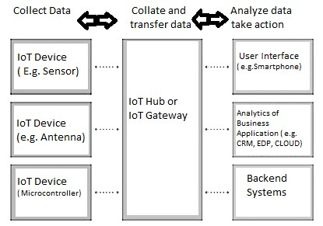

### Fig 4.1: IoT System

[IoT devices](https://internetofthingsagenda.techtarget.com/definition/IoT-device) share the sensor data they collect by connecting to an IoT gateway or other edge device where data is either sent to the cloud to be analyzed or analyzed locally. Sometimes, these devices communicate with other related devices and act on the information they get from one another. The devices do most of the work without human intervention, although people can interact with the devices -- for instance, to set them up, give them instructions or access the data.

The connectivity, networking and communication protocols used with these web-enabled devices largely depend on the specific IoT applications deployed.

**Importance of IoT:**

1. The IoT helps people live and work smarter as well as gain complete control over their lives and also offers smart devices to automate homes.
2. IoT provides businesses with a real-time look into how their companies’ systems really work, delivering insights into everything from the performance of machines to supply chain and logistics operations.
3. IoT enables companies to automate processes and reduce labor costs.
4. It also cuts down on waste and improves service delivery, making it less expensive to manufacture and deliver goods as well as offering transparency into customer transactions.
5. IoT touches every industry, including healthcare, finance, retail and manufacturing.
6. Smart cities help citizens reduce waste and energy consumption and connected sensors are even used in farming to help monitor crop and cattle yields and predict growth patterns. As such, IoT is one of the most important technologies of everyday life and it will continue to pick up steam as more businesses realize the potential of connected devices to keep them competitive.

Advantages of IoT:

1. Ability to access information from anywhere at any time on any device.
2. Improved communication between connected electronic devices.
3. Monitor their overall business processes.
4. Improve the customer experience.
5. Save time and money.
6. Enhance employee productivity.
7. Integrate and adapt business models.
8. Make better business decisions.
9. Generate more revenue.
10. IoT encourages companies to rethink the ways they approach their businesses, industries and markets and gives them the tools to improve their business strategies
11. Transferring data packets over a connected network saves time and money.
12. Automating tasks helps improve the quality of a business’ services and reduces the need for human intervention.

Disadvantages of IoT:

1. As the number of connected devices increases and more information is shared between devices, the potential that a hacker could steal confidential information also increases.
2. Enterprises may eventually have to deal with massive numbers of IoT devices and collecting and managing the data from all those devices will be challenging.
3. If there’s a bug in the system, it’s likely that every connected device will become corrupted/ effected.
4. Since there’s no international standard of compatibility for IoT, it’s difficult for devices from different manufacturers to communicate with each other.

**4.1.1: Cyber Physical system components:**

**Cyber-Physical Systems (CPSs):** Cyber-Physical Systems represent systems, where computations are tightly coupled with the physical world, meaning that physical data is the core component that drives computation. Industrial automation systems, wireless sensor networks, mobile robots and vehicular networks are just a sample of cyber-physical systems. CPS’s have limited computation and storage capabilities due to their tiny size and being embedded into larger systems. CPSs extend their capabilities by taking advantage of the emergence of cloud computing and the IoT.

**Sensors:**

Different types of applications require different types of sensors to collect data from the environment. In an IoT ecosystem, two things are very important: the Internet and physical devices like sensors and actuators.

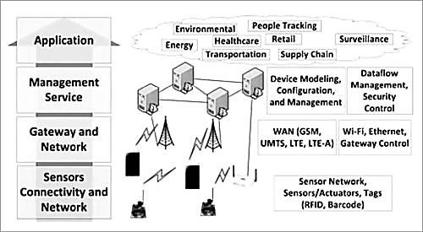

Fig. 4.2: IoT architecture layers

As shown in Fig 4.2, the bottom layer of the IoT system consists of sensor connectivity and network to collect information. This layer is an essential part of the IoT system and has network connectivity to the next layer, which is the gateway and network layer.

The main purpose of sensors is to collect data from the surrounding environment. Sensors, or

‘things’ of the IoT system, form the front end. These are connected directly or indirectly to IoT networks after signal conversion and processing. But all sensors are not the same and different IoT applications require different types of sensors. For instance, digital sensors are straightforward and easy to interface with a microcontroller using Serial Peripheral Interface (SPI) bus. But for analogue sensors, either analogue-to-digital converter (ADC) or SigmaDelta modulator is used to convert the data into SPI output.

**Edge Gateway:**

The main function of the Edge (IoT) Gateway:

* Forwarding packets between LAN and WAN on the IP layer
* Performs application layer functions between IoT nodes and other entities
* Enables local, short-range communication between IoT devices

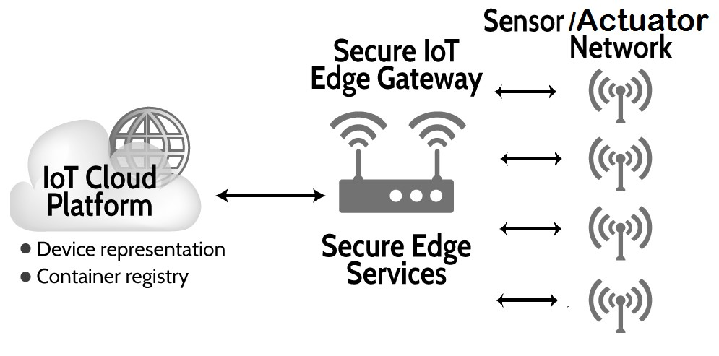

### Fig 4.3: Edge gateway

An IoT gateway is a physical [device](https://internetofthingsagenda.techtarget.com/definition/IoT-device) or software program that serves as the connection point between the [cloud](https://searchnetworking.techtarget.com/definition/cloud) and controllers, sensors and intelligent devices as shown in fig 4.3. All data moving to the cloud, or vice versa, goes through the gateway, which can be either a dedicated hardware appliance or software program. An IoT gateway may also be referred to as an intelligent gateway or a control tier.

Some [sensors](https://whatis.techtarget.com/definition/sensor) generate tens of thousands of data points per second. A gateway provides a place to preprocess that data locally at the [edge](https://searchdatacenter.techtarget.com/definition/edge-computing) before sending it on to the cloud. When data is aggregated, summarized and tactically [analyzed](https://searchbusinessanalytics.techtarget.com/definition/edge-analytics) at the edge, it minimizes the volume of data that needs to be forwarded on to the cloud, that have a big impact on response times and network transmission costs.

Another benefit of an IoT gateway is that it can provide additional security for the IoT network and the data it transports. Because the gateway manages information moving in both directions, it can protect data moving to the cloud from leaks and IoT devices from being compromised by malicious outside attacks with features such as tamper detection, [encryption,](https://searchsecurity.techtarget.com/definition/encryption) hardware random number generators and crypto engines.

**Cloud:**

Cloud has the responsibility of accepting large amount of information from the IoT gateway, store and process them into actionable resources and send them to the user interface (web app/mobile app/dashboard).

There is an inextricable link between IoT and Cloud. The data collected by the sensors is quite huge in the case of an industrial application of IoT and a gateway is not capable of processing and storing it. This data is stored in cloud (a secure database) and processed in an affordable and scalable way. (Refer fig 4.4)

The cloud is connected to the IoT gateway through the internet and receives all the data fed to the gateway by the sensors. There are a few protocols that connect gateways to the IoT cloud applications and the most common among them is MQTT.

Sensors collect and feed data at all times and this huge chunk of data after the aggregation and some pre-processing is transferred to the cloud for storage and processing

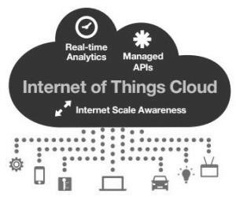

### Fig 4.4: Cloud basics

Depending on the nature of the IoT implementation the cloud may have varying degrees of complexity. In simple applications, the cloud may consist of a database that stores the data collected by the IoT as well as the information of the users who possess the right to access/modify the data.

In bigger and more complex implementations the IOT cloud applications may also have the capability of machine learning, performing analytics, generating reports and more.

IoT Cloud Applications:

Cloud is where the real action takes place. IoT cloud application along with the APIs and other interfaces manage the data and commands to and from the sensors or the gateways. Different APIs need to be integrated so that the data is read and stored accurately.

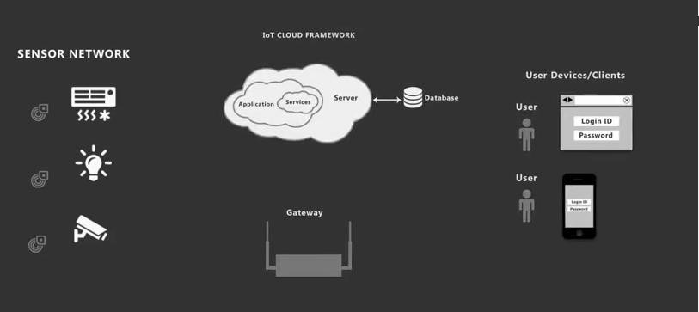

### Fig 4.5: Cloud Application

Some of the protocols such as MQTT, Web socket, CoAP, and AMQP are used to develop a powerful and secure interface that facilitates seamless communication between the sensors and the cloud. In order to ensure that there is no data loss during heavy inflow of data, a robust database is designed as well.

**Benefits of Cloud in an IoT ecosystem:**

1. Caters the data storage and processing demands of IoT:

IoT has huge potential and in near future, all kinds of physical entities connected to each other. This would require raw computing power and only cloud can provide that.

1. Advanced analytics and monitoring:

With ‘things’ now being connected, there would be a need for constant analysis and monitoring in order to ensure seamless IoT experience to the users. Advanced cloud application development will ensure that the cloud is equipped with such capabilities.

1. Smoother inter-device connectivity:

In an IoT, the sensors not only talk to the users, they also interact with each other. IoT Cloud applications along with the IoT gateway ensure that different sensors and actuators are able to talk to each other without any incompatibility.

## 4.2: Architecture: Data routes

Before revealing the IoT data routes it is important to understand, IoT architecture layers and elements such as sensors, protocols, actuators, cloud services, and layers. **IoT Architecture Layers:** Basically, there are three IoT architecture layers:

1. The client side (IoT Device Layer)
2. Operators on the server side (IoT Getaway Layer)
3. A pathway for connecting clients and operators (IoT Platform Layer)

In fact, addressing the needs of all these layers is crucial on all the stages of IoT architecture. Being the basis of feasibility criterion, this consistency makes the result designed really work. In addition, the fundamental features of sustainable IoT architecture include functionality, scalability, availability, and maintainability. Without addressing these conditions, the result of IoT architecture is a failure. Therefore, all the above-mentioned requirements are addressed in 4 stages of IoT architecture is as follows.

### Main Stages in the IoT Architecture Diagram

In simple terms, the 4 Stage IoT architecture consists of

1. Sensors and actuators
2. Internet getaways and Data Acquisition Systems
3. Edge IT
4. Data center and cloud.

The detailed presentation of these stages can be found in the fig 4.6 **Stage 1. Networked things (wireless sensors and actuators):**

The outstanding feature about sensors is their ability to convert the information obtained in the outer world into data for analysis. In other words, it’s important to start with the inclusion of sensors in the 4 stages of an IoT architecture framework to get information in an appearance that can be actually processed.

For actuators, the process goes even further — these devices are able to intervene the physical reality. For example, they can switch off the light and adjust the temperature in a room. Because of this, sensing and actuating stage covers and adjusts everything needed in the physical world to gain the necessary insights for further analysis.

**Stage 2. Sensor data aggregation systems and analog-to-digital data conversion:**

Even though this stage of IoT architecture still means working in a close proximity with sensors and actuators, Internet getaways and data acquisition systems (DAS) appear here too. Specifically, the later connect to the sensor network and aggregate output, while Internet getaways work through Wi-Fi, wired LANs and perform further processing.

The vital importance of this stage is to process the enormous amount of information collected on the previous stage and squeeze it to the optimal size for further analysis. Besides, the necessary conversion in terms of timing and structure happens here.

In short, Stage 2 makes data both digitalized and aggregated.

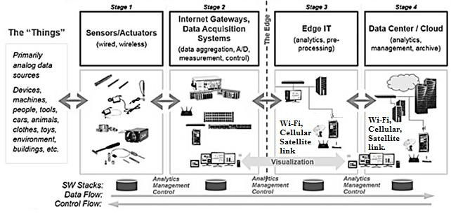

#### Fig 4.6: 4 Stage IoT Solutions Architecture

**Stage 3. Edge IT systems:**

In particular, edge IT systems perform enhanced analytics and pre-processing here. For example, it refers to machine learning and visualization technologies. At the same time, some additional processing may happen here, prior to the stage of entering the data center.

Likewise, Stage 3 is closely linked to the previous phases in the building of architecture of IoT. Because of this, the location of edge IT systems is close to the one where sensors and actuators are situated, creating a wiring closet. At the same time, the residing in remote offices is also possible.

**Stage 4. Analysis, management, and storage of data:**

The main processes on the last stage of IoT architecture happen in data center or cloud. Precisely, it enables in-depth processing, along with a follow-up revision for feedback. Here, the skills of both IT and OT (operational technology) professionals are needed. In other words, the phase already includes the analytical skills of the highest rank, both in digital and human worlds. Therefore, the data from other sources may be included here to ensure an in-depth analysis.

After meeting all the quality standards and requirements, the information is brought back to the physical world — but in a processed and precisely analyzed form.

**Stage 5 of IoT Architecture:**

In fact, there is an option to extend the process of building a sustainable IoT architecture by introducing an extra stage in it. It refers to initiating a user’s control over the structure — if only user result doesn’t include full automation. The main tasks here are visualization and management. After including Stage 5, the system turns into a circle where a user sends commands to sensors/actuators (Stage 1) to perform some actions.

And the process starts all over again.

**4.2.1 Sensor to Cloud various Data routes:** In the world of industrial automation, applying human-machine interface [HMI] to control and monitor machines, processes and even smart buildings has been a common practice for many years. These industrial HMIs, sometimes called operator interface terminals (OITs), are good at what they do but have traditionally required significant engineering effort for development, deployment and maintenance. They also typically include many proprietary elements and require ongoing expenditures for software and licensing.

Automation engineers are increasingly taking advantage of available “smart” systems in the field, including IoT devices. These devices have lots of useful data to offer and frequently need monitoring, and are sometimes used as inputs to real-time control systems. But the traditional methods of connecting these remote devices through standard industrial systems are difficult and costly.

However, a next generation of HMI and SCADA hardware and software addresses these and other challenges. By using the latest commercial and open-source technologies, these products can make users free to connect with smart systems, getting data, transforming it into actionable information, and visualizing it when and where user want. **Sensor-PLC-SCADA-Cloud data route:**

The “classic” approach involves several steps and linkages to make edge data available up to the cloud. These connections are difficult to configure initially, but they are also challenging to maintain over time, with required maintenance beginning at the periphery and progressing inward.

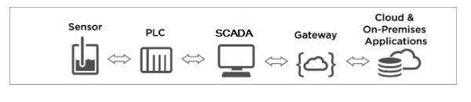

#### Fig 4.7: Sensor –PLC-SCADA- Cloud Data route

First, the field device is likely wired or networked to a local programmable logic controller (PLC), since this is often the nearest programmable system to the edge component. The PLC requires some device-specific communication driver or instructions to obtain the data, which may involve choosing the desired points and mapping them in a spreadsheet-like format. Next, the PLC data is networked up to a PC-based HMI or SCADA system, with either approach requiring configuration of data tags, drivers and polling rate assignments. In turn, the HMI or SCADA needs additional configuration or programming steps to transport the data into a cloud-based database, where it can be made more widely available.

**Drawbacks:** All these tasks are feasible and commonly employed, but they have many downsides:

1. Typical PLCs and communications drivers may be proprietary,
2. Requires costly configuration software and licenses.
3. Even with the right hardware and software in hand, designers require specialized knowledge of devices, programming and networking.
4. The last networking link from the project site to the cloud demands dedicated attention to go through firewalls and maintain security.

**Sensor- Server-Cloud Data Route:**

An IoT system has a three-level architecture: devices, gateways and data systems. The data moves between these levels via four types of transmission channels.

1.**Device to device (D2D)** — direct contact between two smart objects when they share information instantaneously without intermediaries. For example, industrial robots and sensors are connected to one another directly to coordinate their actions and perform the assembly of components more efficiently. This type of connection is not very common yet, because most devices are not able to handle such processes.

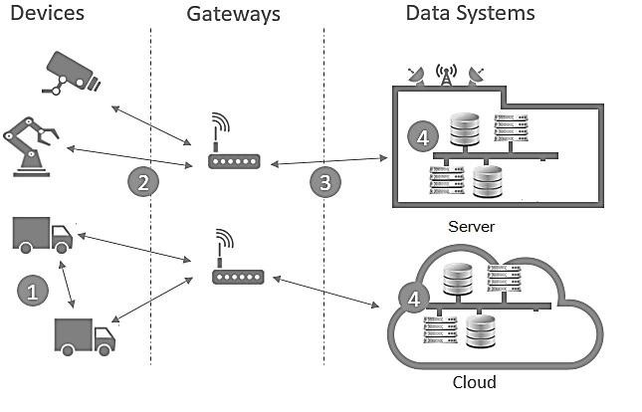

#### Fig 4.8 Sensor – Server-Cloud Data route

1. **Device to gateway** — telecommunications between sensors and gateway nodes. Gateways are more powerful computing devices than sensors. They have two main functions: to consolidate data from sensors and route it to the relevant data system; to analyze data and, if some problems are found, return it back to the device. There are various IoT gateway protocols that may better suit this or that solution depending on the gateway computing capabilities, network capacity and reliability, the frequency of data generation and its quality.
2. **Gateway to data systems** — data transmission from a gateway to the appropriate data system. To determine what protocol to use, you should analyze data traffic (frequency of burstiness and congestion, security requirements and how many parallel connections are needed).
3. **Between data systems** — information transfer within data centers or clouds. Protocols for this type of connection should be easy to deploy and integrate with existing apps, have high availability, capacity and reliable disaster recovery.

**Sensor to Edge gateway to Cloud Gateway:**

The [IoT](http://www.mouser.com/applications/internet-of-things/) is becoming an indispensable part of our daily lives: Where would user be without the ability to turn on the hot tub from users smart phone when user is still five miles from home? Don’t ask. Enabling functions like these—and others perhaps more critical—requires an ecosystem that consists of many components working seamlessly together. The architecture can be organized by function into several layers or tiers:

#### Fig 4.9 Sensor to Edge Gateway to Cloud Architecture

* **The Device layer** (also called the edge tier) typically contains three elements: Sensors measuring real-world data; actuators affecting changes to the real world; and transceivers transmitting sensor data and receiving actuator commands.
* **The Data way tier** acts as a secure intermediary between these sensors and actuators and the Cloud. An IoT gateway is an integral part of the IoT ecosystem, handling communication with local sensors and remote users as well as a suite of other functions.

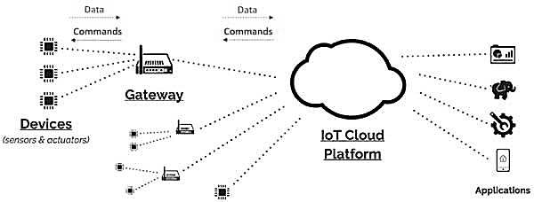

* **The Cloud tier** handles overall monitoring and management of the IoT ecosystem. It interfaces with multiple gateways and performs analytics on the collected and stored data.
* **The Application layer** is the interface to the end user, allowing access and control of IoT products and services

**4.2.2 IoT Applications:**

**Use of IoT in Automotive:**

IoT has a significant impact on automotive industry. Not long ago, the idea of IoT in the automotive sector was being seen as a futuristic theoretical concept and today we are already seeing possibilities of connected cars, driverless cars and application of IoT in the car ecosystem. This includes smart parking, environment, supply chain, transport governing bodies. It is also used in related automotive segments such as Car services/applications, Vehicle communications, IoT in Intelligent Transportation, IoT based Supply Chain Management in Automotive Industry and New Generation Cars.

IoT is at the heart of this digital transformation in Auto sector. It connects people, machines, vehicles, auto parts, and services to streamline the flow of data, enable real-time decisions, and improve automotive experiences. Leading automotive manufacturers, suppliers, and dealers have started investing heavily in IoT and are gaining returns in the form of efficient inventory management, real time promotions that grow sales, reduced operational expenses and increase in revenue. They are beginning to change their business processes and recognize that, in time, IoT will touch every area of automotive operations and customer engagement. Todays advanced car is one big IoT device with a lot of IoT properties inbuilt. Applications are developed that use data collected by connected cars in many ways.

Example, traffic control systems can provide real-time data collected from connected cars to avoid traffic jams and accidents. Automotive components manufacturers can benefit from data about wear and tear to pre-order the components to be replaced and notify customers before there are equipment failures. Car sharing mobile apps can use real-time location data to encourage car pools. Also, in insurance systems, premium rates would be based on geo location of vehicles and driving behavior of drivers.

Fig. 4.10 shows these and many more developments on IoT in Automotive sector these include:

* **Connected Car:** Automobile manufacturing companies, telecommunication service providers and software companies are coming together to build the Connected Car/ Internet enabled car. A connected car is a car which using its onboard sensors and internet connectivity enhances the in-car experience of its users. Connected car, just doesn’t mean the capacity to surf the internet on the move, but the communication between cars, communication of cars with other devices. As of date, there are only a small number of cars which are internet enabled but it is expected that the number will rise considerably in future.
* **Car Services/Applications: Infotainment:** Infotainment refers to a system in vehicles that delivers a combination of information and entertainment content/services. Typical features are – providing navigation features while driving, managing audio/visual entertainment content, delivering rear-seat entertainment, and connectivity with smart phones for hands free experience with the help of voice commands. With rapid growth in smart phone and Cloud technologies, consumers are demanding for live streaming of music and Internet radio.

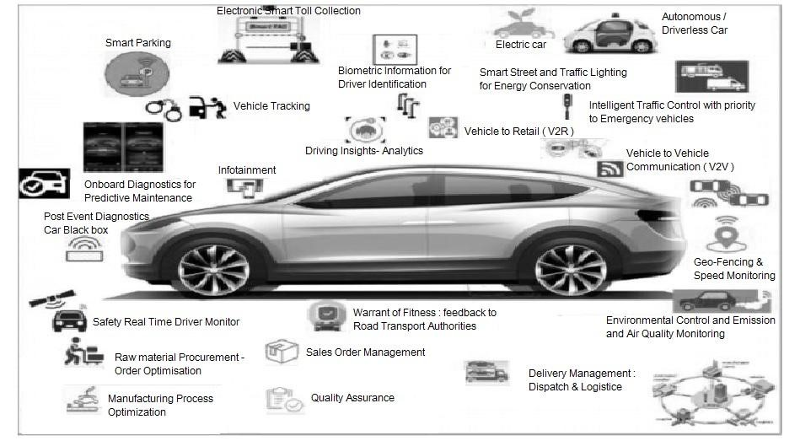

#### Fig 4.10: Application of IoT in Automotive

* **Vehicles and Smart phones Integration:** Using the On-Board Diagnostics (OBD) port, which is like computer which monitors emissions, mileage, speed, and other useful data information regarding engine and other crucial vehicle parameters can be displayed on the drivers smart phones and same can be sent to service provider for analysis. Alerts related to the car like Open doors, Lights ON and Hand brake ON and performing actions on certain vehicle parts such as Lock/Un-lock vehicle doors, roll windows up/down and AC temperature +/- are becoming seamless.
* **Driving Insights – Analytics:** Smart phones sensors such as GPS, Gyroscope or Orientation sensor and Accelerometer can be used to model the driving behavior. It can detect driving patterns such as sharp turns, sudden acceleration, hard braking, drifting and speeding. This can be used to profile the driver as safe or aggressive, to rate and compare different drivers and share such data with insurance companies for customized premiums.
* **On-Board Diagnostics for Predictive maintenance:** The On-Board Diagnostics port is commonly used in automobile service and maintenance for self-diagnosis and reporting of any issues that may occur, or have occurred within the system. Using this, information such as emissions, mileage, faults, vehicle and engine speed, engine temperature, fluid levels, gear shifts, battery status, etc. can be monitored and information can be sent to vehicle owners and service stations giving them a better picture of the car performance.
* **Safety: Real Time Driver Monitor:** Advanced sensor based technologies to detect and monitor behavior and fatigue levels of driver are emerging which makes the cars more intelligent for avoiding accidents on roads. Systems are being developed for real time monitoring of vehicles which controls the speed of the vehicle and fatigue level of the driver to prevent accidents. The primary components of such a system are microcontrollers along with some sensors like eye blink, gas, impact sensors, alcohol detecting sensor and fuel sensors. GPS and Google Maps API’s is used to track the location of the vehicle which can sent to a predefined number in the system.
* **Geo-fencing and Speed Monitoring:** The geo fencing and speed monitoring applications can be used to inform the car owner if the vehicle has gone out of the predefined geographical area or is being driven faster than a preset threshold speed. Speed of the vehicle can be measured speed sensors and geo-fencing can be achieved with the help of GPS.
* **Law: Stolen Vehicle Tracking** GSM and GPS based Vehicle Tracking System is used for tracking device which is hidden in the vehicle to monitor and track the location of vehicles .Satellite signals will be received by a remotely located application server and then position coordinates with latitude and longitude are determined. Exact position of the vehicle can be determined from these coordinates and using the GSM system, thus vehicle can be notified.
* **Biometrics Information for Driver identification:** Biometrics refers to the physical, biological or behavioral characteristics of a person. It can be used to identify and authenticate a driver. Biometric identifiers include face recognition, fingerprints or voice recognition.
* **Vehicle Communications:** As more and more connected cars emerge and in-vehicle embedded connectivity becomes common, a whole new paradigm of vehicle communications is set to unfold.
  1. Vehicle to Vehicle (V2V*)*
  2. Vehicle to Infrastructure(V2X)
  3. Vehicle-to-Retail Industry (V2R)
* **Other applications of IoT in automotive are**o In Intelligent Transportation: Electronic Smart Toll Collectiono Smart Parkingo Energy Conservation: Smart Street & Traffic Lighting o Post Event Diagnostics: Car Black Box.
  + Intelligent traffic control with priority for emergency vehicles
  + Warrant of Fitness certificate of vehicle: Feedback to Road Transport Authorities for required safety inspections.
  + Environmental Control: Emissions and Air Quality Monitoring.
  + IoT Based Supply Chain Management in Automotive Industry

**Use of IoT in Discrete manufacturing:**

Discrete manufacturing is an industry term for the manufacturing of finished products that are distinct items capable of being easily counted, touched or seen. Discrete manufacturing involves parts and systems like nuts and bolts, brackets, wires, assemblies and individual products.A discrete unit is a separate part of something larger. The crankshaft is a discrete part of a car engine. Almost every item sold in stores is an example of discrete manufacturing. Examples of discrete manufacturing could include:

* Vehicles
* Aircraft
* Smart phones
* Computers
* Cookware
* Clothing
* Cabling

Discrete manufacturing can be characterized by unit production; where units can be produced with high complexity and low volume, like aircrafts or computers, or low complexity and high volume, like nuts or bolts.

Discrete manufacturers have the opportunity to adapt processes with IoT to lower costs, optimize operations, reduce resource consumption, improve productivity, enhance customer service, and manage the supply chain. Similarly, they can also use IoT to drive product-related benefits, such as improving product quality, increasing uptime, and using actual performance data to drive future design changes in the next generation of products.

As IoT provides the basis for an increasing amount of automated data acquisition, manufacturers will be able to adapt their processes and their products not just for incremental improvements but also for transformation of the product, service, and business model. IoT gives manufacturers the opportunity to create "intelligent" products that can sense, learn, and predict customer needs as well as interconnect with other product ecosystems.

Discrete Manufacturing Industry challenges are

* Connected products,
* Connected supply chain, and
* Smart manufacturing.

These challenges are overcome with IOT.

**IoT and Today's Connected Products:** The key benefits resulting from the promise of connected products are as follows:

* Documenting actual product performance, creating early warning and detection signals, and enabling closed loop feedback to drive quality improvements in future products.
* Easing the transition to new services that should bring substantially higher margins and greater customer satisfaction levels

**IoT and the Connected Supply Chain:** The key benefits resulting from the connected supply chain are as follows:

* Managing inventory positions throughout an increasingly complex logistics network, with greater visibility into actual inventory
* Increased fulfillment execution capabilities, including the use of smaller, more localized warehouses located closer to customers.

**IoT and Smart Manufacturing:** The key benefits resulting from smart manufacturingareas follows:

* Increasing reliability and quality through ongoing access to operational intelligence
* Connecting shop-floor decisions with corporate-level objectives, whether they are primarily focused on lowering costs, increasing customer service, or increasing revenue

Thus IoT is making easier to track information about products and processes and more automation will provide greater efficiency, eventually reducing costs and boosting profit margins and more productivity.

**Use of IoT in Telecom:**

The IoT is transforming the world around us, especially in telecommunications. This fourth industrial evolution also driven by Artificial Intelligence (AI), robotics, 3D printing, and other emerging technologies will irrevocably change the way machines interact with humans and each other.

It is predictions that over 20 billion connected things will be in use worldwide by 2020, putting service providers in a race to tailor their strategies, data services, and telecom infrastructure to make the most of this trend.

IoT in telecommunications will be defined by the ability to deliver high-value, scalable datadriven services that prioritize cost and convenience, while making a positive impact on people’s lives. The market leaders will be the telecom providers that partner with customers, domain specialists, and platform providers to co-create the next generation of IoT networks

### Data-driven networks

Service quality, reliability, and intelligent dynamic capacity allocation are critically important to IoT services such as autonomous cars, heart-rate monitors, and insulin pumps. Improved network analytics capabilities will allow providers to perform real-time and predictive IoT network maintenance to improve services and keep costs down. This data-driven approach will become a core enabler of intelligent, automated networks that incorporate next-generation technologies like 5G, SDN, NFV, and service cloudification.

### Security and privacy

Problems of security and privacy will be particularly challenging in the age of IoT in telecommunications. As there are more devices in a network, there are more points of vulnerability. Additionally, their computational and energy constraints could make higherlevel security measures difficult to implement.

The concept of a distributed network, rather than a centralized one with a single point of failure, could greatly benefit IoT security. Additionally, as network intelligence evolves, it’s likely that devices and networks will become knowledgeable enough to be able to proactively identify, locate, and neutralize any harmful threats. The development of uniform regulatory standards for the collection and usage of IoT data will also be important as IoT and Machineto-Machine (M2M) communications pave the way to the Internet of Everything (IoE).

### Telecom infrastructure management

Sharing telecom infrastructure is becoming increasingly popular around the world as changes to regulations lower the barriers to entry and increase competition among providers. Passive infrastructure sharing is a core part of this, given the fact that building and maintaining telecom infrastructure is capital-intensive. The need will only grow as 5G wireless leads to networks that are increasingly decentralized, segmented, and built atop small-cell infrastructure.

IoT will play a key role in not just 5G network services, but also surveillance and monitoring of this next-generation infrastructure. An IoT-enabled Tower Operations Center (TOC) integrates on-site IoT sensors with cloud-based analytics to extract and analyze cell-tower data. This results in increased tower up-time, reduced operational costs, more efficient OSS and BSS, improved site security and intrusion detection, and more efficient energy/power management.

The degree of remote monitoring allows tower and infrastructure companies to monitor alarms and manage key performance indicators via a centralized console. In turn, this allows better overall management of critical passive infrastructure at cell sites, while freeing up IoT telecom professionals to concentrate on better network planning and resourcing.

**Use of IoT in Agriculture:**

Improving farm productivity is essential for increasing farm profitability and meeting the rapidly growing demand for food that is fueled by rapid population growth across the world. Farm productivity can be increased by understanding and forecasting crop performance in a variety of environmental conditions.

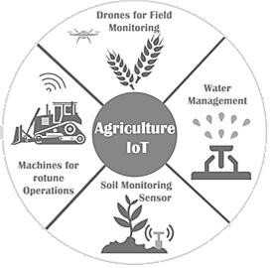

#### Fig 4.11: IoT use in Agriculture

Emerging IoT technologies, such as IoT devices (e.g., wireless sensor networks, networkconnected weather stations, cameras, and smart phones) can be used to collate vast amount of environmental and crop performance data, ranging from time series data from sensors, to spatial data from cameras, to human observations collected and recorded via mobile smart phone applications. Such data can then be analyzed to filter out invalid data and compute personalized crop recommendations for any specific farm. IoT based farming can automate the collection of environmental, soil, fertilization, and irrigation data, automatically correlate such data and filter-out invalid data from the perspective of assessing crop performance. Then compute crop forecasts and personalized crop recommendations for any particular farm. Major activities of farming can be smartly monitored, controlled and managed using IoT as follows:

**Crop Water Management**: In order to perform agriculture activities inefficient manner, adequate water is essential. Agriculture IoT is integrated with Web Map Service (WMS) and Sensor Observation Service (SOS) to ensure proper water management for irrigation and in turn reduces water wastage.

**Precision Agriculture:** High accuracy is required in terms of weather information which reduces the chances of crop damage. Agriculture IoT ensures timely delivery of real time data in terms of weather forecasting, quality of soil, cost of labor and much more to farmers.

**Integrated Pest Management or Control (IPM/C):** Agriculture IoT systems assures farmers with accurate environmental data via proper live data monitoring of temperature, moisture, plant growth and level of pests so that proper care can be taken during production.

**Food Production & Safety:** Agriculture IoT system accurately monitors variousparameters like warehouse temperature, shipping transportation management system and also integratescloud based recording systems.

**Benefits of IoT in Agriculture:**

The following are the benefits of IoT in Agriculture:

1. IoT enables easy collection and management of tons of data collected from sensors and With integration of cloud computing services like Agriculture fields maps, cloud storage etc., data can be accessed live from anywhere and everywhere enabling live monitoring and end to end connectivity among all the parties concerned.
2. IoT is regarded as key component for Smart Farming as with accurate sensors and smart equipment’s, farmers can increase the food production
3. With IoT productions costs can be reduced to a remarkable level which will in turn increase profitability and sustainability.
4. With IoT, efficiency level would be increased in terms of usage of Soil, Water, Fertilizers, and Pesticides etc.
5. With IoT, various factors would also lead to the protection of environment.

**Smart Farming Based Agriculture IoT Stick:** It is regarded as IoT gadget focusing on Live Monitoring of Environmental data in terms of Temperature, Moisture and other types depending on the sensors integrated with it. Agricultural IoT stick provides the concept of “Plug & Sense” in which farmers can directly implement smart farming by as such putting the stick on the field and getting Live Data feeds on various devices like Smart Phones, Tablets etc. and the data generated via sensors can be easily shared and viewed by agriculture consultants any where remotely via Cloud Computing technology integration. IoT stick also enables analysis of various sorts of data via Big Data Analytics from time to time.

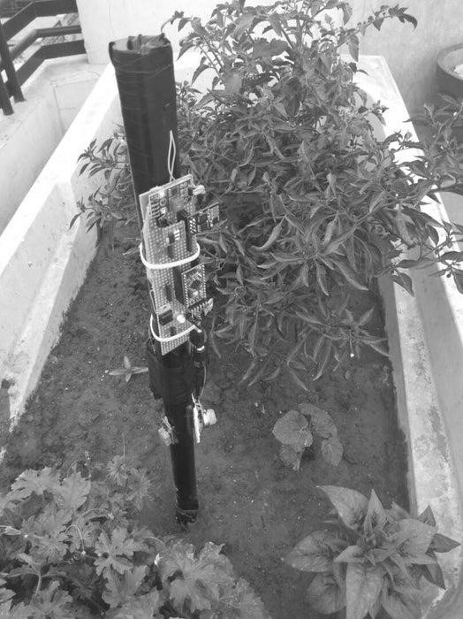

#### Fig 4.12: Agricultural IoT Stick

**4.3: I4.0/IIoT/Smart Manufacturing:**

**4.3.1: Introduction/Evolution from I1.0 to I4.0:**

**Evolution:** Professor Klaus Schwab, Founder and Executive Chairman of the World Economic Forum and author of The Fourth Industrial Evolution describe an industrial evolution as the appearance of “new technologies and novel ways of perceiving the world which triggered a profound change in economic and social structures.”

The first industrial evolution began with the mechanization and mechanical power generation. It brought the transition from manual work to the first manufacturing processes; mostly in textile industry. It is characterized by use of water and steam to mechanize production, an improved quality of life was a main driver of the change.

The second industrial evolution was triggered by electrification that enabled industrialization and mass production.

The third industrial evolution is characterized by the digitalization with introduction of electronics, IT and automation. In manufacturing this facilitates flexible production, where a variety of products is manufactured on flexible production lines with programmable machines.

The fourth industrial evolution is the IoT, [robotics,](https://whatis.techtarget.com/definition/robotics) Augmented Reality (AR) Virtual Reality (VR) and Artificial Intelligence (AI) are changing the way we live and work.

It began at the turn of this century and builds on the digital evolution. It is characterized by a much more global and mobile Internet, by smaller and more powerful sensors that have become cheaper, and by artificial intelligence and machine learning

The world is at the cusp of the fourth industrial evolution. It is current and developing environment in which [disruptive technologies](https://whatis.techtarget.com/definition/disruptive-technology) and trends such as the Internet, AI, IoT, Autonomous Vehicles, 5G Telephony, Nanotechnology, Bio Technology, Robotics, Quantum 3D printing, Cloud Computing and the like marked the era of 4th industrial evolution..

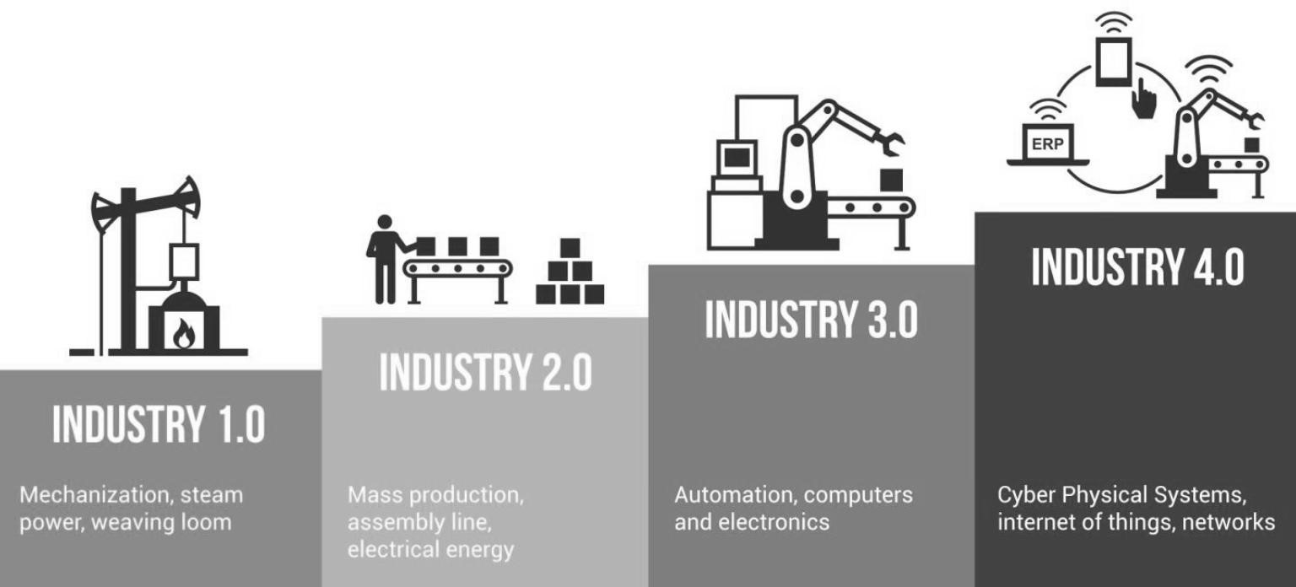

#### Fig 4.13 The industrial evolutions from 1 to 4

**First Industrial Evolution: Agrarian societies to Mechanized production.**

The first industrial evolution, began in the 18th century involved a change from mostly agrarian societies to greater industrialization as a consequence of the steam engine and other technological developments. It is marked by a transition from hand production methods to machines through the use of steam power and water power. It is started with use of steam power and mechanization of production. It is also called as the Age of Mechanical Production. Its effects had consequences on textile manufacturing, which was first to adopt such changes, as well as iron industry, agriculture, and mining. What before produced threads on simple spinning wheels, the mechanized version achieved eight times the volume in the same time using Steam power.

The use of it for industrial purposes was the greatest breakthrough for increasing human productivity. Instead of weaving looms powered by muscle, steam-engines were used for power. Through the advent of the steam engine, the focus has shifted from agriculture to textile manufacturing. But with steam power, those agrarian societies gave way to urbanization.

Developments such as the steam ship or the steam-powered locomotive brought about further massive changes because humans and goods could move great distances in fewer hours. The world began to rely on steam power and machine tools, while steamships and railroads revolutionized how people got from A to B and what emerged as the new center of community life? Ultimately, advancing industrialization created a middle class of skilled workers. Cities and industries grew more quickly than ever before, and economies grew along with them.

### Second Industrial Evolution: The Age of Science and Mass Production

The Second Industrial Evolution better known as the technological evolution is the period between 1870 and 1914. It began with the discovery of electricity and assembly line production**.** Henry Ford took the idea of mass production from a slaughterhouse in Chicago. The pigs hung from conveyor belts and each butcher performed only a part of the task of butchering the animal. Henry Ford carried over these principles into automobile production and drastically altered it in the process. By the early part of the 20th century, Henry Ford’s company was mass producing the groundbreaking Ford Model T, a car with a gasoline engine built on an assembly line in his factories.

While before one station assembled an entire automobile, now the vehicles were produced in partial steps on the conveyor belt **-** significantly faster and at lower cost**.** It was made possible with the extensive railroad networks and the telegraph which allowed for faster transfer of people and ideas. It is also a period of great economic growth, with an increase in productivity. It, however, caused a surge in unemployment since many workers were replaced by machines in factories.

Things started to speed up with a number of key inventions. Think gasoline engines, airplanes, chemical fertilizer. All inventions that helped us go faster and do more. But advancements in science weren’t limited to the laboratory. Scientific principles were brought right into the factories. Most notably, the assembly line, which effectively powered mass production. People follow the jobs, and the early 1900s saw workers leaving their rural homes behind to move to urban areas and factory jobs. By 1900, 40% of the population lived in cities, compared to just 6% in 1800. Along with increasing urbanization, inventions such as electric lighting, radio, and telephones transformed the way people lived and communicated.

### Third Industrial Evolution: Digital Evolution

The Third Industrial Evolution called the digital evolution involved the development of computers and Information Technology (IT) since the middle of the 20th century. This began in the 70’s of the 20th century through partial automation using memory-programmable controls and computers. Since the introduction of these technologies, user can now able to automate an entire production process **-** without human assistance. Known examples of this are robots that perform programmed sequences without human intervention.

The third industrial evolution or Industry 3.0 occurred, after the end of the two big wars, as a result of a slowdown with the industrialization and technological advancement compared to previous periods. It is also called digital evolution. The global crisis in 1929 was one of the negative economic developments which had an appearance in many industrialized countries from the first two evolutions.

The production of Z1 (electrically driven mechanical calculator) was the beginning of more advanced digital developments. This continued with the next significant progress in the development of communication technologies with the supercomputer. In this process, where there was extensive use of computer and communication technologies in the production process. Machines started to abolish the need for human power in life.

Beginning in the 1950s, the third industrial evolution brought semiconductors, mainframe computing, personal computing, and the Internet—the digital evolution. Things that used to be analog moved to digital technologies, like an old television you used to tune in with an antenna (analog) being replaced by an Internet-connected tablet that lets you stream movies (digital).

The move from analog electronic and mechanical devices to pervasive digital technology dramatically disrupted industries, especially global communications and energy. Electronics and information technology began to automate production and take supply chains global.

**Fourth Industrial Evolution: Cyber Physical Systems, IoT and Networks:**

The Fourth Industrial Evolution is characterized by the application of information and communication technologies to industry and is also known as **"**Industry 4.0**".** It builds on the developments of the Third Industrial Evolution but considered as new era because of the explosiveness of its development and the disruptiveness of its technologies.

Origin of Industry 4.0 concept comes from Germany, since Germany has one of the most competitive manufacturing industries in the world and is even a global leader in the sector of manufacturing equipment. Industry 4.0 is a strategic initiative of the German government that traditionally supports development of the industrial sector. In this sense, Industry 4.0 can be seen also as an action towards sustaining Germany’s position as one of the most influential countries in machinery and automotive manufacturing.

The basic concept was first presented at the Hannover fair in the year 2011. Since its introduction, Industry 4.0 is in Germany a common discussion topic in research, academic and industry communities at many different occasions. The main idea is to exploit the potentials of new technologies and concepts such as:

1. Availability and use of the internet and IoT.
2. Integration of technical processes and business processes in the companies.
3. Digital mapping and virtualization of the real world.
4. ‘Smart’ factory including ‘smart’ means of industrial production and ‘smart’ products.

Besides being the natural consequence of digitalization and new technologies, the introduction of Industry 4.0 is also connected with the fact that, many up to now exploited possibilities for increasing the profit in the industrial manufacturing are almost exhausted and new possibilities have to be found. Namely the production costs were lowered with introduction of just-in-time production, by adopting the concepts of lean production and especially by outsourcing production to countries with lower work costs. When it comes to the decreasing costs of industrial production, Industry 4.0 is a promising solution.

Advantages and reasons for the adoption of this concept including:

1. A shorter time-to-market for the new products.
2. Improved customer responsiveness.
3. Enabling a custom mass production without significantly increasing overall production costs.
4. More flexible and friendlier working environment.
5. More efficient use of natural resources and energy.

Production systems that already have computer technology are expanded by a network connection and have a digital twin on the Internet so to speak. These allow communication with other facilities and the output of information about themselves. This is the next step in production automation. The networking of all systems leads to **"**cyber-physical production systems**"** and therefore smart factories**,** in which production systems**,** components and people communicate via a network and production is nearly autonomous**.**

The advent of 5G telecommunication technologies will make real-time downloads possible. This will enable a whole host of things, such as a majority of driverless cars plying on the roads, and talking to each other using the IoT. The autonomous vehicle, enabled by 5G technology, will result in a lower demand for automobiles and release parking space for parks. When combined with an increasing population of non-polluting electrical vehicles, it will benefit the environment.

The electrical vehicles will be powered by renewable energy, and the use of fossil fuel would reduce. The cost of solar panels is likely to drop. Real-time speeds using 5G would allow devices to be connected and to communicate with each other through the IoT. Thus cars on the road will talk to each other, avoiding accidents. Machines in factories will talk to each other, leading to productivity gains.

**4.3.2: Benefits of Industry 4.0** The main benefits of industry 4.0 are:

1. Improved Efficiency and thus Productivity: [Industry 4.0 technologies](https://slcontrols.com/demystifying-industry-4-0/) enable you to do more with less. That is, user can produce more and faster while allocating resources more cost-effectively and efficiently. User production lines will also experience less downtime because of enhanced machine monitoring and automated/semi-automated decision-making. Overall Equipment Effectiveness will improve as facility moves closer to becoming an Industry 4.0 Smart Factory. Multiple areas of user production line will become more efficient as a result of Industry 4.0-related technologies. These efficiencies are less machine downtime, the ability to make more products and make them faster. Other examples of improved efficiency include [faster batch changeovers,](https://slcontrols.com/total-batch/) automatic track and trace processes, and automated reporting. New product introductions also become more efficient as does business decision making and more.
2. Increased Knowledge Sharing and Collaborative Working: Traditional manufacturing plants operate individually and in isolation. This results in minimal collaboration or knowledge sharing. Industry 4.0 technologies allow your production lines, business processes, and departments to communicate regardless of location, time zone, platform, or any other factor. This enables, for example, knowledge learned by a sensor on a machine in one plant to be disseminated throughout other organization.

Best of all, it is possible to do this automatically, i.e. machine-to-machine and system-tosystem, without any human intervention. In other words, data from one sensor can instantly make an improvement across multiple production lines located anywhere in the world.

1. Flexibility and Agility: The benefits of Industry 4.0 also include enhanced flexibility and agility. For example, it is easier to scale production up or down in a Smart Factory. It is also easier to introduce new products to the production line as well as creating opportunities for one-off manufacturing runs, high-mix manufacturing, and more.
2. Better Customer Experience: Industry 4.0 also presents opportunities to improve the service you offer to customers and enhance the customer experience. For example, with [automated track and trace capabilities,](https://slcontrols.com/total-data/) you can quickly resolve problems. In addition, you will have fewer issues with product availability, product quality will improve, and you can offer customers more choice.
3. Cost Reduction:Becoming a Smart Factory does not happen overnight, and it won’t happen on its own. To achieve it, you need to invest, so there are upfront costs. However, the cost of manufacturing at your facilities will dramatically fall as a result of Industry 4.0 technologies, i.e. automation, systems integration, data management, and more.

Primary drivers for these reduced costs include:

* 1. Better use of resources
  2. Faster manufacturing
  3. Less machine and production line downtime
  4. Fewer quality issues with products
  5. Less resource, material, and product waste
  6. Lower overall operating costs

1. Better return on Investment: Industry 4.0 technologies are transforming manufacturing across the world. The benefits of Industry 4.0 and potential return on investment are what is truly important, though. To stay competitive and equip your production lines for the future, the time to think about the next stage of Industry 4.0.
2. Machine downtime reductions: Predictive maintenance in Industry 4.0 means that equipment failure will be identified before it occurs. Systems can spot repetitive patterns that precede failures, notify teams and have them schedule an inspection. Such systems also learn over time, becoming capable to spot even more granular changes and help continuously optimize production process.
3. Improved supply/demand matching: Cloud-based inventory management solutions enable better interactions with suppliers. Instead of operating in “individual silo”, user can create seamless exchanges and ensure that user has:
   1. High service-parts fill rates;
   2. High levels of product uptime with minimal risk;
   3. Higher customer service levels.

By pairing user inventory management system with a big data analytics solution, user can improve his demand forecasts by at least 85%. User can also perform real-time supply chain optimization and gain more visibility into the possible bottlenecks, protruding your growth.

### Challenges in implementation of Industry 4.0

1. Economic
   1. High economic costs
   2. Business model adaptation
   3. Unclear economic benefits/ excessive investment.
2. Social
   1. Privacy concerns
   2. Surveillance and distrust
   3. General reluctance to change by stakeholders
   4. Threat of redundancy of the corporate IT department
   5. Loss of many jobs to automatic processes and IT-controlled processes, especially for blue collar workers
3. Administrative/policy:
   1. Lack of regulation, standards and forms of certifications
   2. Unclear legal issues and data security
4. Organizational/ Internal
   1. IT security issues, which are greatly aggravated by the inherent need to open up those previously closed production shops
   2. Reliability and stability needed for critical machine-to-machine communication

(M2M), including very short and stable latency times

* 1. Need to maintain the integrity of production processes
  2. Need to avoid any IT snags, as those would cause expensive production outages
  3. Need to protect industrial know-how (contained also in the control files for the industrial automation gear)
  4. Lack of adequate skill-sets to expedite the transition towards the fourth industrial evolution
  5. Low top management commitment
  6. Insufficient qualification of employees

Table 4.1 Comparison I3.0 with I4.0

|  |  |  |  |
| --- | --- | --- | --- |
| **Sr.**  **No** | **Feature** | **I4.0** | **I3.0** |
| 1 | Characterized by | A fusion of technologies across physical, digital and biological spheres.  Physical– Autonomous Vehicles,  3D Printing, Advanced Robotics,  New Materials etc. Digital–IoT, Block chain, AI etc.  Biological – Molecular biology and genetics, application of  engineering principles to biology, , 3DBio printing etc. | Digital evolution. Rise of telecommunications technologies, computers and  IT |
| 2 | Technologies used | For smart automation technology used are Cyber physical systems, IOT, IIoT, smart factory, Cloud**,** Big Data Analytics, and AI. | For automation technology used is mainly PLC’s and Robots. |
| 3 | Automation level | in Industry 4.0 machines work autonomously without the intervention of a human | Industry 3.0 the machines are only automatized. |
| 4 | Impact | The impact of the fourth industrial evolution is global and  is on all the aspects of human life  i.e. Economy, Business,  Governments, Society, and Individuals. | Impact is limited to geographical and  manufacturing industry only |
| 5 | Efficiency,  Productivity and performance | By combining machine-tomachine communication with  industrial big data analytics, I4.0  is driving unprecedented levels of efficiency, productivity, and performance. | Due to limitation of technological advancements  lower Efficiency, Productivity and performance |
| 6 | Implemented by | Cyber physical systems, IoT,  Smart factory, Big data, Cloud, Cyber security. | Production, planning and control, IT support, ERP, MES and data management. |
| 7 | Scope | Real time, Interconnected global system. | Not real time and global in nature |
| 8 | Example | if the CNC Milling machine is in the Industry 4.0 the tool changes are automatic at the same time  the spindle speeds and all other  parameters essential to carry out the process are recorded by the  hundreds of sensors present in the machine and the optimum settings are done on its own | If a CNC Milling machine is in the era of Industry 3.0, the tool changes can be done  automatically but the speed at  which the spindle should run is to be observed by the operator  and the corrections should be made by him. i.e. Human intervention/ assistance. |
|  |  | based on the large amount of data  there is to compare and optimize the process. i.e. No human  intervention |  |

### IoT Layered Architecture:-

The IoT is a technology which is currently emerging and it can be viewed as a network of objects connected via. Internet, which aims to increase the availability of Internet at any place and any time through integration of the physical objects (embedded with software, sensors, actuators etc.) into the information network which enables these objects to collect data and exchange it.

IoT is the ability to connect, communicate with, and remotely manage an incalculable number of networked, automated devices, from the factory floor to the hospital operating room to the residential basement. It is a scenario in which storage, computing and communication technologies are embedded in everyday objects. Processing, storage and communication capabilities attached to an object turns object into a service for which users pay per use. Since the IoT was proposed in 1999, it has been in continuous development and expansion, but there are no uniform definition standards. The IoT concept broadly refers to RFID, infrared sensors, GPS, laser scanners and other information sensing devices, according to the agreed protocol, to achieve any time, any place, any object information exchange and communication in order to achieve intelligent identification, locate, track, monitor and manage a network. The IoT has full perception, reliable transmission, intelligent processing and other features.

IoT was making extensive use of, and made throughout the wisdom industry, wisdom agriculture, intelligent transportation, smart security, environmental protection, wisdom health care, government livelihood management, intelligent home, food safety and so on. Although the IoT industry has been in rapid development in recent years, there is still no large-scale applications in reality. There is no uniform construction standards, norms things access and integration management platform.

The three-layer framework of IoT is widely considered and it is consisting of perception layer, network layer and application layer. Although the three-layer framework describes the architecture of the IoT from the technical level, but not fully shows the characteristics and reference of the IoT. Now some applications require the closed-loop system, and the IoT is an open-loop global network system, so its application and promotion still faces many difficulties and challenges. To overcome this five layer architecture of IoT is proposed.

**The Five-Layer Architecture of IoT:**

Architecture of IoT is consisting of perception layer, network access layer, network layer, application support layer and presentation layer, as shown in figure 4.14.

**Perception/Edge layer:** The perceptual layer is the foundation of IoT, is the interface between the layer of physical world and information world. It uses radio frequency identification technology, bar code technology, sensor technology, positioning technology, or other information sampling technology to complete the information collection, and with the help of controlling the objects of perception by the actuator, implement the interface control between the physical space and information space. Its main components include twodimensional code label, code reader-writer, RFID tags and RFID reader-writer, cameras, and all kinds of sensors. So, the IoT perception layer has the main functions of information perception and original data collection, necessary auxiliary complete downward at the end of the control object. Therefore, the main function of perception layer of IoT is information and data collection, when necessary, assist to complete the control objects of perception.

**Network access layer:** The network access layer is mainly composed of the base station node and the network access gateway. It completes the network control and the data fusion of each node in the perception layer, or forward the information from the above layers (The network transmission layer or the application layer). When the perception layer’s nodes complete networking, the perception layer’s nodes need to upload data, and send the data to the base station node. The base station node will receive the data, and complete the connection with the network transmission layer by the access gateway. When the application layer and the network layer needs to downlink data, the base station node sends data to each node in the perception layer after the network access gateway receiving the data from the network transmission layer, then complete the forwarding information and interaction between the perception layer and the network transmission layer. The current access methods in the network access layer mainly include WIFI, Ad hoc, Mesh, ZIGBEE, industrial bus. It collects the information by various cognitive tools, or to preliminary process and network access.

**Network transmission layer:** The network transmission layer is mainly used to realize the transmission and exchange of information provide the basis transmission network for the necessary of applications and services within a wide range, including the satellite communication network, the mobile communication network, the optical fiber communication network and the local independent private network and so on. It is a problem in the network layer that the neutral access and seamless integration between different network and means of communication, and how to form the transmission and exchange capacity with end-to-end. This layer normally uses TCP and UDP protocols

**Application support layer:** With the support of the information technology, cloud computing technology, middleware technology, database technology, expert system and so on, the application support layer complete public intelligent analysis and storage of data information, realize information processing, and all kinds of intelligent application sharing and exchanging. This layer normally uses HTTP, MQTT, CoAP protocols.

**Application presentation layer:** The application presentation layers task is the development of a variety of applications of IoT base on the data processing of the application support layer, and uses the technology with multimedia, virtual reality, human-computer interface to build the interface of intelligent application between the IoT and the user, implement present and application of all kinds of intelligent information.

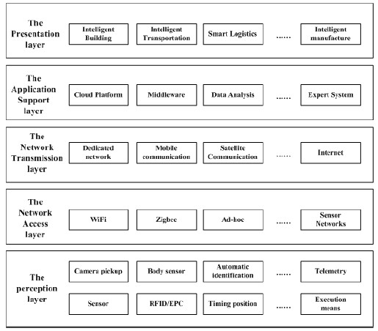

#### Fig 4.14: Five Layer Architecture of IoT

**Industrial IoT (IIoT):**

Industrial domain is dierent from consumer domain. It has specialized communications protocols, security requirements, QoS and device life cycles. Initially, IIoT applications referred to any application that relied on an Internet- (or Intranet-) capable sensor and actuator networks. Many web, industrial automation, embedded and wireless sensor network applications are usually grouped under the umbrella of IIoT. While IoT has maintained its position covering domain of home automation and consumer electronics, IIoT extended it to include industrial domain with all its implications. The key enabler of both is connectedness (networked).

The IIoT integrates with a wider array of communication protocols. IIoT based low power wireless networks may require real-time performance with time triggered variations of IEEE 802.15.4. Hence, IIoT applications must handle changes in and introduction of new communications protocols. Security is an important aspect for networked systems, such as IIoT. The open connectedness of IIoT applications make them vulnerable and require protection from various threats.

The traditional security triad of confidentiality, integrity and availability still apply to the IIoT, and now privacy must also be included. Traditionally, industrial computer networks rely on network segregation with highly controlled network access or an “air gap” between factory floor and IT networks. This includes using firewalls to control what connections are allowed to pass between network segments, for example network traffic entering and leaving the factory may be fully denied.

IIoT applications have monetary consequences and could expose commercially sensitive information. Authenticity terms and conditions must be taken seriously. IIoT applications operating in continuous production require QoS agreements and monitoring. QoS refers to the non-functional requirements of an application. The QoS concerns could be battery life time, bandwidth, round trip delay, redundancy, backup, resilience, recovery or more. QoS is an important issue for IIoT therefore it must comply stricter limits.

The life-cycles of IIoT applications differ to those of IoT. By comparison IIoT applications must pass thorough testing, simulation, validation and verification prior to deployment. The deployment environment of IIoT applications requires integration with areas, such as legacy systems and devices, simulators, intelligent robotics, big data, analytics and augmented reality etc. In addition, IIoT must not introduce cyber security vulnerabilities to other areas, such as robotics. Therefore, a software architecture style must account not only for IIoT but also the surrounding domains.

#### Table 4.2 Comparison of IoT and IIoT

|  |  |  |  |
| --- | --- | --- | --- |
| **Sr.**  **No.** | **Parameters** | **IoT** | **IIoT** |
| 1. | Devices | IoT includes devices located in consumer or commercial settings: offices, business, homes. | IIoT includes devices located in industrial settings: factory floor, automation control, HVAC, energy grid. |
| 2. | Reliability | Moderate requirements: ease of use, short product life cycles. | Stringent requirements than the consumer IoT: Hi-reliability, harsh environments, high product life cycles. |
| 3. | Security | Require identify and privacy. | Requires robust security protecting against access. |
| 4. | Function | Synonymous with functions that benefit end users-human life style. | Provide basic operational roles and requirements many are independent of human intervention. |
| 5. | Availability | Function in environment of updates, add-ons, apps, charging and random rebooting. | Requires high availability and up time. Unscheduled patching and rebooting is not tolerated. |
| 6. | Failure | Retry, replace. | Resilient, fail in place. |
| 7. | Connection | Connects people to people or people to internet. | Peer-Peer and M2M. |
| 8. | Protocol | For the most part is IP. | Based upon numerous protocols standards based and proprietary. |
| 9. | Market | Green Field new device uptake is almost immediate. | Brownfield new device uptake must be phased in. |
| 10. | Area of focus | Commercial or consumer  convenience | Monitoring and managing systems for high stake industries- defense, Manufacturing, Health Care and others. |
| 11 | Focus development. | Smart Devices. | Sophisticated Machines. |
| **Sr.**  **No.** | **Parameters** | **IoT** | **IIoT** |
| 12 | Degree of  application | Sensitive sensors, Advanced controls and Analytics. | Simple application with low risk impacts. |
| 13 | Scalability | Low scale networks. | Large scale networks. |
| 14 | Precision and Accuracy | Critically Monitored. | Synchronized to milliseconds. |
| 15 | Programmabi  lity | Easy off-site programming. | Remote on-site reprogramming required supporting new processes. |
| 16 | Output | Convenience | Economic Growth. |
| 17. | Resilience | Not required. | Must be automated to support fault tolerance. |
| 18. | Maintenance | Consumer preferred. | Scheduled and Organized. |

**Industry 4.0 Architecture*:***

Industry 4.0 is the German initiative that aims to bring about challenges of the fourth industrial evolution. It undertakes to bring together advances in digital technologies. Starting with a focus on the smart factory concept, it now includes concepts such as big data and analytics, CPS, cloud, fog and edge computing, IIoT, augmented reality, intelligent robotics, additive manufacturing, and simulation and cyber security. Each of these fields is being developed within their own areas, but combining the technologies together and creating a cohesive technological environment is a challenge.

Industry 4.0 has proposed the Reference Architecture Model for Industry (RAMI) 4.0. It is a reference architecture that joins life-cycle, software concerns and the automation pyramid into a cube view. Refer the RAMI Architecture as per reference number 10. It shows the need for recognizing the multi-dimensional relationship between engineering domains within industrial automation. RAMI 4.0 make explicit the need for all hierarchy components to share some burden of the software layer distribution. To address the standardization issue, a Reference Architecture Model for the Industry 4.0 was developed in Germany.

This is a meta-model so it describes the aspects that play an important role in the Industry 4.0 production system. It is based on the internationally accepted Smart Grids architecture model introduced in year 2014. Two additional bottom layers are added to address specific aspects of Industry 4.0.

The three dimensional RAMI4.0 should enable:

* Identification of the existing standards,
* Identification and closure of gaps and loopholes in the existing standards,
* Identification of overlaps in the existing standards.

The first dimension of the RAMI 4.0 addresses two elements, type and instance. As long as an idea, a concept, or a product is still a plan and is not available/realized yet, it is called type. The second dimension of the model deals with location, functional hierarchy from the product to the connected world (as the last stage of Industry 4.0development with all enterprises, customers and suppliers connected).

The third dimension of the RAMI4.0 model is organized in functional layers as follows

* An assets layer includes physical components such as robots, conveyer belts, PLCs, documents, archives, but also non-physical objects such as software and ideas.
* An integration layer provides information for assets in a form that can be digitally processed. It includes elements connected to IT such as sensors, integration to HMI and computer-aided control of technical processes.
* A function of the communication layer is standardization of communication using uniform data format and predefined protocols. It also provides services for the integration layer.
* An information layer is processing and integrating available data into useful information.
* A functional layer includes formal descriptions of functions. Also ERP functions belong to this layer.
* A business layer includes mapping of the business model and links between different business processes.

Thus the vertical axis representing software concerns, the horizontal axis representing life cycle stages and the diagonal axis represents automation hierarchy.

RAMI4.0 is in Germany registered as DIN SPEC 91345 and it is as such a first compilation of the essential technological elements of Industry 4.0. It is perceived as a precondition for deployment of Industry 4.0 concept in practice and also as a model that requires international acceptance.

### Case Study Smart City Street Light and Monitoring

City Street light can be controlled through smart embedded device having sensing and computing power which will communicate central coordinator and command station through internet. Here streetlights are grouped together having sensing, computing and communication circuit on each streetlight lamp post. Each group connects to a group controller or coordinator through Bluetooth or ZigBee. Each controller further connects to command and control station through internet.

The station receives data of each streetlight from a group in specific period or intervals. This data may be about status of these streetlights related to nonfunctional/ faulty lights, nearby traffic conditions, daylight whether cloudy, dark and normal and so on. The station remotely programs the group controller to take appropriate action as per the condition of traffic or light. It also sends data related to faulty light and its location for remedial action. This way each group of city streetlight is controlled through coordinator, controller and command station through internet.

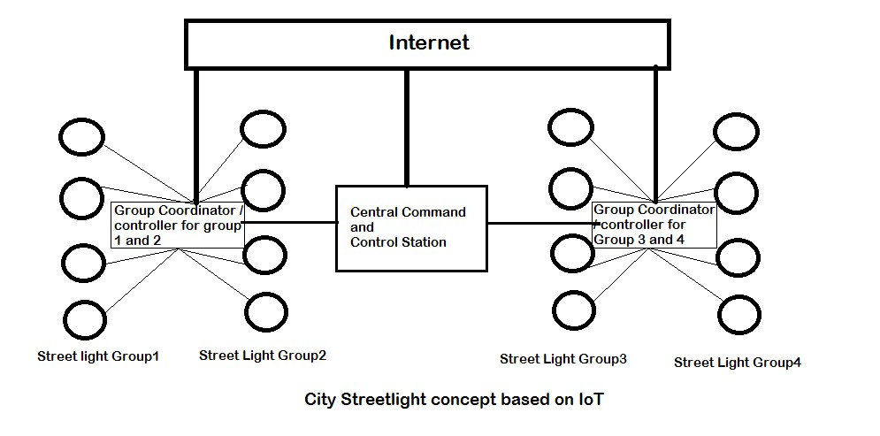

#### Fig 4.15 Street Light using IoT

Fig4.15 shows the concept of streetlight using IoT. Here lamppost hosts a streetlight, wireless sensor network (WSN) actuator and sensors. Sensors send messages about status of lamp, ambient light and traffic. Actuator makes light on or off.

When light is above threshold then lights are switched on. The WSN sensors deployed detects presence of traffic and its density. If traffic is not present the lights are switched off. This saves energy. Traffic density data is communicated to traffic signal monitoring service. The WSN transceiver also accepts data from other services such as Wi-Fi service, security service, traffic signaling service and retransmits to network of WSN and then to access points. Thus lamppost may act as information network or active node in service network.

Each transceiver at the lamppost receives and retransmits in real time. Events messages alerts, triggers and notifications from a number of services can transmit for service such as smart parking, traffic signaling, waste management, weather monitoring, air pollution control services, security services for home, banks and important public spaces, emergency services and hospitals.

Functions of control and monitoring service for city streetlights are

1. Measure light intensity and monitor city street lights.
2. Measure and monitor traffic parameters in real time intervals
3. Each WSN has program that configure and communicate with WSN network.
4. The WSN network connects a coordinator/controller which has data adaption, store, time, location, IDs stampings and gateway interfaces.
5. Communicates the WSN messages
6. These massages are transmitted at preset intervals to access points which are in turn connected to coordinators.
7. Coordinator generates and communicates alerts, triggers, messages and data after aggregating, computing, processing, filtering and compacting at data adaption layer.
8. Coordinator creates and uploads in real time a database which transfers to the cloud for processing and for cloud data store.
9. An OTP module at the cloud node provides OTP management and uploads connectivity programs for gateways.
10. Runs and monitors at data adaption layer for faulty or inaccessible sensor at periodic intervals
11. Integrates data and activates the alerts and triggers.
12. Cloud node provides platform for processes, analyze and visualization of data and database information. The node provides analytics and AI for optimizing, monitoring and control functions.
13. Cloud platform could be CISCO IoT, IOX and Fog, Nimbits, TCUO, AWS or Bluemix platform with Watson Analytics.

**Data flow diagram, architecture and reference Model for Smart City Streetlight Monitoring and Control for WSN networks.**

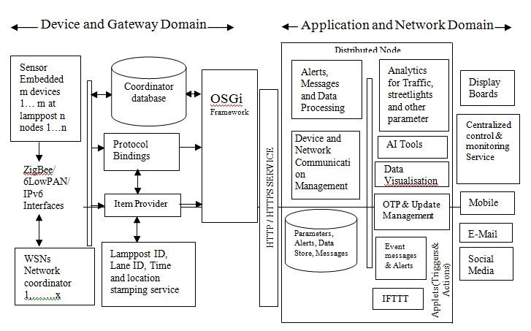

#### Fig 4.16 Data Flow Diagram

(Reference from Book Internet of things by Raj Kamal McGraw Hill Education)

Fig, 4.16 shows data flow diagram and domain architecture reference model for monitoring service. It is divided in two domains namely 1) Device and gateway domain 2) Applications and network domain.

**Device and Gateway Domain:** It has three major components i) Hardware ii) Software iii) Module component

**Hardware:** Hardware consist of m embedded devices n WSN node networks which communicate between them using ZigBee/6lowPAN/IPv6 protocol through x coordinators. Coordinator functions as data store, protocol binder, item provider and gateway.

Each lamppost deploys a WSN. Each node senses a set of sensors data. Sensor circuits can deploy Arduino boards with ZigBee. Each WSN interfaces with other WSN and forms a network of ZigBee devices

WSN measures parameters such as i) light condition below or above threshold value ii) Nearby traffic presence or absence iii) traffic density iv) Lamppost status functional or not. Each lamppost need not measure traffic parameters. Each WSN configures the sensing device so that measurement may be activated or deactivated by the command from the coordinator and central monitor service. Nodes can be configured to measure parameter at different preset intervals. Similarly each WSN is configures actuator to make light on or off.

A group of WSN communicates among themselves using ZigBee and form a network. Each network has an access point which receives messages from each node using LPWAN. Each access point is associated with a gateway, which communicated with cloud using LPWAN.

**Software:** Open source IDE or IoT stack which include OSGi can be used for software development at devices and gateway domain. Each WSN, Lamppost, Lane, sensor node of

WSN and coordinator is assigned a unique respective ID’s.

**Modules:** Each coordinator has three modules. i) protocol binding module ii) item provider module for communication of queried items, alerts, messages and data iii) time, lamppost Id, lane ID and location stamping service. The coordinator can use open source OSGi framework. A database at coordinator stores in associated streetlights, lanes and lanes subgroup data.

**Application and Network Domain:** Cloud platform for city streetlight monitoring service deploys a number of distributed nodes. Internet connectivity is achieved through HTTP/HTTPS services. The IP protocol network connects each coordinator with a distributed node.

The distributed node platform provides

1. Alerts, messages and data processing module.
2. Device, network and communication management module.
3. Analytic tools for traffic, streetlight and other parameters.
4. Data storage for parameter alerts and messages.
5. AI tools
6. Data Visualizations tools.
7. Coordinator, networks and nodes update management using OTP.
8. Event messages, triggers and alerts for central control and monitoring services.
9. IFTTT for communication to mobile, email, social media, web services and applications.

|  |  |
| --- | --- |
| **Sr. No.** | **Reference Books/ Website used** |
| 1. | Study on the IOT Architecture and Gateway Technology by Chang-le  Zhong, Zhen Zhu, Ren-gen Huang at 2015 14th International Symposium |
| 2. | https://internetofthingsagenda.techtarget.com/definition/Internet-of-ThingsIoT |
| 3. | https://www.sequiturlabs.com/secure-edge-gateway/ |
| 4. | https://electronicsforu.com/technology-trends/tech-focus/IoT-sensors |
| 5. | https://whatis.techtarget.com/definition/IoT-gateway |
| 6. | https://www.embitel.com/blog/embedded-blog/role-of-cloud-backend-inIoT-and-basics-of-IoT-cloud-applications |
| 7. | https://www.automation.com/automation-news/article/the-next-generationof-hmi-and-scada |
| 8. | https://solace.com/blog/understanding-IoT-protocols-matchingrequirements-right-option/ |
| 9. | https://www.mouser.com/blog/gateways-the-intermediary-between-sensorsand-the-cloud |
| 10. | For RAMIhttps://www.plattform-  i40.de/I40/Redaktion/EN/Downloads/Publikation/rami40-anintroduction.pdf?__blob=publicationFile&v=4 |
| 11. | https://ec.europa.eu/futurium/en/system/files/ged/a2-schweichhartreference_architectural_model_industrie_4.0_rami_4.0.pdf |
| 12. | www.aiplindia.com |

**Sample Questions**

|  |  |
| --- | --- |
| **Sr. No.** | **Question** |
| 1. | Identify which is not an element of IoT? A. People.   1. Process. 2. Security. 3. Things. |
| 2. | Internet of things is natural extension of ---------------- A. Smart Factory   1. Computer 2. SCADA 3. I3.0 |
| 3. | Which of the following is first and most commonly used smart, interactive IoT device?   1. Smart Watch 2. ATM 3. Health Tracker 4. Video Game. |
| 4. | IOT is evolved from --------------- communication   1. B2B 2. M2B 3. M2H 4. M2M |
| 5. | ------------------ are smart devices that uses embedded processors, sensor and communication hardware to collect and send data which is acquired from environment   1. Computers 2. Network 3. Things 4. Protocols |
| 6. | -------------- is the physical device or software program that serves as the connection point between the cloud and controllers   1. SCADA 2. PLC 3. Actuator 4. IOT Gateway |
| 7. | Sequence of devices in IoTarchitecture from bottom layer to top layer is   1. Sensosrs->things->IoTgatway->Edge IT-> Data Center/ Cloud 2. Things ->Sensosrs ->IoTgatway->Edge IT-> Data Center/ Cloud 3. Things ->Sensosrs -> Edge IT->IoTgatway-> Data Center/ Cloud 4. Data Center/ Cloud-> Edge IT ->IoTgatway->Sensosrs->Things |

|  |  |
| --- | --- |
| **Sr. No.** | **Question** |
| 8. | Which IEEE standard refers to WiFi for IoT devices? A. 802.5.  B. 802.3 C. 802.11.  D. None of these |
| 9. | ----------------- is the direct contact between two smart objects when they share information instantaneously without intermediaries   1. Device to device 2. Device to gateway 3. Gateway to data systems 4. Between data systems |
| 10. | Top layer in IOT architecture is   1. Sensors connectivity and network layer 2. Application layer 3. Management Service 4. Gateway and network |
| 11. | Agriculture IoT stick is smart gadget work on principle of   1. Plug & sense 2. Plug and play 3. Plug and work 4. Plug and socket |
| 12. | Vehicle communication, driverless car, connected cars are the example of IoT in A. Agriculture   1. Electronics 2. Automotive 3. Discrete Manufacturing |
| 13. | Real time driver monitor system to detect monitor fatigue level of driver using IoT in automotive includes   1. Sensors to detect eye blinks, gas, impact sensors and alcohol detecting sensors 2. Sensors for GPS 3. Fluid level sensors 4. RFID tags |
| 14. | Movement of materials from suppliers to shop floor and throughout the assembly line can be tracked with the help of   1. GSM 2. GPS 3. Gyroscope 4. RFID |
| 15. | Nut and Bolt manufacturing is an example of discrete manufacturing with   1. High complexity and low volume 2. Low complexity and high volume 3. Low complexity low volume 4. High complexity high volume |
| **Sr. No.** | **Question** |
| 16. | The first revolution is about   1. Water and steam to mechanize production 2. Mass production Electronics & IT 3. Electric power 4. Mass Production |
| 17. | Electrical power and locomotives are the inventions of   1. First revolution 2. Second revolution 3. Third Revolution 4. Fourth revolution |
| 18. | What is an industrial revolution?   1. Significant change that affects a single industry only 2. New technologies and novel ways of perceiving the world that trigger a profound change in economic and social structures 3. An event that happened in a previous century and doesn't affect modern society 4. A series of technological advances that may or may not have a profound effect on societies |
| 19. | Which series of events best describes the transformations of the first three industrial revolutions?   1. Mechanization of production; introduction of mass production; the digital revolution 2. Mechanization of production; invention of steamships and railroads; the digital revolution 3. Discovery of electricity; the growth of mass production; the digital revolution 4. Mechanization of production; the agrarian revolution; the digital revolution |
| 20. | Steps to turn big data become smart data. Please choose the correct one.   1. Data > Knowledge > Information > Wisdom > Decisions 2. Data > Information > Knowledge > Wisdom > Decisions 3. Data > Information >> Decisions > Wisdom > Knowledge 4. Data > Information > Wisdom > Knowledge > Decisions |

**Unit– 5**

**Smart World**

**Expected Course Outcome: Suggest the different electronic systems for smart world.**

### Teaching Hrs. 8 Marks 12

**To attain above course outcome candidate must able to a. List the features of smart home.**

1. **Understand the various components of smart home.**
2. **List the requirements and features of smart city.**
3. **Understand M2M IOT architecture.**

**e .Understand network components and their functions.**

**Unit focus on following major points:**

5.1 **Evolution of smart home**.

5.2 **Basic requirements and components for Smart Home**: Video Monitoring, Security and Alarm, Door control, *Heating Ventilation and Air Conditioning* control (HVAC), Smart lighting, Smart metering and Web controlling appliances.

5.3 **Basic requirements for Smart City**: Smart Transportation, Smart Healthcare, Smart waste, Smart physical safety/Security (IP based CCTV, Fire and Gas detection, Fire extinguishers) and Smart education.

5.4 **IOT/M2M Network architecture**: Conceptual diagram, Domains for operation: Application domain, Network domain, M2M device domain.

5.5 **Network components**: functions of Sensors, Access devices, Gateways, Access Protocols, Communication Network and Application server

### Introduction

A smart home is one that incorporates all the advanced automation systems so as to offer those who live in with the ability to monitor and control various devices such as the refrigerator, washing machine, TV, ovens, the opening and closing of doors and windows, without the need to physically operate the devices and interacting with them remotely through a wireless connection.(Wi-Fi, Bluetooth, or Zigbee) that allows multiple devices connected to each other through an appropriate app (developed and made available by the manufacturers of smart devices) that work as an administrative console. This supports, from anywhere in one’s home or office.

• **Need**:-Smart home technology provides homeowners with security, comfort, energy efficiency and convenience. The term “smart home” is used to describe a residence that has lighting, appliances, heating, TVs, air conditioning, entertainment audio and video systems, computers, cameras and security systems that can communicate with one another and be remotely controlled from any room in the home, as well as remotely from any location via a smart phone or the internet. Thus smart home provides- 1. Comfort, security and convenience.

1. Remote automation.
2. Conserve the earth’s limited resources.
3. Increase the independency and given greater control of home environment.
4. Make it easier to communicate with family.
5. Save time and effort.
6. Improve personal safety.
7. Reduce heating and cooling costs.
8. Increase home’s energy efficiency.
9. Alert audibly and visually to emergency situations.
10. Allow to monitor home while away.
11. Detect intruders.

### 5.1 Evolution of smart home

In 1923, brilliant Swiss-born architect Le Corbusier (1887–1965) described a house as["a machine for living in "a](https://placeexploration.com/2015/10/28/a-house-is-a-machine-for-living-in/)nd then slowly, during the 20th century, it turned into reality, with the advent of arrival of convenient, [electric power](https://www.explainthatstuff.com/electricity.html) started to strip away the drudgery from all kinds of domestic chores, including [washing clothes](https://www.explainthatstuff.com/washingmachine.html) and [dishes](https://www.explainthatstuff.com/dishwashers.html) and [vacuuming](https://www.explainthatstuff.com/vacuumcleaner.html) the floor. Then, when [transistors](https://www.explainthatstuff.com/howtransistorswork.html) made [electronics](https://www.explainthatstuff.com/electronics.html) more affordable in the mid-20th century, appliances started to control themselves in a very limited way, using built-in sensors and programmers. Today in the 21st century, that the vision of the fully automated, smart home is actually being realized. This possible because of [Internet,](https://www.explainthatstuff.com/internet.html) due to which it's easy to set up virtually any electric appliance in the home, can be controlled from a Web browser anywhere in the world, known as the Internet of Things.

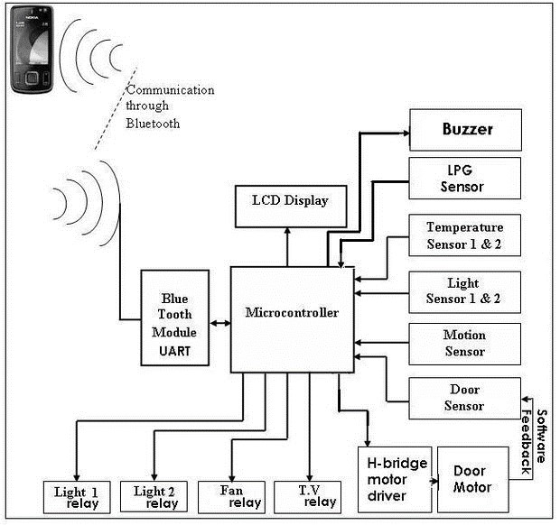

#### Fig.5.1:-Block diagram of Smart Home

A smart home has various electric and [electronic](https://www.explainthatstuff.com/electronics.html) appliances are wired up to a central [computer](https://www.explainthatstuff.com/howcomputerswork.html) control system so they can either be switched on and off at certain times (for example, heating can be set to come on automatically at 6:00 am on winter mornings) or if certain events happen (lights can be set to come on only when a [photoelectric](https://www.explainthatstuff.com/how-photoelectric-cells-work.html) sensor detects that it's dark).

For a natural-gas-powered [central heating](https://www.explainthatstuff.com/gasboilers.html) system, likely has a [thermostat](https://www.explainthatstuff.com/thermostats.html) on the wall is switched on and off according to the room temperature, or an electronic programmer that activates it at certain times of day whether or not in the house. Thus the system is hi-tech, with having a [robotic vacuum cleaner](https://www.explainthatstuff.com/how-roomba-works.html) that constantly crawls around floors sweeping the dust.

**Operation**- The central controller sends regular switching signals through the ordinary household wiring, effectively treating it as a kind of [computer network.](https://www.explainthatstuff.com/howcomputernetworkswork.html) Because these signals work at roughly twice the switching frequency of ordinary AC power (which works at 50– 60Hz), they don't interfere with it in any way. Each signal contains a code identifying the unit it relates to (a table lamp in living room, perhaps, or a radio in the bedroom) and an instruction such as turn on, turn off, or (for lamps) brighten, or dim. Although all the control units listen out for and receive all the signals, a particular signal affects only the appliance (or appliances) with the correct code. Apart from appliances that receive signals, can also plug in sensors such as motion detectors, [thermostats,](https://www.explainthatstuff.com/thermostats.html) and so on, so the system will respond automatically to changes in daylight, temperature or intruders. Most of the systems, can also switch appliances on and off with a handheld [remote control](https://www.explainthatstuff.com/remotecontrol.html) (similar to a TV remote) The remotes either send signals directly to each module using [radio](https://www.explainthatstuff.com/radio.html) wave (RF) signals or communicate with the central controller, which relays the signals accordingly. X-10 has become one of the international standard for remotely controlling appliances

#### **Example - Plug-in X-10 modules**

Developed in 1975, the oldest and best-known smart home automation system is called [X10](https://en.wikipedia.org/wiki/X10_%28industry_standard%29) (sometimes written "X10") and uses ordinary household electricity wiring to switch up to 256 appliances on and off with no need for any extra cables to be fitted.

Each appliance is plugged in order to automate into a small control unit (usually called a module) and plug that into an ordinary electrical power outlet. Using a small screwdriver, then adjust two dials on each module. One dial is what's called the house code and set this to be a letter from A through P, so use the house code to link appliances together (for example, so all the lamps on the first floor of home can be controlled as a group). The other dial is set so each individual appliance has a unique identifier known as its unit code, which is a number 1–16. Further, the plug of central controller unit into another electrical socket and program it to switch the various appliances on and off (identifying them through their codes) whichever is required.

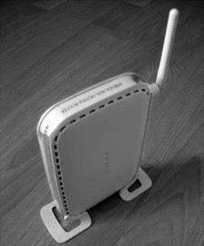

Fig. 5.2-Wireless router

Wireless router can be used to control an X-10 system

#### **Wireless Internet system**

Security is one of the biggest reasons why many people are interested in smart homes. When away at work or on holiday, making the home seem lived in is a good way to deter intruders, a basic X-10 system can turn the lights and the TV on and off at unpredictable times, but if required to push the boat out on security, a wireless, Net-connected system is much better. Effectively, it's a computer-controlled X-10 system with an interface one can access over the Web. With a system like this, one can hook up webcams to watch home/ pets, switch appliances on and off in real time, or even reprogram the whole system. Example -Harmony Home Automation provides this system.

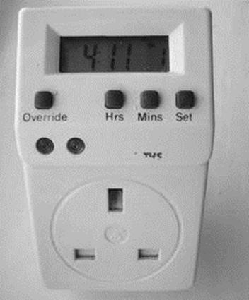

##### Fig5.3-Remote for setting and control

Features:-

1. Control upto minimum four home appliances wirelessly (expandable based on free IO pins).
2. Monitor status of home like temperature inside and outside the home, light intensity inside and outside the home, motion (presence) on the main entrance, LPG leak in the home and status of main door.
3. Open/close main door electrically and wirelessly.
4. As the android application is password protected it automatically adds security to home as it can be controlled by the user only.
5. Automate indoor lightening, outdoor lightening and fan/AC to switch ON/OFF automatically when the light intensity and temperature conditions exceed the programmed threshold values.(This feature, we named it “SENSOMATE”).
6. It automatically monitor home against LPG leaks and cases of fire. If it detects something wrong, it automatically switches off all home appliances instantly and immediately opens the door to let the LPG/fire exhaust off home.
7. It has a “SLEEP MODE”, once activated will switch light off and program the motion sensor and door sensor to raise alarm if anything goes wrong.
8. As it uses Bluetooth the user can use the android phone within a range from 10-100m.

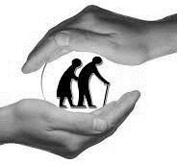

Fig 5.4:- Home automation for elderly and disable people.

There are many elderly and disabled people, and those with special needs, struggle with simple household tasks. Home automation could make all the difference between them being able to live happily and independently in their own home or having to move into expensive sheltered accommodation.

This application gives them a **helping hand,**feel secure with the help of motion sensor, give alarm to the guardian at times of emergency, check indoor and outdoor temperatures, Enable/Disable Automatic AC control, Enable/Disable Automatic Room light control and monitor windows/doors.

###### **5.2 Basic requirements for smart home**

While the recent smart home market still has plenty of room for growth, examples of smart home technology currently on the market include [internet-](https://www.webopedia.com/TERM/I/Internet.html)enabled and controlled refrigerators, smart thermostats like the Nest thermostat, smart lights with light occupancy sensors, and smart door locks and security systems. Most of these smart home devices now include a mobile app for managing them via a [smart phone](https://www.webopedia.com/TERM/S/smartphone.html) or [tablet.](https://www.webopedia.com/TERM/T/tablet_PC.html)

**5.2.1 Components -The few of the smart home devices available on today’s market:**

* Monitored Security System
* Security Cameras and Video Surveillance
* Smart Door Locks
* Thermostat Control
* Lighting Control System
* Intercoms
* Video Doorbells
* Home Entertainment
* Smart TVs
* Energy Management • Garage Door Opener
* HVAC Units with Climate Control
* Window Blinds Control
* Bed Mattress Control
* Wireless pendants for senior citizens
* Fire and Gas detection systems

5.2.2 Requirements and Components for Smart Home

Various sensors are placed at different places .It gathers physical conditions such as motion, temperature illumination etc. The parameters are processed using controllers such as Raspberry Pi or Arduino. Processor generates various control signal depending upon sensor information. These control signals are used to control the operation of home appliances through switches and relays.

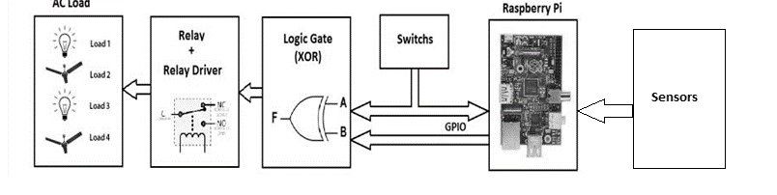

Fig 5.5 Block diagram of Appliances control

#### **5.2.3 Video monitoring**

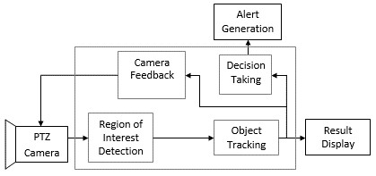

Fig 5.6:- Video Recording system

Video monitoring system for home consists of camera (outdoor unit) and displays (indoor unit). Camera can be wired or wireless. Cameras transmitting the capture video through a radio (RF) transmitter. The video is sent to a receiver that is connected to a built-in storage device .Display unit have an easy link to access all of image or video clips.

Video monitoring system can be outfitted with motion sensor technology that is both energyefficient and more secure. Video monitoring system that include motion detectors will start recording automatically any time they sense movement in range. In the case of pan-and-tilt cameras, the camera lens will automatically point itself in the direction of the motion and record.

#### **5.2.4 Security and Alarm**

ALARM SYSTEMS- Alarm systems are made up of a combination of different sensors which will trigger an alarm when it detects an action it was specifically built for. Here are some of the basic alarm systems which can install in the home to safeguard family from any outside danger.

Wired / Wireless home alarm systems-Wired alarm systems use a low-voltage current that flows between two points throughout the home’s entry points, and breaking the circuit will

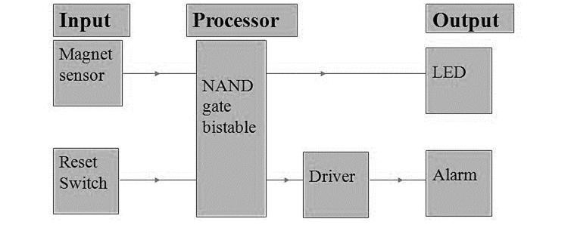

##### Fig 5.7:- Security and alarm system

result in the alarm being triggered; wireless alarm systems use built-in radio frequency transmitters where the signal is transmitted to the control panel and the alarm is activated. Monitored / Unmonitored alarm systems- Alarm systems may be monitored by a call center who will get notified if the alarm gets triggered who will dispatch emergency services, or they may be unmonitored i.e. it’ll just set off a loud siren inside and outside the house when the alarm is tripped and will have to take necessary action .

Outdoor / Indoor Siren-The alarm system sirens may be installed indoor, outdoor or both places so that when the alarm is triggered the loud siren will be heard by neighbors as well who can alert the police.

Burglar Alarm System

A combination of different sensors and security cameras make up the burglar alarm system detects an unauthorized entry in home. When the alarm is triggered, an alert is sent to and the police so that immediate action can be taken.

#### **5.2.5 Door control**

SMART DOOR-Smart doors are nowadays by installing video door phones and smart doorbells. These instruments will help know who is standing outside door before opening

it,

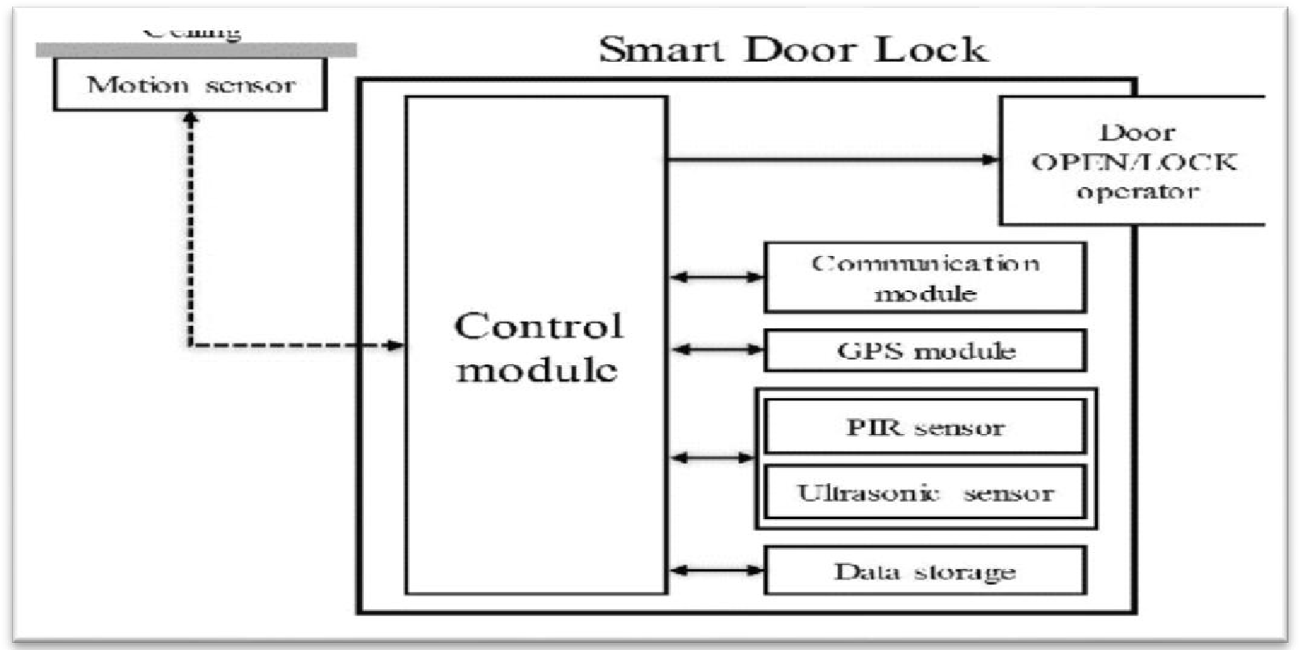

##### Fig 5.8 -Door control system

can even communicate with them about the reason for their visit without the need for physical interaction with them. By making doors smart, can rest assured that family will be safe even from unforeseen dangers.

#### **5.2.6 Heating Ventilation and Air Conditioner control (HVAC)**

**Introduction**: Heating, ventilation, and air conditioning (HVAC) is the technology of indoor environmental comfort. Its goal is to provide [thermal comfort](https://en.wikipedia.org/wiki/Thermal_comfort) and acceptable [indoor air quality.](https://en.wikipedia.org/wiki/Indoor_air_quality)

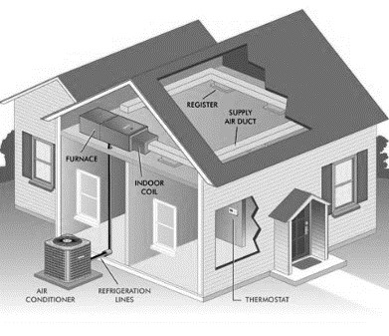

##### Fig. 5.9:- HVAC model

The three major functions of heating, ventilation, and air conditioning are interrelated, especially with the need to provide thermal comfort and acceptable indoor air quality within reasonable installation, operation, and maintenance costs. HVAC systems can be used in both domestic and commercial environments. HVAC systems can provide ventilation, and maintain pressure relationships between spaces. The means of air delivery and removal from spaces is known as [room air distribution.](https://en.wikipedia.org/wiki/Room_air_distribution) The HVAC system will collect heat from within a space, soak it up like a sponge, and push it back out into the air.

**HEATING-**Heaters are appliances whose purpose is to generate heat (i.e. warmth) for the building. This can be done using system containing a [boiler/](https://en.wikipedia.org/wiki/Boiler) [furnace](https://en.wikipedia.org/wiki/Furnace) in a home, or a large building. The heat can be transferred by [convection,](https://en.wikipedia.org/wiki/Convection) conduction, or [radiation.](https://en.wikipedia.org/wiki/Radiation)

**VENTILATION-** Ventilating or [ventilation](https://en.wikipedia.org/wiki/Ventilation_(architecture)) is the process of exchanging or replacing air in any space to provide high indoor air quality which involves temperature control, oxygen replenishment, and removal of moisture, odours, smoke, heat, dust, airborne bacteria, carbon dioxide, and other gases. Methods for ventilating a building may be divided into mechanical/forced and [natural](https://en.wikipedia.org/wiki/Natural_ventilation) types.

##### **AIR CONDITIONING**

An air conditioning system provides cooling and [humidity control](https://en.wikipedia.org/wiki/Air_conditioning#Humidity_control) for all or part of a building, having sealed windows. Outside, fresh air is generally drawn into the system by a vent into the indoor heat exchanger section, creating positive air pressure. Air conditioning and refrigeration are provided through the removal of heat. Heat can be removed through [radiation,](https://en.wikipedia.org/wiki/Thermal_radiation) convection, or [conduction.](https://en.wikipedia.org/wiki/Thermal_conduction)

###### **5.2.7 Smart Illumination system**

Smart switches are the most cost-effective way to make the lights in home work with a mobile app or smart home system, because it doesn’t need to replace every light bulb in the home with a smart one, which is more expensive than replacing a few switches. Controlling lights with voice ,have smart lighting systems to make a feel all-powerful. Smart lighting generally uses mesh networking, where each smart bulb wirelessly connects to its nearest neighbor. That network is controlled by a hub that plugs into router, enabling other networked devices - such as phone or tablet - to communicate with bulbs. Some systems also have an away from home mode that enables to control the lights when far away, which is handy if just remembered that the lights were left on. Smart light systems can also be accessorized with additional items such as dimmer switches or motion detectors, and in some cases they can be linked to the [IFTTT (If This Then That)](https://www.techradar.com/how-to/world-of-tech/how-to-control-your-smart-home-with-ifttt-1326142) service to create complex rules that trigger particular recipes for particular things.

Example-Smart lighting systems are controllable with smart phone or tablet apps. [Philips’ Hue](https://www.techradar.com/reviews/gadgets/appliances/philips-hue-1124842/review) system works with Apple’s [Home Kit,](https://www.techradar.com/news/digital-home/the-apple-homekit-collection-these-are-all-the-home-appliances-that-work-with-homekit-1291197) Amazon’s [Echo](https://www.techradar.com/reviews/audio-visual/hi-fi-and-audio/audio-systems/amazon-echo-1329791/review) and [Google Home,](https://www.techradar.com/reviews/google-home) can use those platforms voice assistants to relay the voice commands. Example-saying “Hey Siri, set scene to cinema” or “Alexa, turn the lights off” and seeing it happen. With Home Kit, can also control the lights with an [Apple Watch.](https://www.techradar.com/reviews/wearables/apple-watch-2-1323213/review) Most smart lighting systems use the same ZigBee wireless networking technology. It’s called ZigBee Light Link and it’s used by Philips, IKEA and Osram, which should ensure ongoing compatibility and interoperability between competing systems. Smart light bulbs aren't currently suitable for enclosed light fixtures, as heat can build up in the fixture, which shortens the bulb's life.

Smart Lighting includes- 1. Smart Light Bulbs

1. Smart Dimmers
2. Smart Ceiling fans
3. Smart flash mount lighting
4. Smart lighting kits
5. Smart light switches
6. Smart outdoor lighting
7. Smart outlets
8. Smart plugs

###### **5.2.8 Smart Metering**

Introduction: A smart meter is an [electronic](https://en.wikipedia.org/wiki/Electronics) device that records consumption of [electric energy](https://en.wikipedia.org/wiki/Electric_energy) and [communicates the information](https://en.wikipedia.org/wiki/Telemetering) to the [electricity supplier](https://en.wikipedia.org/wiki/Public_utility) for monitoring and billing. Smart meters typically record energy hourly or more frequently, and report at least daily. Smart meters enable two-way communication between the meter and the central system. Such an advanced metering infrastructure (AMI) differs from [automatic meter reading](https://en.wikipedia.org/wiki/Automatic_meter_reading) (AMR) in that it enables two-way communication between the meter and the supplier. Communications from the meter to the network may be wireless, or via fixed wired connections such as power line carrier (PLC). Wireless communication options in common use include cellular communications (which can be expensive), Wi-Fi (readily available), [wireless ad hoc networks](https://en.wikipedia.org/wiki/Wireless_ad_hoc_network) over Wi-Fi, [wireless mesh networks,](https://en.wikipedia.org/wiki/Wireless_mesh_network) low power long range wireless (LoRa), [ZigBee](https://en.wikipedia.org/wiki/ZigBee) (low power, low data rate wireless), and Wi-SUN (Smart Utility Networks).

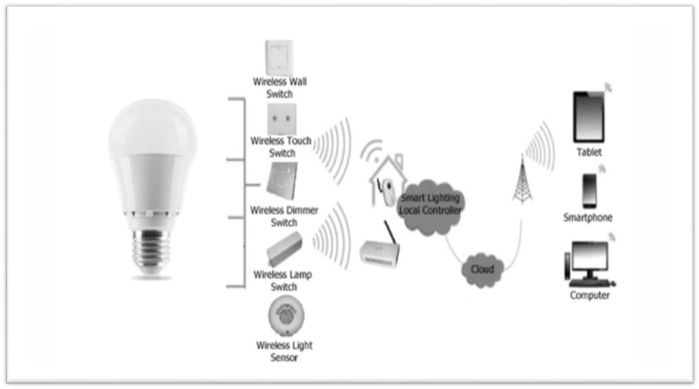

Fig 5.10:-Smart lighting for home and its control

Smart metering offers potential benefits to householders. These include,

1. an end to estimated bills, which are a major source of complaints for many customers
2. a tool to help consumers better manage their energy purchases-stating that smart meters with a display outside their homes could provide up-to-date information on gas and electricity consumption and in doing so help people to manage their energy use and reduce their energy bills. An academic study based on existing trials showed that homeowners' electricity consumption on average is reduced by approximately 3-5%.

Advance metering system: -Advanced Metering Infrastructure (AMI) refers to systems that measure, collect, and analyze energy usage, and communicate with metering devices such as electricity meters, gas meters, heat meters, and water meters, either on request or on a schedule.

These systems include hardware, software, communications, consumer energy displays and controllers, customer associated systems, [meter data management](https://en.wikipedia.org/wiki/Meter_data_management) software, and supplier.

business systems. The network between the measurement devices and business systems allows collection and distribution of information to customers, suppliers, [utility companies,](https://en.wikipedia.org/wiki/Utility_companies) and service providers. This enables these businesses to participate in demand response services. Consumers can use information provided by the system to change their normal consumption patterns to take advantage of lower prices. Pricing can be used to curb growth of [peak demand](https://en.wikipedia.org/wiki/Peak_demand) consumption. AMI differs from traditional [automatic meter reading](https://en.wikipedia.org/wiki/Automatic_meter_reading) (AMR) in that it enables two-way communications with the meter. Systems only capable of meter readings do not qualify as AMI systems. Fig 5.12 shows block diagram of smart meter.

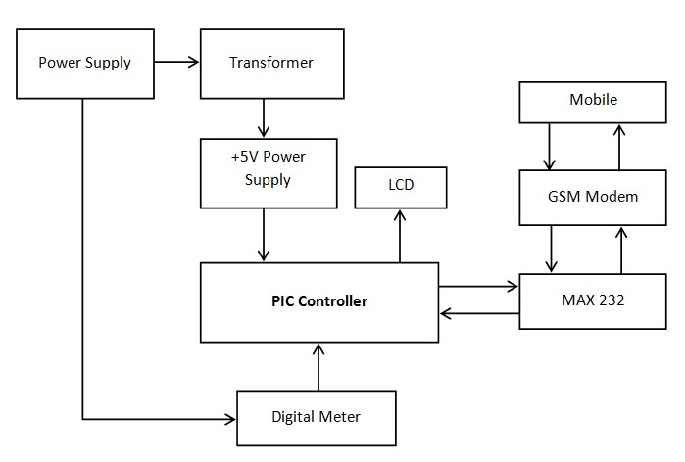

Fig 5.11:- Smart meter system

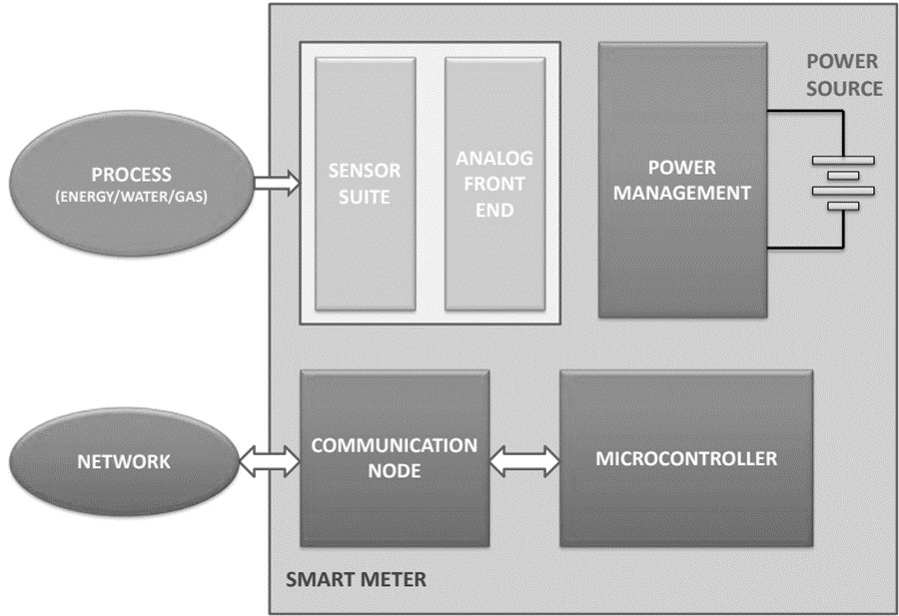 Fig 5.12 :- Block diagram Smart Meter

#### **5.2.9 Web controlling appliances**

A web-based application is any program that is accessed over a network connection using HTTP, rather than existing within a device’s memory. Web-based applications often run inside a web browser. However, web-based applications also may be client-based, where a small part of the program is downloaded to a user’s desktop, but processing is done over the internet on an external server.

Web-based applications are also known as web apps.

Home Mobile: The home mobile is connected to the computer using a standard data cable. The computer communicates with the mobile using AT command.

Home Computer: The computer in our prototype uses the AT command protocol to determine if a new Home Control Message is received in the home mobile. The prototype software is developed in windows based platform but can easily be migrated to other OS like Unix/Linux and so on.

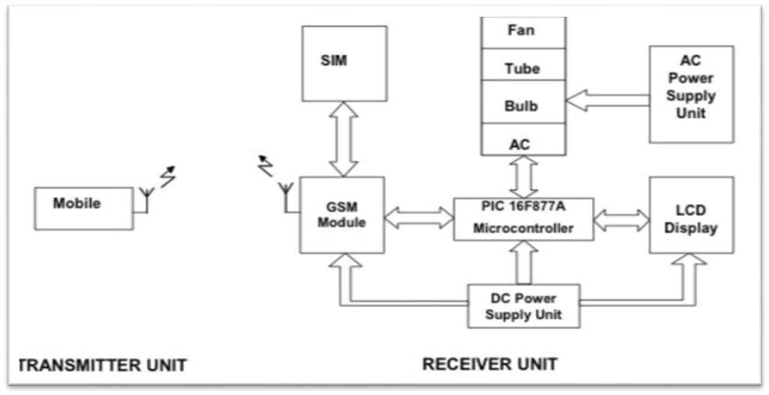

##### Fig.5.13: Web controlled appliances

Home appliance control system accessed by a remote device such as mobile or a palm top to allow a home owner to control, monitor and coordinate home appliances.

The system provide secured login to the system. It accepts instructions remotely and communicate those instructions to the appropriate devices within the home. It shall control, monitor and coordinate appliances as programmed. Like if any unauthorized user enters into the house, the security alarm will produce.

##### **Applications:-**

1.Household appliances-Microwave ovens, Television, DVD payers and recorders, Audio players

2.Integrated systems in aircraft and missiles

3.Cellular telephones

4.Electric and electronic motor controller

5.Engine controllers in automobiles

6.Calculators

**7.**Medical equipment’s etc.

**Benefits of web based applications and systems-**Both web and desktop apps excel in their own particular areas, have major advantages that are exclusive to an application software development company devoted to creating web based applications and systems.

1. No more updating issues
2. Less money, more power
3. Quick development cycles
4. Improved Security
5. The Flexibility of the Internet
6. Higher Usage Rates
7. User Tracking
8. Offline Use

### 5.3 Basic requirements for Smart City

A Smart city is an urban area that uses different types of electronic Internet of things (IoT) sensors to collect data and then use these data to manage assets and resources efficiently. This includes data collected from citizens, devices, and assets that is processed and analyzed to monitor and manage traffic and transportation systems, power plants, water supply networks, waste management, crime detection, information systems, schools, libraries, hospitals, and other community services

#### **Requirements that makes smart city are-** 1. Health and education

1. Sustainable environment
2. Affordable housing, especially for the poor
3. Adequate water supply
4. Assured continuous Electric power supply and backup
5. Sanitation, solid waste management
6. Efficient urban mobility along with public transport and broad highways
7. E-governance and participation of citizens
8. Safety and security ,especially senior citizens, women and children
9. Security for banks, ATMs
10. Complete digitization and online trading , IT Connectivity

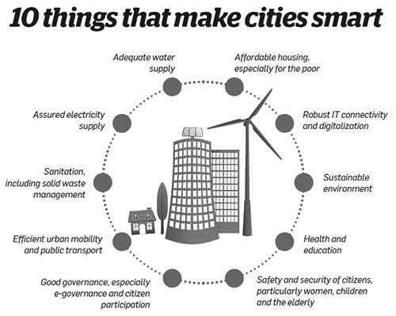

Fig 5.14:- Requirements of smart city

#### **Concept of Smart City**

New Internet technologies is platform for promoting [cloud-based services,](https://en.wikipedia.org/wiki/Cloud_computing) the [Internet of Things](https://en.wikipedia.org/wiki/Internet_of_Things) (IoT) real-world user interfaces, use of [smart phones](https://en.wikipedia.org/wiki/Smart_phone) and [smart meters,](https://en.wikipedia.org/wiki/Smart_meter) [networks of sensors](https://en.wikipedia.org/wiki/Sensor_network) and [RFIDs,](https://en.wikipedia.org/wiki/Radio-frequency_identification) and more accurate communication based on the [semantic web,](https://en.wikipedia.org/wiki/Semantic_web) open new ways to collective action and [collaborative](https://en.wikipedia.org/wiki/Collaborative_problem-solving_group) [problem solving.](https://en.wikipedia.org/wiki/Problem_solving)

Online collaborative sensor data management platforms are on-line database services that allow sensor owners to register and connect their devices to feed data into an on-line database for storage and allow developers to connect to the database and build their own applications based on that data.

Large IT, telecommunication and energy management companies launched the Global Intelligent Urbanization initiative to help cities using the network as the fourth utility for integrated city management, better [quality of life](https://en.wikipedia.org/wiki/Quality_of_life) for citizens, and economic development.

Smarter Cities stimulates [economic growth](https://en.wikipedia.org/wiki/Economic_growth) and quality of life in cities and metropolitan areas with the activation of new approaches of thinking and acting in the [urban ecosystem.](https://en.wikipedia.org/wiki/Urban_ecosystem) Sensor developers and startup companies are continually developing new Smart city applications.

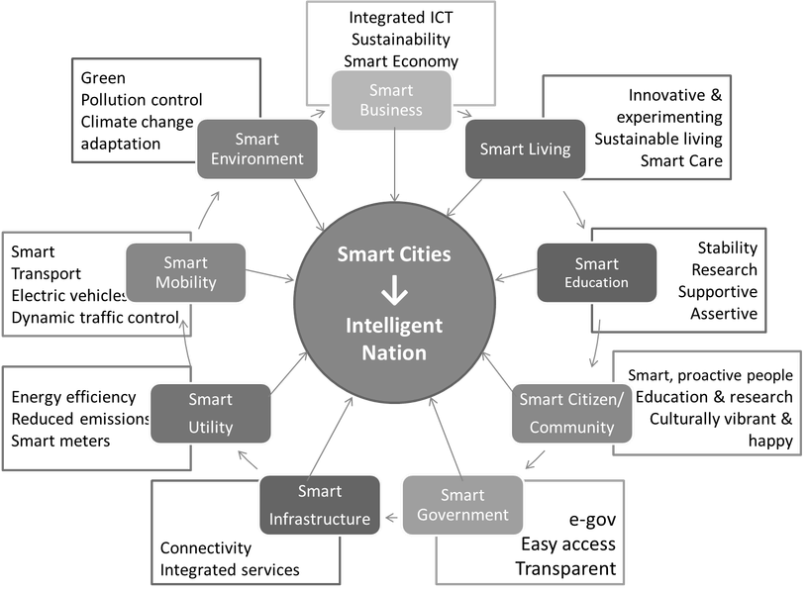

Fig 5.15 : -Features of smart city

#### **Smart city model**

Thus a Smart city, also called as community, business cluster, urban agglomeration or region, uses information technologies to:

1.Make more efficient use of physical infrastructure (roads, built environment and other physical assets) through artificial intelligence and data analytics to support a strong and healthy economic

, social, cultural development.

2.Engage effectively with local people in local governance and decision by use of open innovation processes and e-participation, improving the collective intelligence of the city's institutions through e-governance, with emphasis placed on citizen participation and codesign.

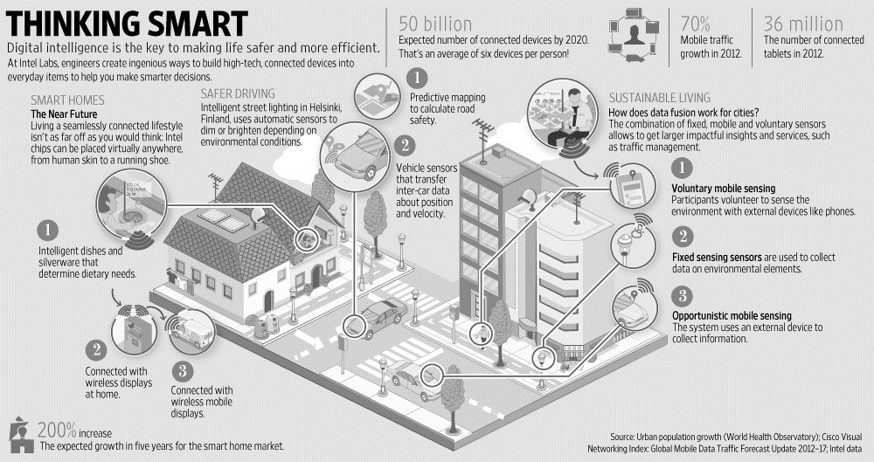

Fig 5.16 :- Smart city model[7]

3. Learn, adapt and innovate and thereby respond more effectively and promptly to changing circumstances by improving the intelligence of the city.

**‘**

#### **Government of India (GoI) planning and budget for upcoming Smart Cities**

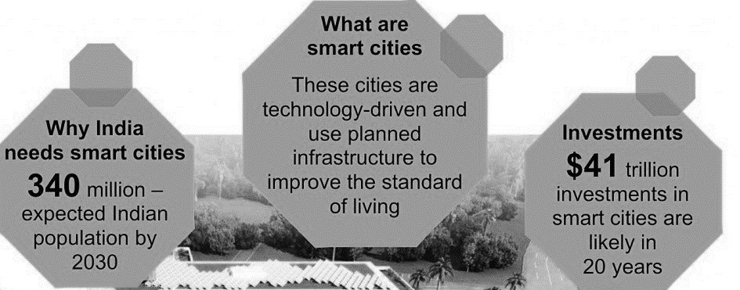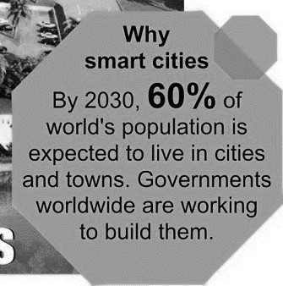

Fig 5.17:- Smart city plan and budget for the future for India [7]

Current Indian working projects/cities towards smart cities

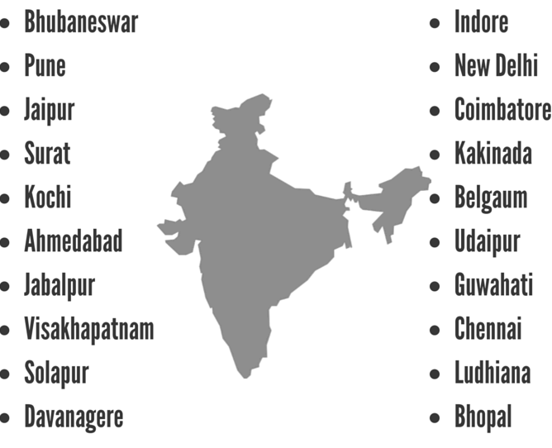

Fig 5.18:- Cities under smart city development

#### **5.3.1 Smart Transportation**

In 1950, thirty percent of the world’s population was urban, expected to grow to 66 percent by 2050. Cities across the world are expanding, so pressures on cities to augment their infrastructure and facilities to accommodate all existing/potential residents and enable them to lead a good quality of life. Smart cities use technology to augment their urban servicestransportation, utilities and energy-to improve efficiency, reduce wastage and operate more sustainably. The government of India, too, launched the Smart Cities Mission to develop 100 Indian cities to be sustainable and citizen-friendly.

**Delivering seamless mobility-** Smart transportation is developed on the base of smart infrastructure that includes not only multi-modal connected conveyance but also automated traffic signals, tolls and fare collection. Data integration drives the system, incorporating weather and traffic data, linking emergency services data as well as information from government agencies. Smart services offer different benefits, from smart parking and vehicle locating systems, to route diversion alerts. A central command centre can tie together the smart transportation ecosystem, with real-time and updated data, handling passenger information, Optimized on-demand services can ensure that citizens can use all modes of transport according to their needs. Shared mobility solutions can help provide first and last mile connectivity in conjunction with public transportation, they can act as feeder services and improve access to metro/rail or bus services. If public transportation is made robust and accessible through multi-modal shared mobility, citizens can choose it for all their commuting needs be it office travel, travel for daily needs or leisure travel. The number of private vehicles can be reduced, which can contribute to lowering congestion and pollution. traffic signals, incident management and vehicle health monitoring.

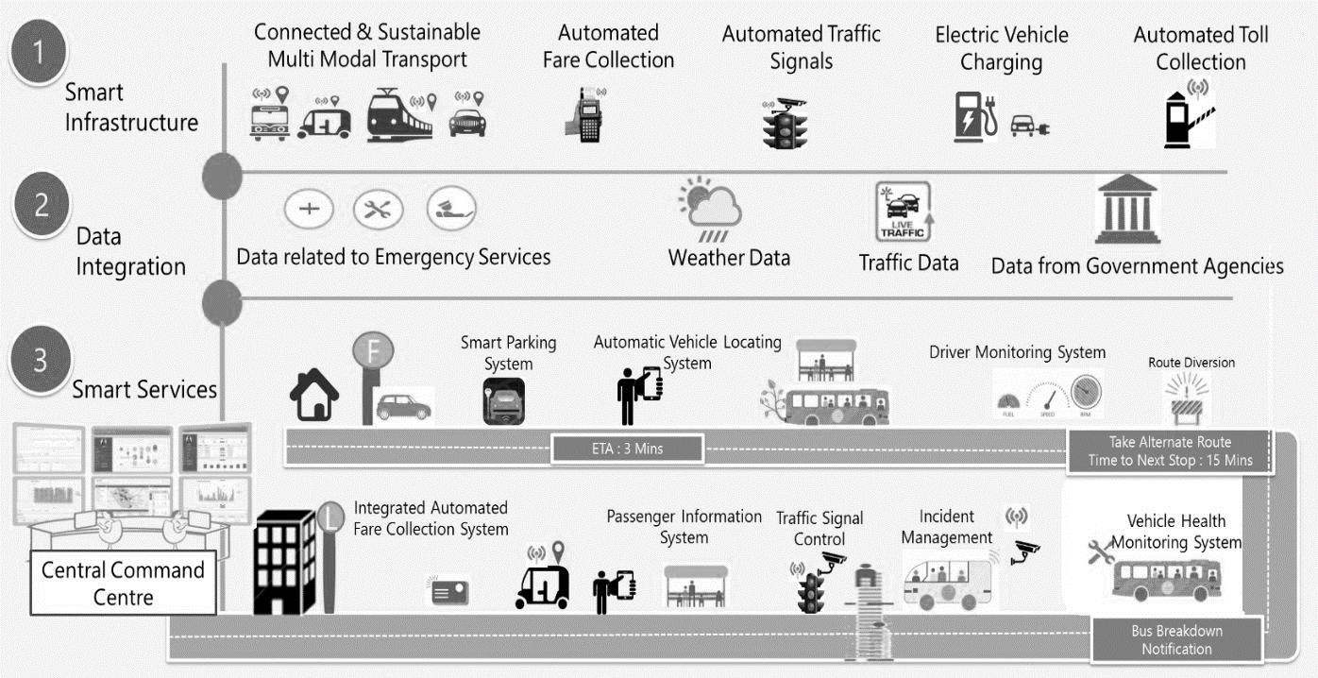

##### Fig 5.19:- Smart transportation [7]

**Multi-modal mobility options-through Mobility-as-a-Service (MaaS):-** MaaS aims to solve the problems associated with urban density and make mobility more efficient and convenient. It offers users access to different modes of transport via a single platform such as a mobile application

**Intelligent traffic management-Traffic Demand Modeling:** City planners can track data records and area-wise people movement and use this information to build models whereby public transportation gets deployed in areas of maximum people movement to ensure better connectivity.

Implementing smart transportation would need the government, transport operators and service providers to collaborate in planning and execution ,saving staff-hours through better traffic management, reducing polluting emissions, or increasing Gross Domestic Product (GDP) by reducing the consumption of vehicular fuel and oil imports, smart transportation is here to stay.State DOTs must closely collaborate with local jurisdictions to understand what the communities’ critical needs are to help them achieve their goals to provide- 1. Connecting underserved communities to jobs

1. Moving goods in and out of the city
2. Integrating data collection throughout various systems
3. Establishing better parking systems
4. Controlling carbon emissions
5. Improving traffic flow

#### **5.3.2 Smart Healthcare**

##### Among all the facilities to citizens in a smart city, smart health care counts as foremost important facility as a city which has healthy citizens is balanced in every sphere. Smart

Health Technology’ combines Smart Technology and latest mobile device with health, such as fitness tracker or fitness bands and even health assessment apps in smart phones have gained grand attention amongst fitness enthusiasts. They not only just monitor health but also provide solutions if needed at the right time. Smart Health technology interacts and engages with data produced by those devices which can be analyzed by doctors, researchers and health care professionals for better-personalized diagnosis and solutions. These digital records save cost and time of both patients and hospitals as they not only offer personalized treatments and medications but also give preventive measures through real-time data collection

Role of technologies in Smart Healthcare - Here IoT plays an important role, allows connecting data collected from smart devices and sensors to extract valuable insights, then convey that information to the doctors and staff in real-time, thus improving the effectiveness in the overall healthcare system. When the health data is collected it needs to be analyzed and managed for accurate treatment and here Artificial intelligence and automation are applied.

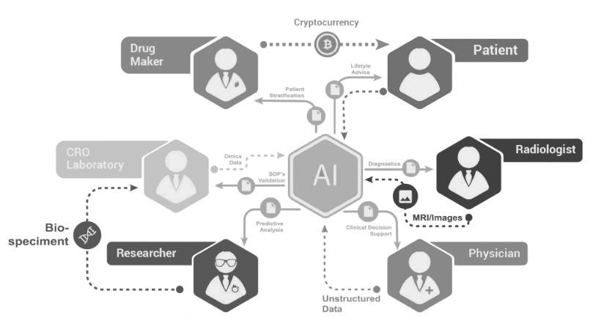

Fig 5.20:- Smart healthcare

E-health delivers health information and services to enable data transmission, storage and retrieval for clinical, educational and administrative purposes. Mobile health (or m-health) is the practice of medicine and public health supported by mobile devices. Speech and hearing systems for natural language processing, speech recognition techniques, and medical devices can aid in speech and hearing (e.g. cochlear implants). Tele-health, tele-medicine, tele-care, tele-coaching and tele-rehabilitation provide various forms of patient care remotely at a distance

**Example- Smart Dust**-Millimeter-scale self-contained [micro-electromechanical](https://www.webopedia.com/TERM/M/MEMS.html) devices that include sensors, computational ability, bi-directional wireless communications technology and a power supply. As tiny as dust particles, smart dust [motes](https://www.webopedia.com/TERM/M/mote.html) can be spread throughout buildings or into the atmosphere to collect and monitor data. Smart dust devices have applications in everything from military to meteorological to medical fields.

#### **5.3.3 Smart Waste Management**

Waste management is all the activities and actions required to manage waste from its inception to its final disposal. This includes collection, transportation, treatment and disposal of waste together with monitoring and regulation. Domestic waste collection services are often provided by local government authorities such as municipal corporations. The waste is collected at regular intervals by specialized trucks. Waste collected is then transported to an appropriate disposal area..

**Need**:- Improvement and involvement of technology is required to manage the disposal of waste as

1. By 2030, almost two-third of the world’s population will be living in cities, demanding for development of sustainable solutions for urban life, managing waste is a key issue for the health.
2. Efficient and energy-saving waste management, reduces CO2 ,air pollution and vehicle exhaust emissions
3. Waste management may swallow up to 50% of a city’s budget, but only serve a small part of the population. Sometimes, up to 60%of waste is not being collected, it is often simply burned by the roadside. It can pollute drinking water, it can spread disease to people living nearby.
4. Even with great route optimization, the worker must still physically go to the dustbin to check waste levels. Because of this, trucks often visit containers that do not need emptying, which wastes both time and fuel.
5. Waste management prevents harm to human health and the environment by reducing the volume and hazardous character of residential and industrial waste.
6. Improving proper waste management will reduce pollution, recycle useful materials and create more green energy. **Features**
7. The smart, sensor based dustbin will judge the level of waste in it and send the message directly to the municipal corporation.
8. It can sense all the type of waste material either it is in the form of solid or liquid.
9. According to the filled level of the dustbin, the vehicles from the municipal corporation will choose the shortest path with the help of the “TRANSPORTATION SOFTWARE”, which will save their time. It emphasizes on “DIGITAL INDIA”.
10. The system is simple. If there is any problem with any equipment in the future, that part is easily replaceable with new one without any difficulty and delay. **Advantages**
11. Less time and fuel consumption as the trucks go only to the filled containers.
12. Decreased noise, traffic flow and air pollution as a result of less trucks on the roads.
13. Smart operating system enable two way communication between the dustbin deployed in the city and service operator. Therefore the focus is only on collection of route based fill level of the containers.
14. The sensors installed in the containers provide real time information on the fill level. This information helps determine when and where to prioritize collection.
15. In this way both service providers and citizens benefit from an optimized system which results in major cost savings and less urban pollution.
16. Reduces the infrastructure (trucks, containers), operating (fuel) and maintenance costs of the service by upto 30%.
17. Applying this technology to the city optimizes management, resources and costs, and makes it a “SMART CITY”.
18. Historical information on collections helps adapt the deployment of containers to the actual needs of the city, therefore reducing the number of containers that clutter up the road and increasing public parking spaces.
19. It keeps the surroundings clean and green, free from bad odour of wastes, emphasizes on healthy environment and keep cities more beautiful.
20. Reducing manpower required to handle the garbage collection

##### **Main equipments used in the smart waste management system**

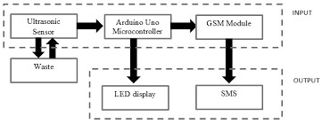

Fig 5.21: –Smart waste System

1. Garbage Container- A waste container is a container for temporarily storing waste, and is usually made out of metal or plastic. The curbside dustbins usually consist of three types: trash cans (receptacles made of metal or plastic), dumpsters (large receptacles ) and wheelie bins (light, usually plastic bins that are mobile). All of these are emptied by collectors, who will load the contents into a garbage truck and drive it to a landfill, consuming crush facility to be disposed of.
2. Ultrasonic Sensor- A special sonic transducer is used for the ultrasonic proximity sensors, which allows for alternate transmission and reception of sound waves. The sonic waves emitted by the transducer are reflected by an object and received back in the transducer. After having emitted the sound waves, the ultrasonic sensor will switch to receive mode. The time elapsed between emitting and receiving is proportional to the distance of the object from the sensor.
3. Arduino Board-: Arduino is a software company, project, and user community that designs and manufactures computer open-source hardware, open-source software, and microcontroller-based kits for building digital devices and interactive objects that can sense and control physical devices.

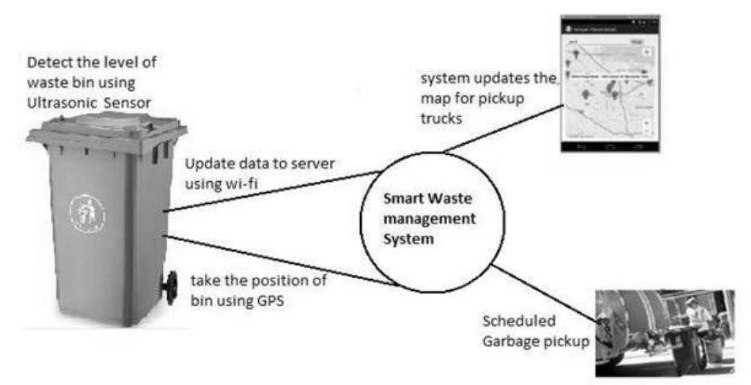

Fig 5.22:- Dustbin features

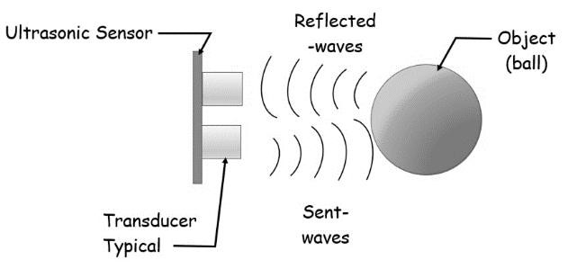

###### Fig 5.23:-Ultrasonic sensor

1. Software Of Arduino : The Arduino project provides the Arduino integrated development environment (IDE), which is a cross-platform application written in the programming language Java.
2. GSM Module- GSM (Global System for Mobile Communications, originally Group Special Mobile), is a standard developed by the European Telecommunications Standards Institute (ETSI) to describe the protocols for second-generation (2G) digital cellular networks used by mobile phones.

Principle of sensor :- Ultrasonic sensors generate high-frequency sound waves and evaluate the echo which is received back by the sensor, measuring the time interval between sending the signal and receiving the echo to determine the distance to an object

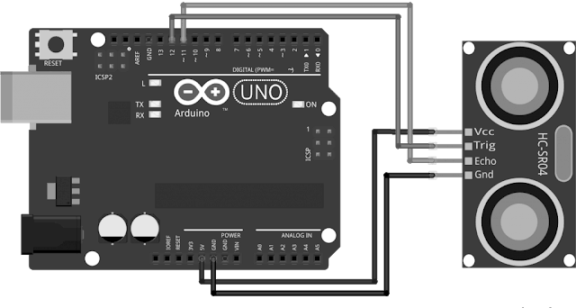

###### Fig 5.24:- Arduino Board

.

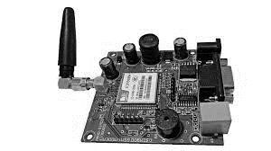

Fig 5.25 :- GSM Module

#### **5.3.4 Smart Physical safety/security**

Life safety products Monitoring typically includes

* Monitored smoke detectors and heat detectors for fire monitoring
* Carbon monoxide poisoning detectors
* Flood sensors to detect unwanted water damage in areas like indoor laundry room and basements
* Medical emergencies.

Every home should have at least one of monitored smoke detector which would be placed in the hallway next to the bedrooms. For a multiple story house, ,it should have at least one monitored smoke detector on each level. Heat detectors should be added to the kitchen, garage and laundry room. Some homeowners would like to replace the smoke detectors in all bedrooms with a monitored photoelectric smoke and heat detector.

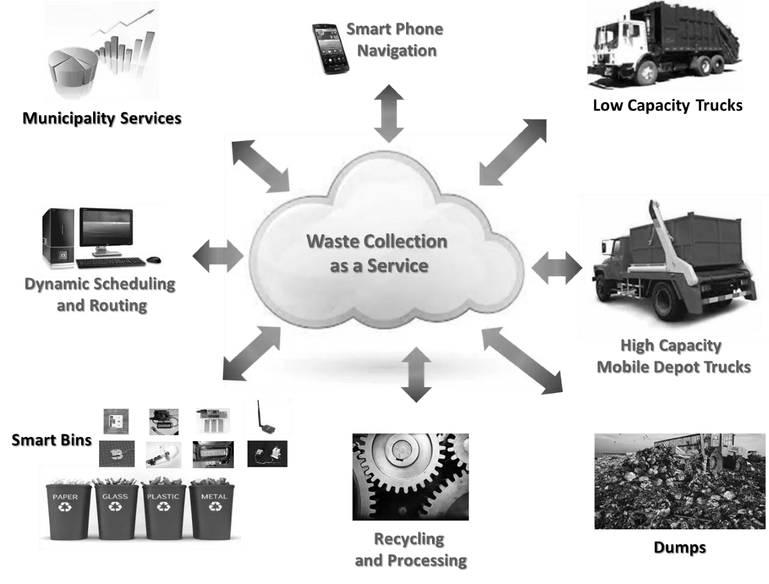

Fig 5.26:- Waste management model Benefits of fire monitoring

* ADT Central Station will call the fire department in the case of a fire emergency
* Photoelectric smoke detectors detect smoldering smoke before a fire starts. Monitoring for carbon monoxide poisoning is also important as it will notify the ADT Central Station in case home is being filled with this poisonous gas. The monitoring center operator will call and notify the detected carbon monoxide poisoning and dispatch local fire department. This will ensure not to enter into home when it is not safe.
* Flood sensors are designed to notify water in unwanted areas. Most often these are installed in the laundry room or in the basement that may have issues. This can protect from the massive damage water can cause.

#### **5.3.5 Smart Education**

For the past few years, the transformation has taken place in higher education system into smart-education and traditional universities into smart-universities, requirements of the smarteconomy and smart-society with the aim of achieving quality training of specialists.

It provides the flexibility of learning in an interactive educational environment, free access to worldwide content, personalization and adaptation of learning are presented and analyzed. The education based on smart-technology helps to realize inner potential through matching the content of the study course with their own results, and building an individual learning program with an emphasis on their personal qualities of a student.

The upcoming revolution in education system is replacing traditional classroom and learning methods. The implementation of information technology is driving the smart education and learning markets. Educational institutes are adopting advanced teaching methods and tool which includes white boards, projectors and smart notebooks. Implementation of such technology in classroom improves understanding of students and provides clear view about what to learn. Coordination between hardware provider ,software innovator and education material provider is making learning easy for students.

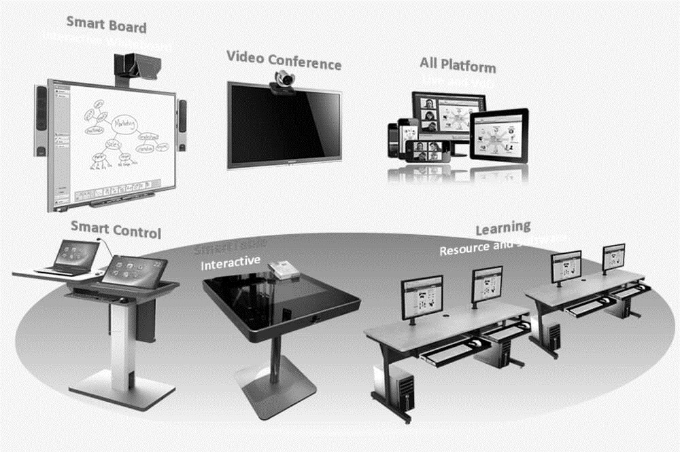

Fig 5.27:- Smart Education Interactive displays

.

The key driver of smart education and learning is the interactive displays hardware ,active learning .Increase number of mobile learning applications and professional expertise with technology and towards digital learning are anticipated to drive the smart education and learning market.

Advantages-

1. Today AR/VR is adopted for more enhanced and detailed learning.
2. Smart classes use all interactive modules like videos and presentations and these visually attractive methods of teaching becomes appealing to students

Smart classes are almost like watching movies as sometimes, animated visuals are used to teach a point.

1. Visual is eye-catching and young students can easily relate with them because the audio-visual senses of students are targeted and it helps the students store the information fast and more effectively.
2. Enhanced and Interactive learning experience
3. Easy Access to Online Resources
4. Follows Go Green Concept
5. Time Saving Technology
6. Increased Productivity 9. Smart Boards are Fun!

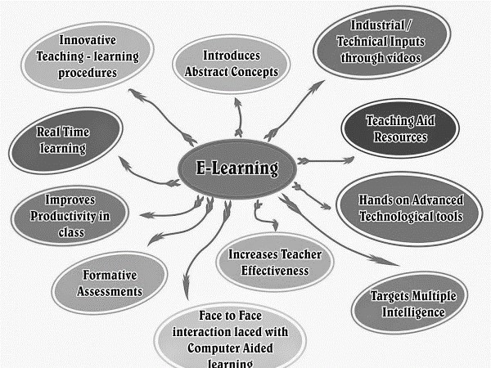

##### Fig 5.28:- E-learning Features

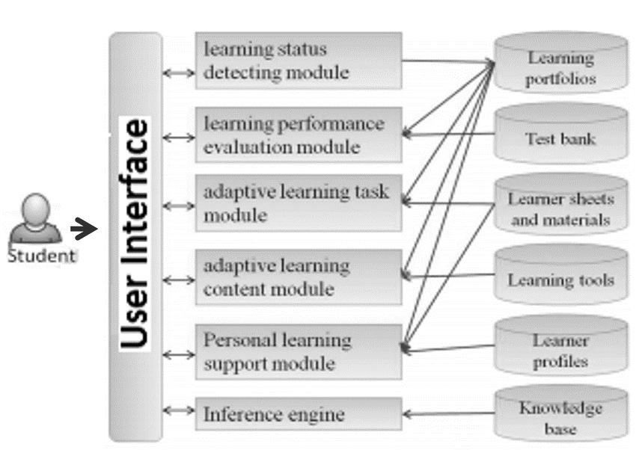

Fig 5.29 Wireless communication network for smart education

### 5.4 IOT/M2M Network architecture

#### **5.4.1 M2M**

M2M or machine-to-machine is a direct communication between devices using wired or wireless communication channels. M2M refers to the interaction of two or more devices /machines that are connected to each other.

M2M technologies allow wired / wireless system to communicate with devices of same ability. M2M uses a device (sensor, meter etc.) to capture an ‘event’ (motion, meter reading, temperature etc.), which is relayed through a network (wireless, wired or hybrid) to an application (software program), that translates the captured event into meaningful information

Controlling electrical appliances like bulbs and fans using RF or [Bluetooth](https://electronicsforu.com/videos-slideshows/bluetooth-technology) from smartphone is simple example of M2M applications [7].

**Features of M2M[8]**:

Features of M2M communication system are given below

1. Low Mobility : M2M Devices move only within a certain region
2. Time Controlled : Send or receive data only at certain pre-defined periods
3. Time Tolerant : Data transfer can be delayed
4. Packet Switched : Network operator to provide packet switched service with or without an MSISDN
5. Online small Data Transmissions: MTC Devices frequently send or receive small amounts of data.
6. Monitoring: Not intend to prevent theft or vandalism but provide functionality to detect the events
7. Low Power Consumption : To improve the ability of the system to efficiently service M2M applications
8. Location Specific Trigger : Intending to trigger M2M device in a particular area.

#### **5.4.2 Concept of M2M**

**M2M device domain** The M2M devices are responsible for the collection and autonomous transmission of sensor data such as the internal temperature and humidity. The M2M devices are usually connected to small local networks called subnets for the transmission or reception of data to or from the M2M application domains (server domain).

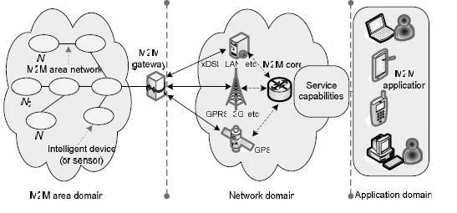

##### Fig 5.30 M2M conceptual diagram[7]

**M2M area networks** The M2M area networks are responsible for establishing the communication path between the M2M devices and the M2M gateways. These networks are usually called subnets which collect and route information from the M2M devices to the M2M gateways. There are several subnets which are used for generating the communication link between the M2M devices and the M2M gateways. Generally, the use of subnets is dependent on the network technology. In fully distributed networks, all M2M devices are connected as peers to the network. One of the nodes which is connected to the network, e.g., via wired or wireless connectivity, acts as a router. In client-server networks, all nodes or devices communicate directly with the server. Where as in cooperative networks, all nodes communicate with each other using some intermediate gateways.

Some of the major subnets are:

1. Power line communication(PLC)
2. Short-range device(SRD)
3. Ultra-wide band(UWB)
4. ZigBee
5. Meter bus(M-BUS)
6. Wireless Meter bus(WM-BUS)

|  |  |  |
| --- | --- | --- |
| **Sensor Type** | **Sensor**  **Name** | **Description** |
| Motion Sensors | Accelero meter | • An electro-mechanical device which can measure changes in acceleration |
| forces along x, y, and z-axis. |
| • Detects various types of motion like shake, tilt, etc. and adjusts the display |
| of the device accordingly. |
| Linear  Acceleration Sensor | • An accelerometer which can detect acceleration along one axis without considering the effect of gravitational force. |
| • Helps to adjust the display with motion. |
| Gyroscope | • Measures the rate of change of angular momentum in all three axes. |
| • Detects rotational movement of the device and adjusts display accordingly. |
| Environ mental  Sensors | Light Sensor | • A photodiode which changes characteristics with the change of light intensity. |
| • adjusts brightness and contrast of the display of the device. |
| • Controls automatic lighting system. |
| Proximity Sensor | • IR-based sensor to detect the presence of nearby objects without any physical contact. |
| • Reduces power consumption of the display by disabling the LCD backlight |
| and avoids inadvertent touches. |
| Temperature Sensor | • Measures temperature of the device as well as ambient temperature. |
| • Controls and sets the temperature in a device. |
| Audio Sensor | • Two types of audio sensor: microphone and speaker. |
| • Microphone: Detects acoustic signal. |
| • Speaker: Playbacks audio signal. |
| Camera | * Deals with light intensity, device ambiance, etc. to capture pictures and videosof surroundings. * Provides live video feeds. |
| Barometer | • Measures the pressure of the device peripheral. |
| Heart rate | • Measures the heart rate of the user in beat per second. |
| Position Sensors | GPS | • Captures signal from the satellite to infer the location of the device. |
| • Helps in navigation systems. |
| Magnetic Sensor | • Measures device’s magnetic field with respect to earth’s magnetic field. |
| • It is also used to fix display position by considering the magnetic field. |

**M2M gateways:** The intelligent sensors, which are deployed to collect information, communicate with the communication network with the help of M2M gateways. Hence, M2M gateways act like bridges between the sensors and the communication network. M2M device/gateway deals with issues related to the processing of raw sensing data. Compared to mote-like sensors, consumer-centric mobile sensing devices have much more computing and storage capabilities and are usually equipped with multimodal sensors. Therefore, complementary to the data-driven processing approaches that have been adopted in traditional sensor networks.More complex operations such as context inference are brought in, and where information gathered from sensor devices (accelerometer, global positioning system [GPS] sensor, . is translated into contextual user information such as current location and/or activity. Data processing at the device/gateway may enhance the lifetime of the device, minimizing energy consumption by means of reducing the amount of data sent.

**Communication networks:** The main role of the communication network is to create a communication path between the M2M devices and application servers either through wired or wireless communication networks.

The main communication networks are

1. Short-range devices (SRDs)
2. Ultra wide band (UWB)
3. Satellite
4. GSM, UMTS, LTE, LTE-A
5. Wireless LAN
6. WiMAX
7. xDSL

**Server/application domain** The M2M application domain consists of a middleware layer where the collected packets pass through several application services and then are used by the related agencies.

#### **5.4.3 Network Components**

Sensors are sophisticated devices that are frequently used to detect and respond to electrical or optical signals. A Sensor converts the physical parameter (for example: temperature, blood pressure, humidity, speed, etc.) into a signal which can be measured electrically.

The main purpose of the sensor is to identify any phenomena in peripheral and obtain the data from real world.

Sensors can be classified in three broad categories as described below.

1. **Motion Sensors**: Motion sensors measure the change in motion as well as the orientation of the devices. There are two types of motions one can observe in a device: linear and angular motions. The linear motion refers to the linear displacement of the device while the angular motion refers to the rotational displacement of the device.
2. **Environmental Sensors:** Sensors such as Light sensor, Pressure sensor, etc. are embedded to sense the change in environmental parameters in the device’s peripheral. The primary purpose of using environmental sensors in devices is to help the devices to take autonomous decisions according to the changes of a device’s peripheral. For instance, environment sensors are used in many applications to improve user experience (Home automation systems, smart locks, smart lights)
3. **Position sensors**: Position sensors deal with the physical position and location of the device. Most common position sensors used are magnetic sensors and Global Positioning System (GPS) sensors. Magnetic sensors are usually used as digital compass

and helps to fix orientation of device display. On the other hand, GPS is used for navigation purposes.

.

Gateway is processor based device having different connectivity technologies. In M2M /

IoT communication, Gateway and the platform play an important role. For

M2MCommunication, devices should be able to communicate with the headend servers (application Server) either through the Gateways and platform or directly through a platform. Gateway connectivity to the

network and platform. It is not necessary that all the devices will communicate via gateway, as an example devices connected on short range communication technologies will communicate with the platform via gateways however the devices connected on WAN / LPWAN technologies may communicate directly to the platform without using gateways. Gateways may have more than one communication technologies supported in the LAN as well as WAN areas.

Both wired and wireless communication technologies can be considered for M2M Gateways. In certain situations, wireless technologies have advantages over wired technologies, such as low cost and ease of connection but disadvantages are interference and signal attenuation. Wired communication are more reliable, less prone to interference but very expensive to deploy.

**Access Protocols and Communication Technology Access Protocol:**

M2M / IoT data from the devices varies from few kilobits (water/ electricity meters, environmental sensors) to several megabytes (Security camera) depending upon the use case. Data may be in the form of bursts and may also be non-critical / critical in nature. In M2M/ IoT domain, there are various types of communication technologies depending upon the coverage, power, Quality of Service (QoS) etc.

**Communication technology:**

Communication technologies may be categorized to work in TAN / PAN/ NAN/LAN / WAN depending upon coverage distance. M2M/ IoT supports both wired and wireless technologies .

1. Wire Technology
   1. fixed line broadband,
   2. Fiber to the home (FTTH)
   3. Power line communication (PLC).
2. Wireless Technology:
   1. Cellular Technology
      1. GSM
      2. WCDMA
      3. LTE
      4. future 5G
      5. NB-IoT
      6. LPWAN
   2. Non Cellular Wireless Technology.
      1. Bluetooth
      2. ZigBee
      3. Wi-Fi iv. NFC
      4. RFID
      5. SIGFOX vii. LoRa

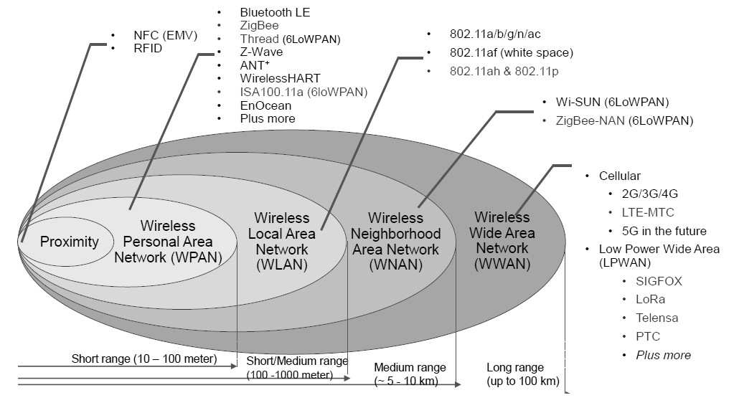

Fig 5.30 Wireless Technology for M2M/IOT

A brief technological description of various communication technologies are given in Following tables.

Table 5.2 Comparison of wire line Communication Technologies

|  |  |  |  |
| --- | --- | --- | --- |
| **Technology**  **/Protocol quency band(s)** | **Advantages** | **Limitations** | **Applications** |
| **DSL**  0-2.208Mhz | Inexpensive(installation and use)  High SLA  Less installation time  Bonded DSL provides inherent redundancy | Low data security  Lower throughput Higher latency | 1Gateway for Remote Health Monitoring 2Concentrator for Tele-Health  3Home Automation |
| **Ethernet**  100 MHz,  250MHz,  500 MHZ,  600MHz,  1GHz  1.6GHZ-2GHz | 1. Inexpensive (installation and use) 2. Excellent throughput 3 Low installation time 4 Easily scalable. | 1. Lowest data security 2. Lowest SLA 3. Highest latency 4. Bursts of additional bandwidth not possible | 1Gateway for Remote Health Monitoring  2Concentrator for TeleHealth  3Smart Metering  4Home Automation |
| PLC  **PLC**  No Defined  Frequency band in India. | 1. Ready infrastructure 2. Communication possible in   Challenging environments such as underground installations, metal- shielded cases   1. Long technology life-cycle Many standards and protocols available | 1. Point-to-point communication 2. It can cause disturbances on the lines 3. Not suitable where power cables are not in a good condition; 4. Highly trained manpower required for   O&M   1. Communication not possible in case of an outage   **5** Absence of regulations on  use of frequency bands | 1. Smart metering 2. Home automation |

Table 5.3 Comparison of wireless Communication Technologies

|  |  |  |  |
| --- | --- | --- | --- |
| **Bluetooth Low Energy**  **2.4GHz.** | 1Mature technology  2Easy to implement   1. Low Power 2. Powered by coin cell 3. Longer battery life | 1 Small data Packets | 1Healthcare devices  2Fitness devices  3 Smart metering |
| **NFC**  13.56 MHz | 1Consumes less power   1. Almost instantaneous connectivity between devices 2. No power is required in- case of passive Tags | 1Extremely short range   1. Expensive 2. Low information security 3. Low market Penetration | 1Healthcare devices   1. Fitness devices 2. Smart   Metering |
| **Wi-Fi**  2.4 GHz | 1Mature technology   1. High home/office penetration 2. High data rates achievable 3. Easy to implement | 1. Limited range 2. Poor building penetration 3. High interference from other sources 4. Power consumption Higher | 1Base station  In Health Clinics 2 Smart metering  3 Home automation |
| **ZigBee**  2.4GHz  920MHz,  915MHz,  868MHz,  780 MHz | 1Full support of IEEE 11073 device specialization profile   1. Longer battery life from low cost coin cells for   wearable devices   1. Wireless range up to 70 meters indoor and 400 meters outdoor | 1 Not widely adopted 2 BLE is the direct  Competition for ZigBee Providing different modes /profiles of operation. | 1Health Monitoring and Safety   1. Client Activity Monitoring 2. Health and Wellness monitoring |
| **Z-Wave**  Sub 1GHz for India  (865 MHz  -867 MHz) | 1Standardized by CSR 564 (E)   1. very successful due to its ease of use and   interoperability   1. Majority share of the Home Automation market | 1. Proprietary radio systems available 2. Limited Range drives up costs | 1. Security systems 2. Home   automation.3  Lighting controls |
| **Wi-SUN**  Sub 1GHz for India  (865MHz  -867 MHz) | 1. Open standards based 2. Interoperable 3. High data rate 4. Long Range 5. Widely adopted worldwide 6. Low power consumption   7. higher reliability. | Based on latest IEEE standard which is not yet adopted widely | 1.Smart metering  2.Distribution automation  3.Smart Home  4.Smart City  5.Industrial automation |
| **ANT**  2.4 GHz | 1. Low power mode supporting longer battery life 2. Adopted by major mobile manufacturer | 1BLE is giving direct competition to ANT as it  is already supported by all the Mobile manufacturer  2 Not all mobile  Manufacturer are  Supporting ANT hardware | 1. Fitness device 2. Healthcare device |

Table 5.4 Comparison of Cellular Communication Technologies

|  |  |  |  |
| --- | --- | --- | --- |
| **Cellular (2G-**  **GSM/ EDGE,**  **3G-UMTS,4G-**  **LTE)**  For India,  900 MHz,  1800 MHz,  2100 MHz and  2300 MHz . | 1. Mature technology 2. Developed by global 3. community of 400+ 4. companies from 39 countries 5. Rapid deployment 6. Communication modules are low cost and   standardized.   1. Roaming 2. Wideavailability of 3. Network Infrastructure | 1. Coverage not 100% 2. Reliability not the best 3. Short technology life- cycle (2G, EDGE, 3G,   LTE etc.) | 1. Tele-Health 2. Remote Health Monitoring 3. Smart metering |
| **Cellular:**  **EC GSM IoT**  2 G Bands | Network infrastructure is backwards-compatible to  previous releases to allow the technology to be introduced into existing GSM networks | Eco system is yet to be developed | 1. Smart cities and homes 2. Smart utilities 3. Wearables 4. Smart energy 5. Intelligent transport systems |
| **Cellular:**  **N B- IoT**  Conventional  LTE cellular  Bands like  700 MHz,  800 MHz and  900MHz, and  re- farmed  2Gbands | 1. Standards based defined by   3gpp,the global   1. organizations supported by a mature global ecosystem 2. Wide area ubiquitous coverage 3. deployed through upgrade of existing network   (reuses existing network ) 5. Ultra-low-power consumption in devices   * 1. Enhanced for 20+dB   2. additional coupling gain   (reaches deeper in-building and underground)   * 1. Low cost terminal   2. Plug and play   3. High reliability and high carrier- class e2e network security (based on LTE) | 1 Limited Mobility is not yet supported (limited support based on cell reselection)  2Voice is not supported  3 Low Data rate applications with link  peak DL = 60~100kbps and  UL=~50kbps | 1. Sensor based applications,   with low data  rate requirement.   1. Applications not requiring high   speed mobility handovers.   1. Systems where devices/sensor   measurements are expected to be for long~10years |
| **Cellular: eMTC**  Conventional  LTE cellular bands like  700 MHz,  800 MHz and  900 MHz | 1. Developed by 3GPP a mature global eco system 2. Low power consumption 3. Works over existing   LTE networks   1. Easily configurable on demand scaling possible 2. Supports full mobility 3. Supports voice through VoLTE 4. high reliability and high carrier- class e2e   network security (based  on LTE | Support of higher bandwidth limits the other optimizations possible,  compared to - IoT and ECGSM-IoT | Wearables ,Asset  Tracking,  Pet Trackers,  Telematics,  KIOSK, Parking  ,Industry environment monitoring, Connected  Healthcare personal and Enterprise equipment  Industrial IoT with  Emergency voice Call support |
| **LoRa**  Sub GHz | 1Network can be defined by the individuals / owners   1. Support long range and high battery life 2. High security using AES 128 encryption | 1. Own deployment with no subscription fees 2. Works in unlicensed band. | 1Smart Metering,   1. Smart street Lighting solutions 2. Asset monitoring |
| **SIGFOX** Sub GHz | Infrastructure being deployed. Several countries SIGFX ready | Deployment by network  Operator , Subscription fee | 1. Smart   Metering   1. Lighting |

**Application Server:**

An **application server** is a [software framework](https://en.wikipedia.org/wiki/Software_framework) that provides both facilities to create [web applications](https://en.wikipedia.org/wiki/Web_applications) and a [server](https://en.wikipedia.org/wiki/Server_(computing)) environment to run them.

Application Server Frameworks contain a comprehensive service layer model. An application server acts as a set of components accessible to the software developer through a standard [API](https://en.wikipedia.org/wiki/API) defined for the platform itself. For applications, these components are usually performed in the same running environment as their [web server(](https://en.wikipedia.org/wiki/Web_server)s), and their main job is to support the construction of dynamic pages. Application servers target much more than just Web page generation they implement services [9].

Features of Application server:

* **Data routing**– data is packaged in smaller objects with some business logic to minimize demands on bandwidth and battery
* **Orchestration**– transactions and data integration across multiple sources
* **Authentication service**– secure connectivity to back-end systems is managed by the mobile middleware
* [**Off-line**](https://en.wikipedia.org/wiki/Online_and_offline) **support**– allows users to access and use data even though device is not connected
* **Security**– data encryption, device control, SSL, call logging

Application server supports open API-based platform. Application server has network capabilities to interface with device and process data and service capabilities to manage service and connect application.

The API platform supports communication via different networks and interfaces with a network operator’s system (e.g. SMS AND LBS). Which helps significantly reduce the cost and time required for M2M/IoT service deployment.

##### **Resources**

|  |  |
| --- | --- |
| **Sr. No.** | **Website used** |
| 1. | <https://en.m.wikipedia.org/wiki/Home_automation> |
| 2. | <https://ieeexplore.ieee.org/xpl/conhome/8232562/proceeding> |
| 3. | <https://www.ijedr.org/papers/IJEDR1601082.pdf> |
| 4. | <https://en.wikipedia.org/wiki/Smart_city> |
| 5. | <https://en.wikipedia.org/wiki/Intelligent_transportation_system> |
| 6. | Electronics For You-Nov-2018,May 2019,July-2019 |
| 7. | [http://tec.gov.in/pdf/M2M/M2M%20Gateway%20&%20Architecture.pdf](http://tec.gov.in/pdf/M2M/M2M%20Gateway%20%26%20Architecture.pdf) |
| 8. | <https://internetofthingsagenda.techtarget.com/definition/machine-to-machine-M2M> |
| 9. | <https://en.wikipedia.org/wiki/Application_server> |

**Sample Question:**

|  |  |
| --- | --- |
| **Sr. No.** | **Question** |
| 1. | A smart city is   1. A city with all facilities. 2. A city run by accountants 3. Somewhere that makes smart use of new technology 4. There is no agreed definition for a smart city |
| 2. | The vital component is often considered in discourse around smart cities is A. The role of the accountant |

|  |  |
| --- | --- |
| **Sr. No.** | **Question** |
|  | 1. The role of central government 2. The role of local government 3. The role of technology |
| 3. | Smart metering causes   1. Increase in precision of billing 2. Decrease in precision of billing 3. Increase in approximation of billing 4. Increase in random estimation of billing |
| 4. | Ventilation is the process of   1. Cooling air in a space 2. Increase in humidity in a space 3. Exchanging /replacing air in a space 4. Purifying air in a space |
| 5. | HVAC provides   1. Air conditioning and purification 2. Light automation 3. Security system 4. Alarm systems |
| 6. | Smart waste deals with __________  A .Garbage collection and disposal   1. Reusing and reducing garbage 2. Recycling waste 3. Dumping trash in landfills. |
| 7. | Smart bins indicate status of bin using __________   1. Level sensors 2. Temperature sensors 3. Garbage Sensors 4. Gas sensors |
| 8. | Smart bins can be monitored using   1. Its own private network implemented by municipality 2. Manual inspection by a person 3. Trained Dogs 4. Housing society |
| 9. | M2M Communication is a communication between   1. Machine to Machine 2. Motor to Machine 3. machine to motor 4. motor to motor |
| 10. | Function of device domain in M2M network A. Collection and transmission of sensor data. B .Interpretation of sensor data C. Processing of sensor data.  D. Analysis of sensor data |
| 11. | Subnet in M2M is used for generating the communication link between the M2M devices and the M2M___________. A. Gateways   1. Devices. 2. Server. |
| **Sr. No.** | **Question** |
|  | D. Router |
| 12. | All nodes communicate with each other using some intermediate gateways in a A. Fully distributed networks   1. Client-server networks 2. Cooperative networks   D.. Multi point network |
| 13. | The brain of IOT system is   1. Sensor 2. Processors 3. Gateways 4. applications. |
| 14. | One of this is not a networking device:   1. Router 2. Switch 3. Bridge 4. Traffic Analyzer |
| 15. | Limitation of Wireless Sensor Network(WSN)   1. Restricted bandwidth 2. Infinite storage capacity 3. High processing speed 4. Large range |
| 16. | One of this is not a sensor:   1. Gyroscope 2. Camera 3. Oscillator 4. Barrometer |
| 17. | ______________ helps in navigation systems:   1. GPS 2. Light sensor 3. barometer 4. accelerometer |
| 18. | One out of these is not LPWAN technologies: A. SigFox   1. WiFi 2. NB-IoT 3. LoRa |
| 19. | Frequency band used by Z-WAVE IS :   1. 60 GHz 2. 2.4 GHz 3. Sub 1 GHz 4. 5 GHz |
| 20. | Transaction and data integration across multiple sources is   1. Orchestration 2. Data routing 3. Data mining 4. Data analyzing |

# APPENDIX A

Abbreviations and acronyms

|  |  |
| --- | --- |
| AAMS | Authorized Account Messaging Service |
| ADC | Analog to Digital Converter. |
| AF | Adaption Function |
| AG | Access Gateway |
| AI: | Artificial Intelligence. |
| AMQP | Advanced Message Queuing Protocol. |
| AMR | Automatic Meter Reading |
| AMS | Automatic Metering System |
| AN | Access Network |
| ANI | Application Network Interface |
| AOI | Automatic Optic Inspection |
| API | Application Programming Interface |
| AR | Augmented Reality |
| ARM | Advanced RISC Machine |
| AS | Application Server |
| ASF | Application Support Function |
| ASIP | Application Specific Instruction Processor |
| ASSP | Application Specific System Processor |
| ATM | Asynchronous transfer mode |
| AU | Administrative Unit |
| AVR | Advanced Virtual RISC |
| BGW | Border Gateway |
| BOS | Bottom of Stack |
| BPON | Broadband Passive Optical Network |
| BSS. | : Business Support System |
| CAPEX | Capital Expenditure |
| CCTV | Closed Circuit Television |
| CDF | Content Delivery Function |
| CDMA | Code-Division Multiple Access |
| CISC | Complex Instruction Set Computer |
| CNC. | Computerized Numerical Control. |
| CoAP: | Constrained Application Protocol. |
| CPS | Cyber Physical System. |
| CSP | Chip-Scale Package |
| DMA | Direct Memory Access |
| DSL | Digital Subscriber Line |
| DSP | Digital Signal Processor |
| DVB | Digital Video Broadcasting |
| DWDM | Dense Wavelength Division Multiplexing |
| E2E | End to End |
| ED | Electro Deposited |
| EDR | Event Data Recorder |
| EPON | Ethernet Passive Optical Network |
| FDMA | Frequency Division Multiplexing |

|  |  |
| --- | --- |
| FEC | Forwarding Equivalence Class |
| FPC | Flexible Printed Circuits |
| FPC | Flexible Printed Circuits |
| FPGA | Field Programmable Gate Array |
| FPSLIC | Field Programmable System Level Integration Circuit |
| FTTB/C | Fiber to take building /curb |
| FTTcab | Fiber to take cabinet |
| FTTcell | Fiber to take cell |
| FTTH | Fiber to take Home |
| Gbps | Giga bits per second |
| GPON | Gigabit Passive Optical Network |
| GPRS | General Packet Radio Services |
| GPS. | Global Positioning System |
| GPU | Graphic Processing Unit |
| GSM | Global System for Mobile (communications) |
| HMI. | Human Machine Interface. |
| HP | Hewlett Packard |
| HVAC | Heating, ventilation and air conditioning |
| ICR | Intelligent Call Routing |
| IEEE | Institution of Electrical and Electronics Engineer |
| IFPON | Interface over Passive Optical Network |
| IFTTT | If This Then That |
| IIoT: | Industrial Internetof Things. |
| IMS | IP Multimedia Subsystem |
| IoE: | Internet of Everything. |
| IoT | Internet of things |
| IP | Internet Protocol |
| ISDN | Integrated Service Data Netwok |
| ISDN-BRI | Integrated Services Digital Network- Basic Rate Interface |
| ISDN-PRI | Integrated Services Digital Network- Primary Rate Interface |
| ISP | In System Programming |
| ITU T | International telecommunication union |
| JTAG | Joint Test Action Group |
| LAN | Local area network |
| LiCoO2 | lithium cobalt oxide |
| Li-ion/ LIB | Lithium-ion |
| LiMn2O4 | lithium manganese oxide |
| LiNiO2 | lithium nickel oxide |
| LMV | Light Motor Vehicle. |
| LoRa | Long Range Wide Area Network |
| LPWAN | Low Power Wide Area Network |
| LSP | Label Switch Path |
| LSR | Label switch router |
| LSW | Label Switch Path |
| LTE | Long Term Evolution |
| M2M | Machine To Machine. |

|  |  |
| --- | --- |
| MCU | Microcontroller Unit |
| MGC | Media Gateway Controller |
| MIPS | Million Instructions Per Seconds |
| MMCF | Mobility Management and Control Function |
| MMS | Multimedia Messaging Service |
| MPLS | Multi Protocol Label Switching |
| MQTT | Message Queuing Telemetry Transport. |
| MS | Media Server |
| MSISDN | Mobile Station International Subscriber Directory Number |
| MTS | Machine type communication |
| NACF | Network Attachment Control Function |
| NAN | Neighborhood Area Network |
| NAPT | Network Address Port Translation |
| NB-IoT | Narrow Band LTE for Internet of Things |
| NE | Network Equipment |
| NFC | Near Field communication |
| NFV | Network Function Virtualization |
| NGN | Next Generation Network |
| Ni-CD | Nickel-Cadmium |
| NiMH /Ni-MH | Nickel Metal Hydride |
| NNI | Network Network Interface |
| NVM | Non Volatile Memory |
| NVM | Non Volatile Memory |
| OBD | On Board Diagnostic. |
| OC | Optical Circuit |
| Och | Optical Channel |
| ODN | Optical Distribution Network |
| OEM | Original Equipment Manufacturer |
| OIT. | Operator Interface Terminal |
| OLED | Organic light-emitting diode |
| OLT | Optical Line Termination |
| OMS | Optical multiplex section |
| ONT | Optical Network Terminator |
| ONU | Optical Network unit |
| OPEX | Operational Expenditure |
| OSE | Open Service Environment |
| OSS. | Operation Support System |
| OTS | Optical transmission section |
| OTT. | Over the Top |
| OUT | Optical transport unit |
| PAEK | Poly Aryl Ether Ketone |
| PAN | Personal Area Network |
| PCB | Printed Circuit Board |
| PCM | Pulse Code Modulation |
| PDA | Personal Digital Assistant |
| PDH | Plesiochronous digital hierarchy |

|  |  |
| --- | --- |
| PEEK | Polyether ether ketone |
| PER | Provider Edge Router |
| PLC. | Programmable Logic Controller. |
| PON | Passive Optical Network |
| POT | Plain old telephone |
| PR | Provider Router |
| PSTN | Public Switch Telephone Network |
| PTF | Polymer Thick-Film |
| PTH | Plated Through Hole |
| QoS | Quality of Service |
| RA | Rolled-Annealed |
| RACF | Resource and Admission Control Function |
| RAMI: | Reference Architecture Model of Industry |
| RAN | Radio Access Network |
| RAN | Radio Access Network |
| ReRAM | Resistor Switching Random Access Memory |
| ReRAM | Resistive switching Random Access Memory |
| RFID | Radio Frequency Identification |
| RISC | Reduced Instruction Set Computer |
| RTG | Radioisotope Thermoelectric Generator |
| RTOS | Real Time Operating System |
| RTOS | Real Time Operating System |
| SAN | Storage area network |
| SBC | Session Border Controller |
| SCADA | Supervisory Control and Data Acquisition System |
| SCF | Service control Function |
| SDH | Synchronous Digital Hierarchy |
| SDN | Software Defined Network. |
| SG | Signaling Gateway |
| SIMD | Single Input Multiple Data |
| SIP | Session Initiation Protocol |
| SIP | Session Initiation Protocol |
| SLA | Service Level Agreement |
| SLR | Single Lens Reflex |
| SMD | Surface-Mount Device |
| SMT | Surface-Mount Technology |
| SoC | System-On-Chip |
| SONET | Synchronous optical Network |
| SOS | Sensor observation Service |
| SPI | Serial Peripheral Interface. |
| SSF | Service Support Function |
| SSF | Service Support Function |
| SSL | Secure socket layer. |
| STD | Subscriber Trunk Dial |
| STM | Synchronous transfer module |
| SUP | Service User Profile |
| TAN | Touch Area Network |
| TCO | Total Cost of Ownership |
| TDM | Time Division Multiplexing |
| TDM | Time Division Multiplexing |
| TDMA | Time Division Multiplexing Access |
| TE | Terminal Equipment |
| THT | Through-Hole Technology |
| TMG | Trunk Media gateway |
| TOC | Tower operations Centre. |
| TTL | Time to Live |
| UE | User Equipment |
| UID | Unique Identifier. |
| UMTS | Universal Mobile Telecommunication System |
| UNI | User Network Interface |
| URL | Unified Resource Locator |
| UTF | Unicode Transformation Format |
| VCR | Video Cassette Recorder |
| VLSI | Very Large Scale Integration |
| VoIP | Voice on Internet Protocol |
| VPN | Virtual Private Network |
| VR. | Virtual Reality |
| VR/AR | Virtual Reality/Augmented Reality |
| WAN | Wide Area Network |
| WCDMA | Wideband Code Division Multiple Access |
| WDM | Wavelength Division Multiplexing |
| Wi-Fi | Wireless Fidelity (IEEE 802.11x) |
| WLAN | Wireless Local Area Network |
| WMS . | Web Map Service. |
| WoF | Warrant of Fitness |
| WPC | Wireless Planning coordination |
| XG-PON | 10 Gigabits Passive Optical Network |

# Appendix B

## Answer key of Sample questions

|  |  |  |  |  |
| --- | --- | --- | --- | --- |
| **Unit No** | **Question No** | **Answer key** | **Question No** | **Answer key** |
| **1** | **1** | **C** | **16** | **A** |
| **2** | **B** | **17** | **A** |
| **3** | **D** | **18** | **B** |
| **4** | **B** | **19** | **B** |
| **5** | **B** | **20** | **C** |
| **6** | **B** | **21** | **A** |
| **7** | **C** | **22** | **A** |
| **8** | **B** | **23** | **A** |
| **9** | **A** | **24** | **A** |
| **10** | **B** | **25** | **A** |
| **11** | **A** | **26** | **A** |
| **12** | **A** | **27** | **B** |
| **13** | **A** | **28** | **B** |
| **14** | **B** | **29** | **A** |
| **15** | **B** | **30** | **A** |
| **2** | **1** | **C** | **11** | **A** |
| **2** | **A** | 12 | **B** |
| **3** | **C** | 13 | **C** |
| **4** | **B** | 14 | **D** |
| **5** | **D** | 15 | **B** |
| **6** | **C** | **16** | **A** |
| **7** | **B** | **17** | **B** |
| **8** | **D** | **18** | **A** |
| **9** | **C** | **19** | **D** |
| **10** | **A** | **20** | **A** |
| **3** | **1** | **C** | **9** | **A** |
| **2** | **B** | **10** | **C** |
| **3** | **D** | **11** | **A** |
| **4** | **D** | **12** | **B** |
| **5** | **A** | **13** | **B** |
| **6** | **B** | **14** | **A** |
| **7** | **B** | **15** | **B** |
| **8** | **B** |  |  |
| **4** | **1** | **A** | **11** | **A** |
| **2** | **C** | **12** | **C** |
| **3** | **B** | **13** | **A** |
| **4** | **D** | **14** | **D** |
| **5** | **C** | **15** | **B** |
| **6** | **D** | **16** | **A** |
| **7** | **B** | **17** | **B** |
| **8** | **C** | **18** | **B** |
| **9** | **A** | **19** | **A** |
| **10** | **B** | **20** | **B** |
| **Unit No** | **Question No** | **Answer key** | **Question No** | **Answer key** |
| **5** | **1** | **C** | 11 | **A** |
| **2** | **D** | 12 | **C** |
| **3** | **A** | **13** | **B** |
| **4** | **C** | **14** | **D** |
| **5** | **A** | **15** | **C** |
| **6** | **A** | **16** | **C** |
| **7** | **A** | **17** | **A** |
| **8** | **A** | **18** | **B** |
| **9** | **A** | **19** | **C** |
| **10** | **A** | **20** | **A** |

# APPENDIX C Bibliography

1. The AVR Microcontroller and Embedded Systems using Assembly and C.MuhammadAli MazidiMicroDigitalEd.com ISBN-13:078-0997925968
2. ARM Assembly Language Programming & Architecture Muhammad Ali Mazidi,

SarmadNaimiMicroDigitalEd.com ISBN-13: 978

1. Getting started with Arduino-Massimo Banzi-First Edition
2. Internet of Things Architecture and Design Principles by Raj Kamal McGraw Hill Education Publication.
3. Industry 4.0 Concept: Background and Overview special focus paper by Andreja Rojko
4. IEEE Access paper Smart Factory of Industry 4.0: Key Technologies,Application Case, and Challenges by Baotong Chen, Jiafu Wan, Lei Shu, Peng Li, Mithun Mukherjee, Boxing Yin.
5. IOSR Journal of Computer Engineering (IOSR-JCE) Internet Of Things (IoT) In The Smart Automotive Sector:A Review by Ruhi Kiran Bajaj,Madhuri Rao, Himanshu Agrawal
6. Study on the IOT Architecture and Gateway Technology by Chang-le Zhong, Zhen Zhu, Ren-gen Huang at 2015 14th International Symposium